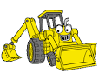
1 2 3 4
Scooooooooooooop

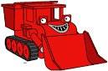
1 2 3 4

Muck- Muck -

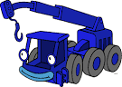 1 2 3 4

Lof-ty Lof- ty

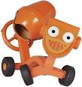
1 2 3 4

Dizzy Dizzy Dizzy Dizzy

