

**Underground  
Music Project**

**A joint Youth:MK and   
MK Music Hub Project**

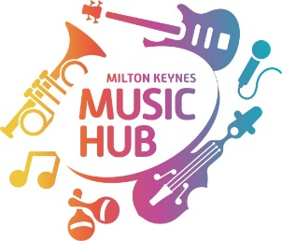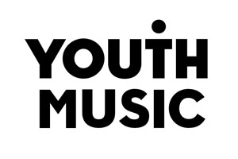

**Start date week commencing 2 November 2020**

**Please complete the referral form below**

Milton Keynes Music Hub  
www.miltonkeynesmusichub.co.uk

**MK Music Hub and Youth:MK have received funding from Youth Music and are working in partnership to extend the ‘Underground’ music project to more young people.**

Underground Tuesday encourages young people to come together and make music with a view to increasing their musical skills and also nurturing their personal and social development. Sessions are led by the young people’s own musical interest and are run by a Youth Worker in partnership with tutors from the MK Music Hub

**Important information:**

Open to young people aged 13-19 with an interest in music (referral needed)

Young people can use their own instruments. If they don’t already own an instrument a loan can be organised

**Covid -19 restrictions:**

The projects will eventually take place in community centres or children’s centres in MK but they will start with online provision



**Registration Form  
Underground Music Project**

**Young person details:**

Name: ……………………………………………………………….

Age and Date of Birth: ……………………………………………………………….

Address: …………………………………………………………………………………………………………………………………

**Parent/Carer details:**

Name: ……………………………………………………………………………………..

Address: …………………………………………………………………………………………………………………………..

Emergency mobile Contact number: …………………………………………………………………………………

Email address: …………………………………………………………………………………………

**Medical information:**

Does the young person have any medical conditions/allergies/food intolerances? If yes, please detail below:

Which team within MKC Children’s services is the young person working with:

Does the young person have any additional and or learning needs? If yes, please detail below and identify any support/strategies the youth team should be aware of:

Please detail below any behaviours and/or risks to peers/adults/themselves the young person may pose:

Please list below any other information the youth team may need to be aware of:

**Data Protection Statement**

Your information will be used by Youth:MK Milton Keynes Council for the purposes of safeguarding you whilst attending a Youth:MK positive activity.

Youth:MK works within the Milton Keynes Council Data Protection Statement which can be found on-line at: <https://www.milton-keynes.gov.uk/privacy>

**Your Signature: Date:**

**Please return to:**[**sue.wakley@milton-keynes.gov.uk**](mailto:sue.wakley@milton-keynes.gov.uk) **or** [**Richard.Lee@milton-keynes.gov.uk**](mailto:Richard.Lee@milton-keynes.gov.uk)