Latitude and Longitude

A 12-week project for Years 5 and 6

Week | Learning Intentions  Children learn… | Activities | Learning Outcomes  Children can….
1 | A new chant  About time values  About the Prime Meridian  To work as a class, in small groups and pairs  About rhythm | Intro: The Human Drum Kit  Where are we?  Discussion and introduce the Prime Meridian (see background information)  Main: Introduction to/revision of metre.  Play ‘Metre Mix’ using names of the countries that lie on the Prime Meridian  UK UK (crotchets), Mal-li- (minims), France---, Spain--- (semi-breves), Togo (quavers).  Clap, say and play time values using un-tuned percussion and revise/introduce notation  Clap and play the names of three other countries on the PM  - Antarctica  - Algeria  - Burkina Faso  Which are the same?  Make up own four (MA) or eight (HA) phrase in pairs and say, clap and play it.  Plenary: Who can work out the rhythm of ‘kino Faso’, ‘geria’, ‘artica’?  What time values are ‘boom-boom-‘, ‘ts, ts, ts, ts’, ‘clap, clap, clap, clap’ and ‘sh---‘ from The Human Drum-Kit? | Move and play with control and awareness of pulse  Name some of the countries that lie on the Prime Meridian  Maintain an independent part within a small group  Create original rhythmic phrases  Understand rhythmic notation
2 | A new rap  How to speak and move in time  To work creatively in groups  How to notate rhythms  How to comment upon performances | Intro: Revise ‘The Human Drum Kit’ and the time values of each vocal effect.  Introduce Longitude with ‘The Longitude Rap’ (see resources) and talk about the meridians (see background information)  Main: Say the rap and keep the beat. (UKUK/walk).  Try saying it with the time-values ‘Mali’/ stride, ‘Spain, France’/ glide and ‘Togo’/jogging underneath as a class or in two groups.  Group work: Make up an accompaniment to the rap using beat-boxing, vocal sounds or un-tuned sounds.  LA- one part  MA- two parts  LA- three or four parts  Notate accompaniment in beat box score (see resources)  Plenary: Perform raps in groups  Who can hear the words/  Which group was most confident?  Who can hear what time value/rhythm was used as an accompaniment? | Talk about longitude and the meridians  Clap the main four time values whilst speaking a rap  Use their knowledge to create a rhythmic accompaniment  Maintain a part within a small group/individually  Use musical language to comment on their work and the work of others’
3 | The Equator and latitude  A new rap  Countries that are on the Equator  About pitch and tuned percussion instruments  To play tuned phrases on one note  To work co-operatively in pairs | Intro: Talk about the Equator, the countries along it, their characteristics and introduce Latitude (see background information)  Introduce ‘The Latitude Rap’ and parallels (see resources)  Main: Use the countries along the Equator to help introduce pitch and tuned percussion.  Talk about how the size of the instrument and length of the keys affects the pitch and revise the names of tuned percussion instruments.  Use the ‘E’s for Equator’ resource sheet to play to the class and ask children to work in pairs on an instrument to copy phrases. (See resources).  Give each pair a composition sheet and ask them to fill in their own choice of countries and to play them back to the class.  Encourage LA to use simple rhythms such as ‘Congo’ and MA/HA to use rhythms such as ‘Galapagos’.  Assess: Who can play rhythms accurately?  Plenary: Who can notate the rhythm of one or more of their phrases? | Name some of the countries that lie on the Equator  Identify the link between size and pitch  Play a sequence of pitched notes (scale)  Create rhythmic phrases  Play with accuracy and fluency  Notate the rhythm of phrases
4 | About staff notation  A new song  A pitch game  To identify changes in pitch  About chords  To play notes of a major chord | Intro: Revise the term pitch and show the children how it is notated on a stave (see resources).  Sing, ‘Heads, shoulders baby’ and touch different parts of body when each note of the C scale is played (see resources)  Main: Repeat ‘Body Game’ with tuned percussion as a call and response in a sequence and then using ‘Head’ (C’), ‘Shoulders’ (G), ‘Knees’ (E) and ‘Toes’ (C) only.  Introduce chords and use the notes of the C chord as class. Split the class in two and introduce the G chord to them (GBDG’)  Half the class to play G and the other C in order to accompany the words, ‘one, two, three’ in ‘Heads, shoulders, baby’.  HA to play notes of both chords (G/C/G)  Plenary: Sing song and record  Assess: Who can play tuned instrument with control and fluency? | Relate changes of pitch to staff notation  Respond to changes of pitch with movement  Copy tuned phrases  Play notes of the C and G major chords accurately and confidently within a musical context
5 | A new rhythm game  About question and answer phrases  About the pentatonic scale  To set words to music  To practise and perform in pairs  To comment upon work they hear | Intro: Revise ‘The Latitude Rap’ and names of all the countries along the Equator.  Play a game of, ‘Put a pattern in Space’ over 4 and then 8 beats.  Main: Children to work in pairs in order to create Q&A phrases (4 beats LA/8 beats HA) using Q&A about countries along the Equator (see background information and resource sheet).  Play a game of ‘Play a pattern in Space’ using the notes of the C pentatonic scale (CDEGA).  Show children how they might set their Q&A phrases to some or all of these notes.  Children to work in pairs in order to set phrases to scale.  Plenary: Listen to each pair.  Which phrase sound finished and why?  Which phrases complement each other and why?  Assess: Can set 4/8 beat phrases to the notes of the pentatonic scale | Create rhythmic phrases over 4 or 8 beats  Create balancing Q&A phrases  Use the notes of the C pentatonic scale in order to create a tuned phrase  Work co-operatively in pairs  Talk about their work and the work of others’ using musical language
6 | About the Northern and Southern hemispheres and the Tropics of Cancer and Capricorn  A new rap  About constellations  About staff notation  About arranging and organising ideas  How to plot their own constellation  How to play from a score | Intro: Introduce the Northern and Southern Hemispheres and the Tropics of Cancer and Capricorn using ‘The Hemisphere Rap’ (see resources).  Main: Look at the constellations of Cancer and Capricorn plotted on a score using the five lines of a stave and separated by bar lines at intervals of 15 degrees (same as each parallel).  Split the class into two and try playing each constellation.  Notice how some sounds are played together, some alone, some have only a few degrees to sound before the next note and some, a longer time to sound.  In groups, ask the children to plot their own constellation and to name it.  They should consider  - Length (duration) of sound  - Pitch of sound  - Combination of sounds  - Silence  Plenary: Listen to each group as they play their music and comment about their selection, organisation and combination of pitched sounds. | Read staff notation with help  Use the Parallels to plot a point North or South on a musical stave  Play from staff notation
7 | To listen to recorded music  To compare and contrast sounds  To use a variety of pitched sounds creatively  To use select sounds according to their duration | Intro: Remind the children of the music they have composed so far using the constellations of Cancer and Capricorn as a starter.  Main: Listen to some music from or inspired by countries along the Equator.  - Rain Forest Dream by Joji Hirota (track 13)  - Festival of Flowers by Alvaro Grana/ South America (track 19)  - Bowl Voices for The Singing bowls of Tibet (track 21)  Compare and contrast the sounds and discuss how they might be ‘plotted’ as a constellation.  Assess: Who can comment upon recorded sounds using musical language  Who can express their likes and dislikes  Introduce the idea of longer sounds e.g. bells and cymbals and other pitched sounds e.g. bow drawn over strings or plucked, bottles blown, bow drawn over a glass.  Revise Constellation Compositions, perform and record  Plenary: Talk about the effectiveness of each composition whilst looking at each constellation score listening to each recording. | Listen attentively and describe the sounds they hear using musical language  Notate pitched sounds on a stave  Combine tuned and un-tuned sounds and silence effectively  Explore the duration and production of sound  Perform with conviction  Talk about the effectiveness of their work
8 | About the Artic and Antarctic circles  About contrasting musical elements  How to create apiece within a given time frame  About major and minor tonality  A new song | Intro: Look at the Artic and Antarctic Circles and the days of light and dark (see Background Information).  Main: Give each group a ‘Contrast Composition Card’ and ask them to produce a piece of music within 10 minutes to illustrate it. (See resources).  Listen to each and ask the audience to guess the contrast and to comment upon the selection, organisation and combination of sounds.  Plenary: Sing the two versions of ‘Frere Jacques’ (see resources) with and without words and identify the sounds of the major and minor chord.  So far we have used the C and G chords- are they major or minor? | Recognise the Artic and Antarctic circles on a map and in relation to the Equator and the Tropics of Cancer and Capricorn  Work quickly and creatively within a group  Use contrasting musical elements  Recognise the sound of the major and minor chord  Sing tunefully
9 | How to identify the character of music through its tonality  To revise what they have learnt about time values  To improvise an accompaniment using notes of a major or minor chord  That other elements affect the mood/character of music | Intro: Revise the major and minor chord and sing through both versions of ‘Frere Jacques’.  Main: Listen to a selection of recorded music and complete the ‘Major or Minor?’ listening sheet (see resources).  Assess: Can identify changes in mood/tonality  Remind the children of the different time values we have explored and of how to find the notes of the C chord.  Split the class in two and ask half to sing the happy version of FJ whilst the other half improvise an accompaniment using CEGC’.  Swap tasks.  Repeat this with the sad version and the notes of the D minor chord (DFAD’).  Plenary: What elements did they immediately change when playing the piece in two different moods? (Pace and volume) | Identify and describe the tonality of a piece of recorded music  Describe its mood and character using musical vocabulary  Play notes of major and minor chords fluently using a variety of time values
10 | About tonality  How to revise their work  To listen attentively to recorded music  How to work co-operatively in groups  How to comment on music they hear | Intro: Sing the two versions of FJ and remind the children of how they changed the mood of the song with pitch, tonality, pace and dynamics. Remind them also of how groups had shown that duration; timbre and texture can also affect the mood or character of music.  Main: Listen to the opening of The Karelia Suite by Sibelius and comment on how the same ‘horn’ tune is played faster, louder and by a combination of instruments.  Ask the children to write a piece of contrast.  They will only have 20 minutes to select, organise and combine their sounds.  They may wish to use one sound I two different ways or to use two different sounds each.  Plenary: Listen and comment upon all the pieces. (Selection, organisation, combination, contrasting elements used, effectiveness) | Can distinguish between the sound of a music written in a major or minor key  Select, organise, combine and contrast sounds.  Comment upon the effectiveness of music that they hear
11 | How to use co-ordinates  How to use the knowledge they have gained in order to plan a piece of music  How to work creatively and co-operatively in groups | Intro: Remind the children how to use longitude and latitude to find a place. They will be given some co-ordinates, a map and some background information about a place in the world and they should use the musical knowledge they have gained and the ideas that they have explored this term to compose a piece called, ‘Where am I?’  Main: Revise the time values, using the names of the countries on the PM and their real names and play a game of ‘Metre Mix’.  Revise rhythm by playing a game of ‘Put a Pattern in Space’ and then by clapping answering phrases to my clapped 4 or 8 beat questions.  Revise pitch by looking at notes from major and minor chords  Revise the other elements of music and how they can be used and contrasted.  Look at the fact sheet provided (see resources) and decide upon elements needed.  The piece must include  - A pitched melody and/or chords  - Rhythmic phrases/ostinato  - Combinations of sound and silence  Explore ideas in groups.  Plenary: Fill in ideas in composition log | Use their knowledge of time values, rhythm and the elements of music in order to plan and create a piece of music  Explore tuned and un-tuned sounds  Combine and organise sounds
12 | How to organise, combine and refine their ideas  How to practise and perform their work  How to notate their ideas (HA)  How to evaluate their work and the work of others’ | Intro: Revise the raps they have learnt this term about Latitude, Longitude and the hemispheres.  Look over ideas in log- book in groups.  Main: Organise, combine (notate/HA), practise and refine ideas.  Perform and record.  Plenary: Listen to a evaluate own and one other performance using sheet provided (see resources)  Assess: Can perform with a sense of balance and ensemble and with awareness of effect and purpose | Select, organise and combine sounds with awareness of balance and effectiveness  Talk about their work and the work of others’ using musical vocabulary

Some children will be able to (emerging)
- Move to and play a steady beat and other time values with some help
- Maintain an independent part within a large group
- Create rhythmic and tuned phrases with some help and a limited number of notes or time values
- Understand the basic concepts of rhythmic and staff notation
- Work co-operatively in a group
- Understand how the different dimensions of music can be used to create contrast
- Talk about the music they hear and play
Some children will be able to (achieving)
- Move to and play a steady pulse and other time values with control
- Maintain an individual part within a small group
- Create original rhythmic and tuned phrases
- Understand rhythmic and staff notation
- Create musical accompaniments and structures
- Understand tonality and chords
- Understand how the use of the different musical dimensions can be used effectively in order to create contrast
- Play from staff notation
- Select, organise and combine sounds effectively
- Talk about and describe the music they hear using musical vocabulary
Some children will be able to (exceeding)
- Play and clap a variety of time values whilst speaking a rap
- Maintain an independent part alone or within a small group with awareness of how the other parts fit together
- Create well-shaped, balanced and fluent rhythmic and pitched phrases
- Understand rhythmic and staff notation and use them to notate their own ideas
- Create, organise, revise and refine musical phrases, accompaniments and structures
- Suggest changes to their group’s music and the music of others’ with musical reasons
- Understand how tonality and the other musical dimensions can be used to create a desired effect
- Justify their preferences and opinions using musical language

Resources
The Human Drum Kit (Banana Splits)
Rhythm cards
The Latitude Rap (see below)
Beat Box score (see below)
The Longitude Rap (see below)
E’s for Equator resource sheet and composition sheet (see below)
Skipping ropes/sheet stave
Heads, shoulders baby (Singing Sherlock Bk2)
Equator Question and answer sheet (see below)
Hemisphere rap (see below)
Constellation sheet and scores
Rain Forest Dream by Joji Hirota (track 13 Listen to This KS1)
Festival of Flowers by Alvaro Grana/ South America (track 19 Listen to This KS1)
Bowl Voices for The Singing bowls of Tibet (track 21 Listen to This KS1)
Contrast composition cards (see below)
Frere Jacques -major and minor version (see below)
Major and Minor listening sheet
Extracts from
- Mahler’s 1st Symphony (opening of 3rd movement)
- Saint Saen’s Organ Symphony (1st movement)
- Tchaikovsky’s 4th Symphony (opening)
- Beethoven’s 5th Symphony (opening)
- William’s ‘Darth Vader’s Theme
- Tchaikovsky Overture to the Nutcracker Suite
- Handel Water Music- Hornpipe
- Susato Renaissance Dance from Danserye
- Mussorgsky The Great Gate of Kiev from Pictures at an Exhibition
- Williams Star Wars Theme
‘Where am I?’ fact sheets and composition cards
Sibelius opening 3 minutes from the Karelia Suite
Evaluation sheets

The Latitude Rap

Parallels help you find your place
North or South on the earth’s surface
The Equator is at 0 degrees
Latitude is the term if you please

Lat- lat-latitude
Let’s get the geography attitude
Lat-lat-latitude
Let’s get in the mood-dude!

The Longitude Rap

Meridians help you find your place
East or West on the earth’s surface
Greenwich is at o degrees
Longitude is the term if you please

Long-long-longitude
Let’s get the geography attitude
Long-long-longitude
Let’s get in the mood-dude!

Latitude Beat-Box Score

 | 1 | 2 | 3 | 4
Me- | ridi | -ans help you | find your | place

1 | 2 | 3 | 4
East or | West on the | Earth’s sur- | face

1 | 2 | 3 | 4
Greenwich | is at | 0 de- | grees

1 | 2 | 3 | 4
Longi- | tude is the | term if you | please
E’s for Equator (teacher’s sheet)

1,2,3,4, C’s for Columbia 1,2,3,4, C’s for Columbia

1,2,3,4, D’s for Democratic –Congo 1,2,3,4, D’s for Democratic –Congo

1,2,3,4, E’s for Equator 1,2,3,4, E’s for Equator

1,2,3,4, F’s for Finding Facts 1,2,3,4, F’s for Finding Facts

1,2,3,4, G’s for Galapagos 1,2,3,4, G’s for Galapagos

1,2,3,4, A’s for Atlantic 1,2,3,4, A’s for Atlantic

1,2,3,4, B’s for Brazil 1,2,3,4, B’s for Brazil

1,2,3,4, C’s for Congo 1,2,3,4, C’s for Congo

E’s for Equator: Composition sheet by ………………………

1,2,3,4, C’s for…………………………………… 1,2,3,4, C’s for……………………………………

1,2,3,4, D’s for…………………………………… 1,2,3,4, D’s for……………………………………

1,2,3,4, E’s for…………………………………… 1,2,3,4, E’s for……………………………………

1,2,3,4, F’s for…………………………………… 1,2,3,4, F’s for……………………………………

1,2,3,4, G’s for…………………………………… 1,2,3,4, G’s for……………………………………

1,2,3,4, A’s for…………………………………… 1,2,3,4, A’s for……………………………………

1,2,3,4, B’s for…………………………………… 1,2,3,4, B’s for……………………………………

1,2,3,4, C’s for…………………………………… 1,2,3,4, C’s for……………………………………

Atlantic Brazil Columbia/Congo/Celebes Democratic Congo
Ecuador/Equator Finding facts Gabon/Gebe/Galapagos
E’s for Equator (Walk, jogging, walk, walk)

C’s for Columbia walk, jogging, jogging, walk

D’s for…………………………………… ………………………………………..

E’s for…………………………………… ………………………………………..

F’s for…………………………………… ………………………………………..

G’s for…………………………………… ………………………………………..

A’s for…………………………………… ………………………………………..

B’s for…………………………………… ………………………………………..

C’s for…………………………………… ………………………………………..

Equator Question and Answer phrases
E.g. (4 beats)

Q: What country begins with S?

A: It is Somalia

E.g. (8 beats)

Q: Can you tell me what Lake lies on the Equator?

A: Lake Victoria is a lake on the Equator

Q: ………………………………………………………………………………….

A: ………………………………………………………………………………….

Places that lie along the Equator

Ecuador Columbia Brazil Gabon Congo Democratic Republic of Congo Uganda Lake Victoria

Kenya Somalia Maldives Indonesia Sao Tome and Principe Islands Celebes Kayua and

Halmahera Islands Gebe Island Galapagos Islands

The Hemisphere Rap

Five parallels circle the Earth
The Equator has the biggest girth
Either side are the hemispheres
North or South-give a big cheer!

Now let’s travel through our topic
To the circles they call the tropics
Cancer and Capricorn
Lots of hot weather and mighty storms

Constellation of Capricorn

__________________________________________________________________*

*____________*____________*_______________*____________*__________

___________________________________________________________________

_________*______________________________________*_________________

___________________________*______________________________________

Constellation of Cancer

_______________________________*___________________________________

_______________________________*___________________________________

___________________________*_______________________________________

_________*______________________________________*_________________

_________________________________________________________________*

Constellation Composition

Constellation of………………………..

____________________________________________________________________

____________________________________________________________________

____________________________________________________________________

____________________________________________________________________

____________________________________________________________________

By……………………………………………………………………………………………………
Happy or Sad?

We are happy x 2 CDEC
Girls and Boys x 2 EFG-
We like singing happy songs x 2 gagfedC
Full of joy x 2 CGC-

We are miserable x 2 DEfeD
Oh so sad x 2 FGA-
When we sing this horrid song x 2 aBbagfeD
We feel bad x 2 DAD-

Background Information

The Prime Meridian

The Prime Meridian is a meridian (line of longitude) at which longitude is defined to be 0 degrees.
It forms a circle around the Earth with its opposite meridian, the 180 degrees meridian which divides the Earth into the eastern and western hemispheres.

The Prime Meridian runs through the Royal Observatory at Greenwich in the UK and was set there by Sir George Airy in 1851.

It was chosen to be the PM of the world in 1884 at a time when 72% of the world’s commerce depended on sea charts which used Greenwich as the PM.

The countries through which the PM runs are the UK, France, Spain, Algeria, Mali, Burkina Faso, Togo, Ghana and Queen Maud Land in the Antarctica.

Longitude

The angular distance of any object East or West of the Prime Meridian. The lines that run vertically around the Earth or meridians are used to measure how far east or west an object or place is. The meridians are placed at 15- degree intervals around the globe.
Longitude is measured in degrees and minutes (‘) and seconds (“). To travel around the Earth you would be travelling 360 degrees so distance is measured between 0 and 108 degrees to the East (E) or West (W). Its opposite line at 180 degrees is the International date -line.

Latitude

Latitude is the angular distance of any object North or South from the Equator measured in degrees, minutes (‘) and seconds (“). Standing at the North or South Poles you are at a 90- degree angle to the Equator.
Both halves of the Earth are the same size and the distance from the Equator is measured from 0-90 degrees North (N) or South (S).
The lines that run horizontally around the world are called parallels. Five of them have names.

The Arctic Circle 66 degrees 33’ N
The Tropic of Cancer 23 degrees 27’ N
The Equator O degrees
The Tropic of Capricorn 23 degrees 27’S
The Antarctic Circle 66 degrees 33’ S

The Equator

The Equator is equidistant from the North and South Poles and perpendicular to the Earth’s axis of rotation.
It is 40,075km (24,901miles) long .
If you stand on the Equator you are moving at about 1.037mph.
78.7% of it runs across water and 21.3% across land.
An imaginary circle projected onto the sky above it is called the celestial Equator.
Places along the Equator experience the quickest sunrises and sunsets and there is little distinction between seasons. Most countries experience high temperatures apart from places like the Andes and Mount Kilimanjaro. The temperature does plummet during rainstorms and the year is usually divided into wet and dry seasons.

Countries along the Equator are

Gabon 0 degrees 0’ N 9 degrees 21’E
Congo 0 degrees 0’ N 13 degrees 56’E
Democratic Republic of Congo 0 degrees 0’ N 17 degrees 46E
Uganda 0 degrees 0’ N 29 degrees 43’ E
Lake Victoria 0 degrees 0’ N 32 degrees 22’ E
Kenya 0 degrees 0’ N 34 degrees 0’ E
Somalia 0 degrees 0’ N 41 degrees 0’E
The Maldives 0 degrees 0’ N 42 degrees 53’ E
Indonesia 0 degrees 0’ N 98 degrees 12’E
Karimata Strait 0 degrees 0’ N 104 degrees 34’ E
Celebes 0 degrees 0’ N 119 degrees 40’E
Halmahera islands 0 degrees 0’ N 127degrees 24’E
Gebe island 0 degrees 0’ N 129 degrees 20’E
Ecuador (Galapagos Island s) 0 degrees 0’ N 91 degrees 35’ W
Columbia 0 degrees 0’ N 75 degrees 32’W
Brazil 0 degrees 0’ N 70 degrees 3’W
Atlantic Ocean 0 degrees 0’ N 49 degrees 20’W

The Tropic of Cancer and the Northern Hemisphere

The Tropic of Cancer (23.5 degrees N) is the place where the sun appears directly overhead at noon on June the 21st.
This is dictated by the tilt of the Earth’s axis of rotation. When the sun reached its zenith it entered the astrological sign of Cancer.

Tropic comes from the Greek word ‘trope’ meaning change of direction.
This parallel is 36,768km (22,847miles) long

Countries along this parallel include Algeria, Niger, Libya, Egypt, Saudi Arabia, United Arab Emirates, Oman, Bangladesh, China, Taiwan, Mexico and the Bahamas. The line also crosses the Red Sea, Indian Ocean, Pacific and Gulf of California.

Most of these areas are hot and dry but the Eastern coastal areas have very heavy rainfall. They have very hot summers (up to 45 degrees C) and warm winters (22 degrees C)
It covers most of the Sahara desert. The eastern part of this tropic is monsoonal form June to September.

The Northern hemisphere is the area between the Equator and the Artic. This is split up into the Northern Tropic (between the Equator and the Tropic of Cancer and the Northern Temperate zone (between the Tropic of Cancer and the Arctic).

The Tropic of Capricorn and the Southern Hemisphere

The Tropic of Capricorn is the place where the sun appears directly overhead at noon on the 21st December.
This is dictated by the tilt of the Earth’s axis of rotation. When the sun reached its zenith it entered the astrological sign of Capricorn.

Countries along this parallel include Namibia, Botswana, South Africa, Mozambique, Madagascar, Australia, Chile, Argentina, Paraguay and Brazil.
The topic also passes through the Atlantic, Indian and Pacific Oceans.

The Southern hemisphere is the area between the Equator and Antarctica. This is split up into the Southern Tropic (between the Equator and the Tropic of Capricorn) and the Southern temperate zone (between the Tropic of Capricorn and the Antarctica).

The Arctic Circle and the Arctic.

The word arctic comes from the Greek word, ‘arktos’ which means bear. The constellation for Ursa Minor can be seen above the Arctic.
The Arctic Circle is 66 degrees 33’ North of the Equator and 1,650km south of the North Pole.
If you were to stand on the Arctic Circle the distance around Earth is reduced to about 10,975 miles and you would be moving at 457mph. The North Pole does not move very quickly as it makes one turn every 24 hours.
The Icelandic island of Grimsey lies exactly on the Arctic Circle.

The temperature is as low as -70 degrees C in Northern Greenland or Siberia.
4,000,000 people live in the Artic as well as polar bears, Artic foxes, walruses, seals, whales and narwhals.

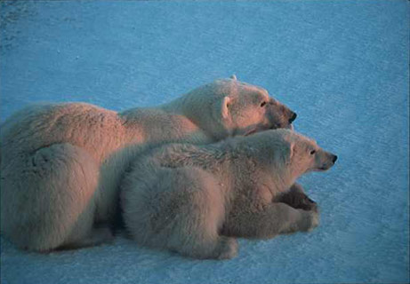

The Arctic includes the Artic Ocean, part so Canada, Russia Alaska, Greenland, Norway, Finland,
Sweden and Iceland. The ice rests on water and not land and contains 10% of the world’s fresh water.
One day a year there is complete darkness (Dec 21st) or sunshine (June 21st).

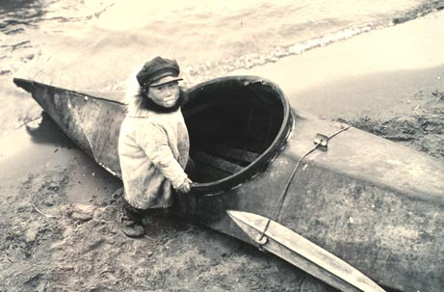

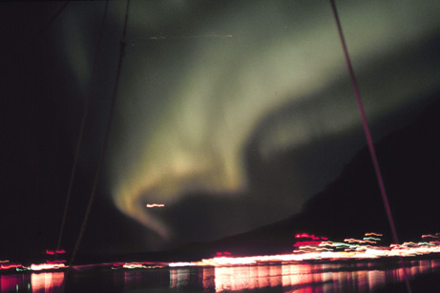

The lights appear when electrically charged particles from the sun collide with air molecules over the Earth's magnetic poles. The charged particle streams are called solar wind. When solar activity is heavy, creating more solar wind, large and brilliant auroras result.
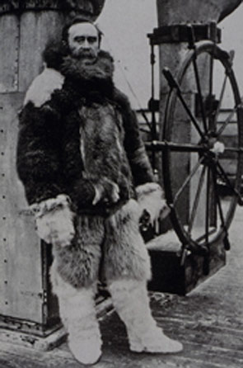

Peary is usually credited as being the leader of the first expedition to reach the North Pole. Peary entered the U.S. Navy in 1881 and remained in the service until retirement, taking periods of leave for Arctic exploration throughout his career. 6th April 1909

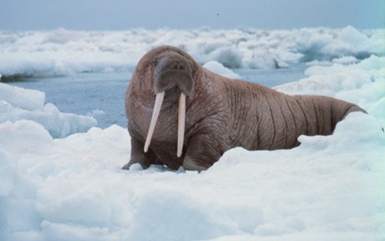

Walruses are social animals, often living in groups of over a hundred individuals. Eskimos and other hunters value the creature for its blubber, hide, and ivory tusks.

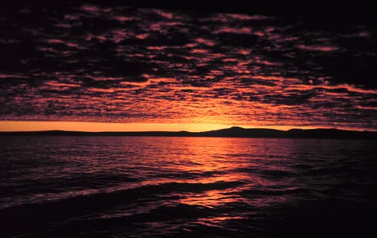

Sunset over Alaska’s Bering Sea
Because of the tilt of the Earth's axis, there is at least one 24-hour period of daylight and nighttime in every year.

The Antarctic Circle and the Antarctic

The Antarctic Circle (66.3 degrees S of the Equator) is the most Northerly latitude at which the sun can remain continuously above or below the horizon for 24 hours.
There are 6 months of complete darkness and 6 of complete light.
The South Pole is 90 degrees 0 degrees E

The area south of the Antarctic circle covers 4% of the Earth and is 98% solid ice.
It was made a continent in 1840.
The highest point is Vinson Massif (4,897m) and the lowest Bentley Subglacial Trench (2,555m)

The Antarctic is one and a half times the size of the USA.
It is the 5th largest continent
99% of the continent is covered by ice.
The Ross ice -shelf is 170 miles long and 25 miles wide.
The ice contains 70% of the planet’s fresh water.
The coldest temperature of -89.2 degrees C every recorded was in 1983 at the Vostok station.
Winds can blow at up to 200miles an hour.

There are no trees or shrubs.
The only inhabitants are penguins and the nematode worm. The male Emperor penguin stays there through the winter, sheltering eggs under his feet whilst the female spends 9 weeks at sea feeding.

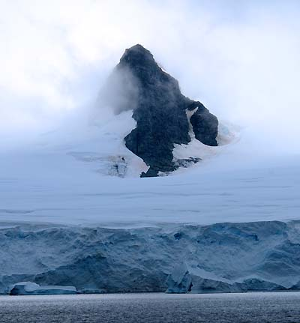

Peak projecting though a massive layer of ice, hundreds of feet thick.

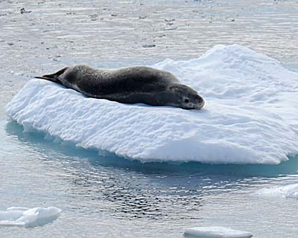

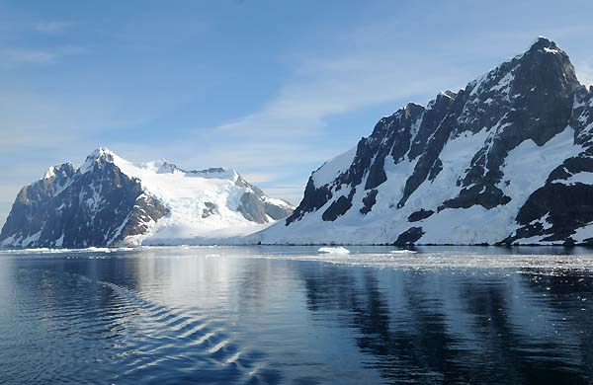
The (very rare) tranquil waters within the Neumayer Channel

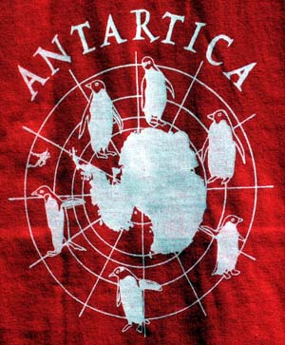
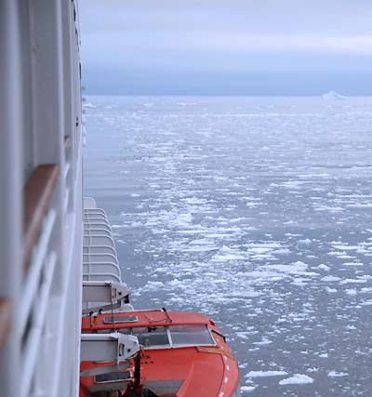
The MS Prinsendam making its way into Paradise Bay through a layer of sea ice.
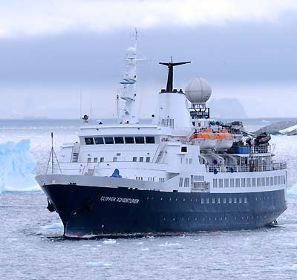

A former research vessel now used by a tour operator out of Ushuaia, Argentina that offers two week-long cruises to Antarctica.

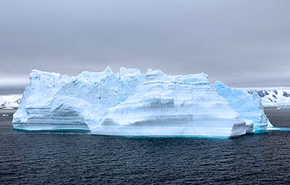

An iceberg, sculptured by the relentless wind, as tall as a ship
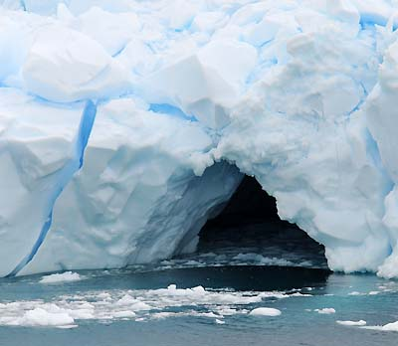

Many large icebergs have water-carved caves indented deep into their hulk.
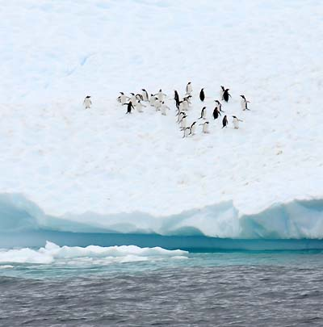

Non-breeding penguins sometimes make a temporary home on icebergs while searching for food in the open sea.

Where Am I?

Co-ordinates: 23 degrees 26’N 98 degrees 54’E

…………………………….

Melodic ideas (The Tune)
- Use the notes CDEGA or all the black notes on the keyboard/tuned percussion to make up a melody using one or two notes at a time
- Make up call and response phrases using Q&A about this country

Ostinato ideas (The Accompaniment)
- Use tuned and un-tuned instruments to make up a flowing ostinato that will keep the pulse

Accompaniment
- Use a combination of cymbals, bells and drums

Where Am I?

Co-ordinates: 23 degrees 26’N 98 degrees 54’E

…………………………….

Composers’ Log

Melody……………………………………………………………………………………………………………

…………………………………………………………………………………………………………………….

Ostinato……………………………………………………………………………………………………….

……………………………………………………………………………………………………………………

Accompaniment……………………………………………………………………………………………..

Combination/Organisation of sounds (notate this below)

Where Am I?

Co-ordinates: 0 degrees 0’N 29 degrees 43’E

…………………………….

Melodic and Rhythmic ideas (The Main part)
- Use the notes CDEGA or all the to make up a melody based on call and response (one than one tune as calls responded to by one tune)
- Make up call and response phrases using Q&A about this country using drums

Ostinato ideas (The Accompaniment)
- Use shakers and one drum to provide a constant pulse/ostinato through

Combination
- decide how you are going to organise all of these ideas

Where Am I?

Co-ordinates: 0 degrees 0’ N 29 degrees 43’ E

…………………………….

Composers’ Log

Melodic Calls…………………………………………………………………………………………………………

…………………………………………………………………………………………………………………………..

Melodic response………………………………………………………………………………………………….

Ostinato……………………………………………………………………………………………………………….

…………………………………………………………………………………………………………………………..

Combination/Organisation of sounds (notate this below)

Where Am I?

Co-ordinates: 0 degrees 0’E 55 degrees 38’W

…………………………….

Melodic ideas
- Use the notes CDEGA and the following rhythm
- Jogging, jogging, stride,
- Jogging, jogging stride
- Jogging, jogging, walk, jogging,
- Walk, walk, stride

Rhythmic ideas (The Accompaniment)
- Use shakers, agogos (or triangles held tightly) and two types of drum and make up a rhythm for each using words

Combination
- Decide how you are going to organise all of these ideas

Where Am I?

Co-ordinates: 23 degrees 26’N 98 degrees 54’E

…………………………….

Composers’ Log

Melody………………………………………………………………………………………………………………..

……………………………………………………………………………………………………………………………

Shaker rhythm……………………………………………………………………………………………………….

Agogo rhythm……………………………………………………………………………………………………………………

Drum 1 (small) rhythm……………………………………………………………………………………………..

Drum 2 (large) rhythm……………………………………………………………………………………………..
Combination/Organisation of sounds (notate this below)

Where Am I?

Co-ordinates: 0 degrees 0’S

…………………………….

Melodic ideas
- Use any notes that you wish to create a soundscape for the pictures below
- Try to provide a contrast of either two types of weather or day/night

Rhythmic ideas (The Accompaniment)
- Use appropriate un-tuned sounds for your piece i.e. shakers, tambourines, bells, rain sticks

Ostinato(tuned and un-tuned)
- Provide an ostinato to give you piece continuity but don’t be afraid to stop it in order to create periods of silence

Combination
- Decide how you are going to organise all of these ideas

Where Am I?

Co-ordinates: 0 degrees 0’S

…………………………….

Composers’ Log

Melody……………………………………………………………………………………………………………

…………………………………………………………………………………………………………………….

Ostinato……………………………………………………………………………………………………….

……………………………………………………………………………………………………………………

Accompaniment……………………………………………………………………………………………..

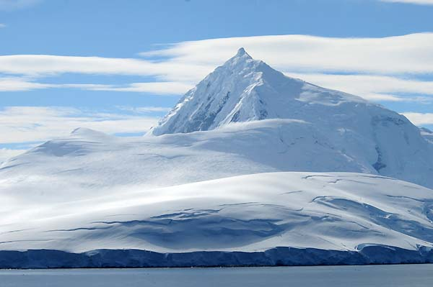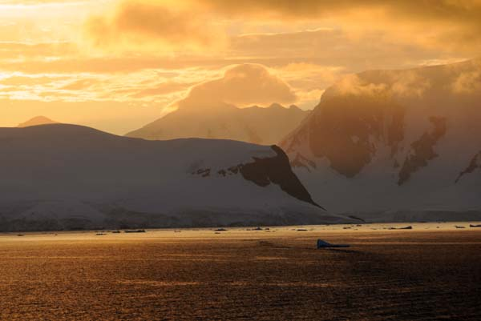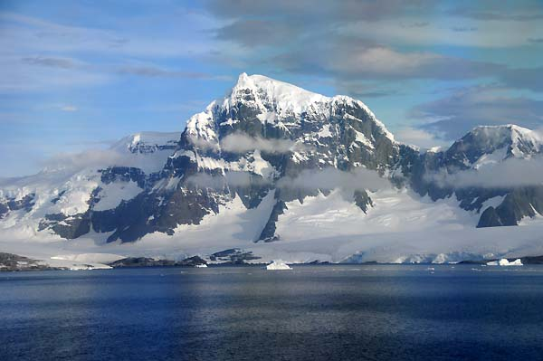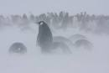

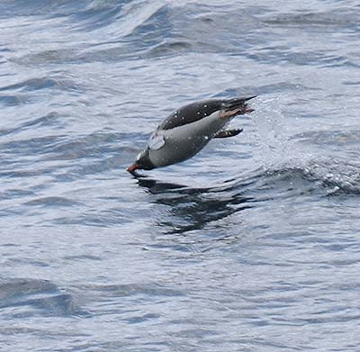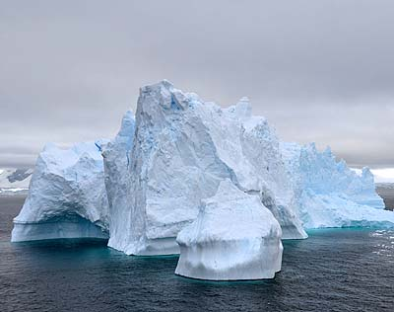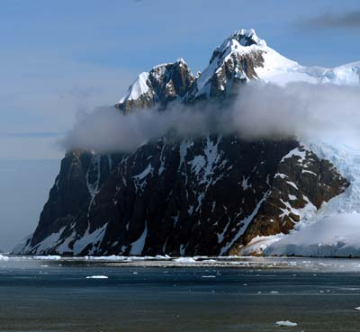

Combination/Organisation of sounds (notate this below)

Where Am I?

Co-ordinates: 0 degrees 0’N

…………………………….

Melodic ideas
- Use any notes that you wish to create a soundscape for the pictures below
- Try to provide a contrast of either two types of weather or day/night

Rhythmic ideas (The Accompaniment)
- Use appropriate un-tuned sounds for your piece i.e. shakers, tambourines, bells, rain sticks

Ostinato(tuned and un-tuned)
- Provide an ostinato to give you piece continuity but don’t be afraid to stop it in order to create periods of silence

Combination
- Decide how you are going to organise all of these ideas

Where Am I?

Co-ordinates: 0 degrees 0’N

…………………………….

Composers’ Log

Melody……………………………………………………………………………………………………………

…………………………………………………………………………………………………………………….

Ostinato……………………………………………………………………………………………………….

……………………………………………………………………………………………………………………

Accompaniment……………………………………………………………………………………………..

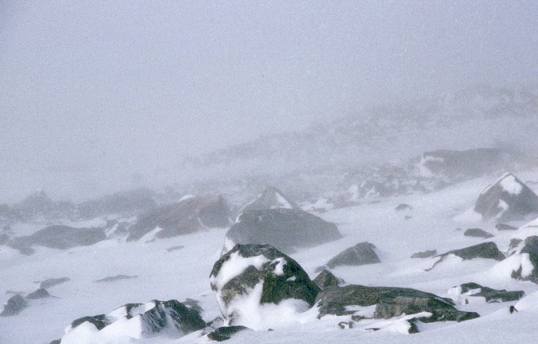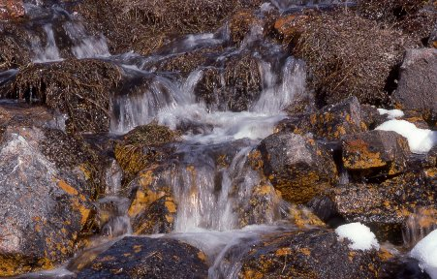

Combination/Organisation of sounds (notate this below)

Co-ordinates | Country, territory or sea

Co-ordinates | Country, territory or sea
66°34′N 000°00′E | Arctic Ocean
66°34′N 12°48′E | Norway
66°34′N 15°31′E | Sweden
66°34′N 23°51′E | Finland
66°34′N 29°28′E | Russia
66°34′N 33°25′E | White Sea
66°34′N 34°28′E | Russia
66°34′N 34°38′E | White Sea
66°34′N 35°0′E | Russia
66°34′N 40°42′E | White Sea
66°34′N 44°23′E | Russia
66°34′N 71°5′E | Gulf of Ob
66°34′N 72°27′E | Russia
66°34′N 171°1′W | Arctic Ocean
66°34′N 164°38′W | United States
66°34′N 163°44′W | Arctic Ocean
66°34′N 161°56′W | United States
66°34′N 141°0′W | Canada
66°34′N 82°59′W | Hudson Bay
66°34′N 73°25′W | Canada
66°34′N 61°24′W | Atlantic Ocean
66°34′N 53°16′W | Greenland
66°34′N 34°9′W | Atlantic Ocean
66°34′N 18°1′W | Iceland

