Barnaby Bear Goes to the Seaside

Overview

Learning Intentions: Children learn
To sing calls and responses
To sing new songs
To say and move to chants
To move to a pulse
To play to a pulse
About pulse and rhythm
About timbre (vocal and instrumental)
About tempo and pace (fast and slow sounds)
About duration (short and long sounds)
To use percussive sounds creatively
To follow a simple graphic score
To notate their own ideas graphically
To work in small groups
To talk about their work and the work of other’s

Most children will (achieving): be able to sing back simple call and response phrases accurately.
Move to a steady pulse
Identify changes in tempo (speed)
Play instruments with control
Identify short and long vocal and instrumental sounds
Play the rhythm/syllables of single words
Follow a graphic score and use symbols to organize their own sounds
Talk about their preferences

Some children will not have made so much progress and will (emerging): Find it difficult to copy sung phrases
Need help in order to move to a changing pulse, play the pattern of words, identify long and short sounds, adapt and select sounds, follow a score, arrange their own ideas, express their preferences.

Some children will have progressed further and will (exceeding): Sing back phrases and songs accurately.
Sing solo phrases
Move to a changing pulse without prompting
Play rhythmic patterns with control
Identify short and long sounds and select them for particular effects
Combine sounds with other members of their group
Follow a graphic score and use symbols to combine sounds/make patterns
Maintain an independent part
Talk about their preferences and how to revise and refine their work and the work of other’s

Tracking progress

Exploring and Composing Skills

Pupils recognize and explore how sounds can be made and changed L1
Pupils recognize and explore how sounds can be organized L2

Creating and Organising Skills

Pupils repeat short rhythmic and melodic patterns and create and choose sounds in response to a given starting point L1

Pupils choose carefully and order sounds within simple structures such as a beginning, middle and end in response to a given starting point L2

Responding skills

Pupils respond to different moods in music and recognise well-defined changes in sounds, identify simple repeated patterns and take account of musical instructions L1

Pupils represent sounds with symbols and recognize how musical elements can be used to create different moods and effects. L2

Performing skills

Pupils use the voice in different ways such as speaking, singing and chanting and perform with awareness of others L1

Children sing with a sense of shape of the melody and perform simple patterns and accompaniments keeping to a steady pulse L2

Appraising skills

Children improve their own work L2

Suggested resources
Carnival of the Animals by Saint Saens
Bingo Lingo (A&C Black)
Seasons: Songs for 4-7 year olds (A&C Black)
Singing Games and Rhymes for Early Years (NYC0S)
Singing Games and Rhymes for Middle Years (NYCOS)
Debussy’s ‘Jeux de Vagues’
Britten’s ‘Storm’ from his ‘Sea Interludes’.

Lesson 1: (30mins)

Learning Intentions: Children learn
To sing a new song
About long and short sounds
About rhyming sounds
About the sounds of the seaside
To make long and short vocal and body sounds

Introductory Activity (15mins)
Sing, ‘Hello’ to Barnaby and look at what he has in his back- pack (items from the seaside e.g. an ice-cream, stone, ball, crab and bat)
Sing a new song for Barnaby
Barnaby the Bear’s my name
Travelling is my game.
Come with me and hold my paw
We are going to the seashore.

Ask the children what’seashore’ is. Is there another word that they might use to describe where land meets sea? (The coast).
Not all coastlines have lovely sandy beaches. Some are rocky or stony and some have huge waves breaking on the rocks where it would be too dangerous to swim.
Explain that at the seaside there are many sounds. Some are long and some are short.
Play a game of, ‘Make your sound as long as mine’ using sounds of the waves, insets, bouncing balls, slurping ice-cream, seagulls, the wind and children crying
Follow this with a game of, ‘Make your sound as short as mine’ and use sounds like nipping crabs, fish popping, stones crunching, batting a ball.

Main activity (10mins)
Teach the children the ‘Seaside Song’ to the tune of ‘Skip to my Lou’.
Talk about the words in the song.
What do they notice about them? (They rhyme)
Are they long or short? (Long)
Draw pictures of these words on the board inside a smooth beach ball

Now try to make up some new verse with short words
E.g. Pinching crabs nip, nip, nip
Batting balls bip, bip, bip
Toes in the water dip, dip, dip
Stones in the rock pools blip, blip, blip

Write these words in a picture of a bucket.

Plenary (5mins)
Talk about the long and short sounds they have found and made up today.
Listen to a short extract form The Carnival of the Animals called ‘The Aquarium’. In this the fish are shown by silvery, long, smooth sounds.

Learning Outcomes: Children can
Sing tunefully and confidently
Identify long and short vocal and body sounds
Explore vocal/body sounds

Lesson 2: (30mins)

Learning Intentions: Children learn
To sing confidently and accurately
About long and short sounds
To make long and short sounds
To use the instruments creatively
To work in pairs
To show their work
To talk about their work

Introductory activity (10mins)
Sing, ‘Hello’ to Barnaby and look at what he has in his back- pack (items from the seaside e.g. an ice-cream, stone, ball, crab and bat)

Sing Barnaby’s new song:

Barnaby the Bear’s my name
Travelling is my game.
Come with me and hold my paw
We are going to the seashore.

Play a game of, ‘Children can you do this?’, using sounds that we discussed last time.
Give individuals the opportunity to lead the game
Last week we grouped the sounds into long sounds and short sounds.
Can they remember which were in which group?

Main activity (17mins)
Listen to The Aquarium and talk about the sounds they have heard.
What colours do they imagine when they listen to the music?
Are the sounds short or long?

Explain to the children that they are going to work in pairs in order to create some of the sounds of the seaside.
They will be given a subject and an instrument each and should work quickly and quietly together in order to create some sounds to illustrate their subject.

Crabs and lobsters-claves and castanets
Sand and stones- cabasa and maracas
Digging-agogo bell and triangle held tightly
Wind in the rigging- cymbal hit with a hard stick and Indian bells
Waves- soft drum roll, rain stick
Sea spray- jingles, high chime bars
Insects- guiros and clatter pillars
Throwing beach balls-tambourine shaken and hit
Hitting a ball- drum and chatterbox
Ice-cream melting- chime bars and Temple bells
Sun- Soft cymbal rolls, Indian bells, finger cymbals
Fish- chime bars
Seagulls- clatter stick and vocal
Children- vocal and hands on drum skin

For each sound they will need to think about how they should play their instrument
Is there more than one way of playing it?
Is the sound they need, long or short?

Listen to each pair and write down who was playing which sound.
Ask the children to comment on the sounds

E.g. That sounds like a crab
That’s good but I can’t hear Joe when Tom is playing
I think those sounds are a little too fast for digging
The sun sounds need to be longer and quieter

Plenary (3mins)
Ask volunteers to talk about their favourite sounds and then pack away the instruments
Sing, ‘Goodbye’ to Barnaby

Learning Outcomes: Children can
Sing a restricted range of notes accurately
Identify vocal or body sounds as long or short
Listen carefully to recorded music
Identify instrumental sounds as long or short
Use percussion instruments carefully and creatively
Talk about the sounds they hear using musical vocabulary

Week 3: (30mins)

Learning Intentions: Children learn
About long and short sounds
About timbre and texture
How to follow a graphic score

Introductory activity (10mins)
Sing, ‘Hello’ to Barnaby and look at what he has in his back- pack (Birds whose calls are either long i.e. an owl or short i.e. a chick)

Sing Barnaby’s seaside song:
Barnaby the Bear’s my name
Travelling is my game.
Come with me and hold my paw
We are going to the seashore.

Play a game of, ‘Some sounds are short’ (Pease Pudding Hot), using long and short sounds form the seaside. Ask volunteers to remember what sound they made last week and to make them using their voice or body.

Main activity (15mins)
Remind the children of the seaside sounds they made last week and show them a card for each.
On a board they will see the outline of a big wave. This will be the basis of our seaside piece of music.
Give out instruments around the room and lay a picture card by each pair so they know which picture they are illustrating with sound.

Last time some children did not play together but took turns.
Others played the instruments in two different ways
All the children thought about whether their sounds should be long or short

Give the children a few minutes to practise and then hold up each card in turn and ask them to play.

Ask the class whereabouts on the seaside score their card should be stuck.
Play though the score several times, making sure the children know when to play and when to stop.

Plenary (5mins)
Ask the children which sounds they liked best today
Which sounds went really well together?
Which were the loudest/quietest sounds?
Which were the longest/shortest sounds?
Pack away and say goodbye to Barnaby

Learning Outcomes: Children can
Sing with confidence and accuracy
Copy and choose long and short vocal/body sounds
Play instruments with control
Make choices about the way in which to play their instrument
Follow signals
Read a graphic score
Talk about their sounds using musical vocabulary
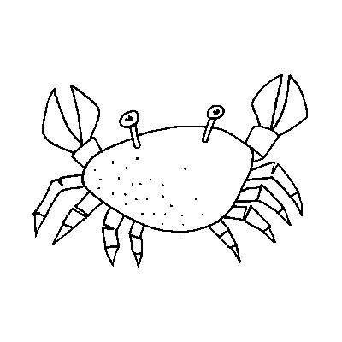

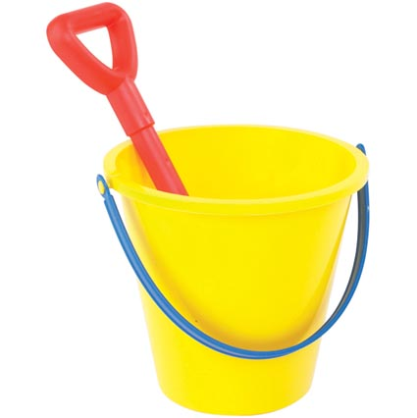

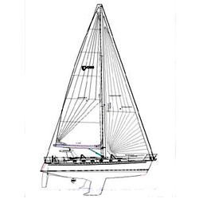

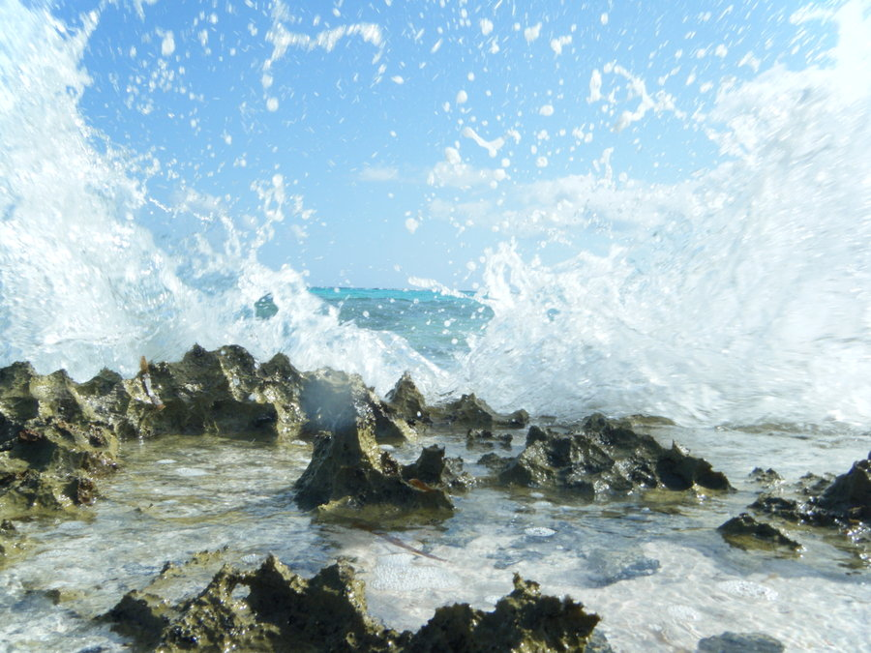

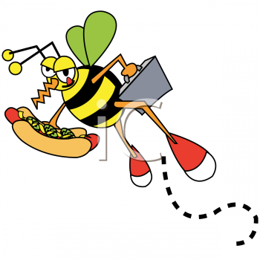

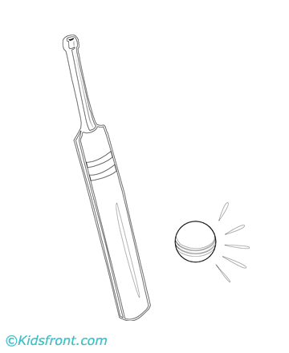

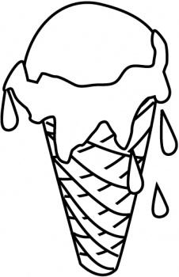

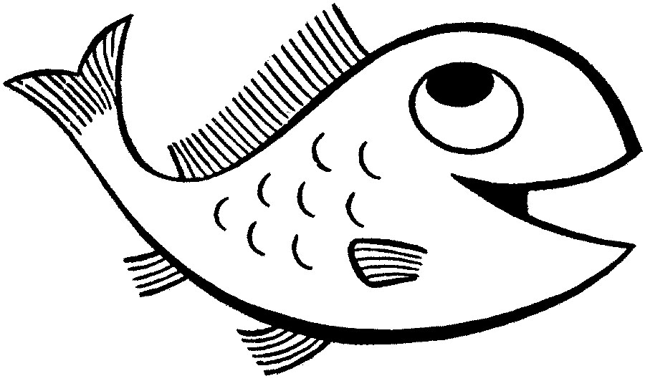

Lesson 4: 30mins

Learning intentions: Children learn
To revise a song
To organise their sounds
To work in pairs or groups
To follow symbols
To talk about their sounds

Introductory activity (10mins)
Sing, ‘Hello Barnaby’ and look at the animals and birds that he has in his backpack e.g. a frog, a lion, a monkey and a snake
Make their sounds and discuss whether they are long or short. Now divide the class into four groups and ask each group to follow one of the toys as we combine the sounds.
Who preferred the sounds alone and who preferred them in layers or in combination?
Can they say why?

Main activity (15mins)
Remind the children that they have been working on sounds from the seaside and sing Barnaby’s travelling song

Barnaby the Bear’s my name
Travelling is my game
Come with me and hold my paw
We are going to the seashore

Hand out instruments for each of the seaside cards and briefly remind the children of how they were working together to find different ways of playing the instruments that complemented each other.
Give the children three or four minutes to practise and then listen to each.

Ask the children to help arrange the sounds into a score on the board and then perform it (Record the performance)

Plenary (5mins)

Talk to the children about the performance
Who likes the way in which we arranged and combined the sounds?
Who felt their sound could not be heard or should not have been combined with another sound?
Can they say why?

Learning Outcomes: Children can
Identify short and long sounds
Make sounds in small groups
Follow symbols
Combine sounds
Talk about the effectiveness of their work
Lesson 5 (30mins)

Learning Intentions: Children learn
A new singing game
To play with a song
To consolidate their knowledge of short and long sounds
To evaluate their work

Introductory activity (10mins)
Sing, ‘Hello Barnaby’ and look at the items he has in his backpack (a fish, a stone, a beach ball, an ice-cream and a sailing boat).
Can they clap the syllables of each?

Sing Barnaby’s travelling song

Barnaby the Bear’s my name
Travelling is my game
Come with me and hold my paw
We are going to the seashore

Main activity (15mins)
Ask the children if they know the difference between a sea and an ocean.
Can they name any oceans?

Teach the children the singing game, ‘Down by the Ocean’ (Singing Games and Rhymes for Middle Years) and ask one child to sit in the middle. He or he will need to listen to the voices of the two children singing in the circle and guess who they are at the end of the song.

Remind the children of the Seaside Song (Tune: Skip to my Lou) and add the following instruments to each verse

(Shakers) Bees on the seashore (Bee x 3).
(Jingles/tambourines/rain sticks) Waves on the seashore (Shee x 3)
(Cabasa) Balls in the air (Whee x 3)
(Indian bells) Sun on the water (Zee x 3)

(Claves/castanets) Crabs on the seashore (nip x3)
(Agogo bells/ triangle held) Stones in the water (Plip x 3)
(Tambours) Bat that ball (Bip x3)
(Chime bars and glockenspiels) Melting ice-creams (drip x3)

They only play on the words in brackets

If time, play each of the sounds by themselves and then try layering them together
Which do the children like best?
Would there be a better order in which to add the sounds?
Give volunteers the opportunity to conduct the sound (Pointing to the group when they want them to play and putting their fingers to their lips when they want them to stop

Plenary (5mins)
Pack away the instruments and ask the children to talk about the sounds
Which were long sounds and which were short?
This term they have used their instruments in many ways- alone, in pairs and in groups. They have selected and organise the sounds and thought about the way I which they should play them.
Sing, ‘Goodbye Barnaby’.

Learning Outcomes: Children can
Listen attentively
Sing alone or as a class
Clap rhythmic patterns
Play with control
Discriminate between short and long sounds
Express preferences using musical language

Lesson 6: Barnaby Bear goes to out to Sea

Learning intentions: Children learn
New songs and singing games
To move to a steady pulse
About tempo/pace
To listen attentively
To sing alone, in groups and/or as a class

Introductory activity (10mins)
Sing, ‘Hello Barnaby’ and look what he has brought with him- a hat, a telescope, some swimming trunks and a life jacket.
What do they think Barnaby wants to do today?

Sing this version of Barnaby’s travelling song:
Barnaby the Bear’s my name
Travelling is my game
Take my paw and come with me
We are sailing out to sea

Main activity (30mins)
Firstly, Barnaby wants to try out his rowing skills.
Teach the children the song, ‘Row boys row’ and make sure they keep a steady pulse as they pull on the oars.
Now ask the girls to sing, ‘Row boys row’ and the boys to sing ‘Row girls row’.
Now everyone can sing, ‘Row bears row’.

Now Barnaby wants to go to the seaside for a picnic.
While he is waiting for his food we will play a singing game.
Revise the game, ‘Down by the Ocean’. Choose a volunteer to sit in the circle. Their name will be used in the song at the end as they broke a teacup.
Two volunteers will sing the lines, ‘I told Ma’ and ‘I told Pa’ and the child in the middle will have to guess the identity of the volunteers.

Now Barnaby wants to go out to sea. We will sing the song, ‘Bobby Shaftoe’ as we sail.
Put the children into groups of three. Two children will make the shape of a boat and the third child will climb inside.
They will gently rock the passenger as they sing to a steady beat.
Change the child in the boat and sing the song as if the water is very clam (slowly) and then very rough (quickly). Change again so that all three children have the opportunity to sit in the boat.

Barnaby is feeling a bit seasick now and would like to go ashore. He can see the cliffs ahead of him.
Who knows what a cliff is?
How are cliffs worn away?
After a Storm parts of cliffs sometimes fall into the water.
Sometimes exciting things like dinosaur bones (fossils) are uncovered when this happens but at other times people have to move out of their homes or caravans if they are too near the cliff edge.

Listen to ‘After the Storm’ and learn each line in turn with some actions to help.
Ask some of the children to sing ostinato 2 with their teachers and give them the chime bars FGA to play the phrase ‘magical light’ (fgAG-)

Plenary (5mins)
Who can remember what activities we have done on or by the sea today?
We have rowed a boat, sailed a boat, had a picnic and sung about a storm.

Who can describe what musical skill we have used when we rowed and sailed our boats? (We kept a beat or pulse)
Sing ‘Goodbye Barnaby’

Learning Outcomes: Children can
Sing tunefully, accurately and confidently
Respond to a steady/changing pulse
Work co-operatively in groups
Sing in two parts

Lesson 7: Storm at Sea

Learning Intentions: Children learn
To explore the elements of music
To listen attentively to recorded music
How changes can affect the character or mood of a piece
To follow symbols and hand signs
To talk about their work

Introductory activity (10mins)
Sing ‘Hello children’ and play, ‘Have you brought your… voice?’ Use playground/whispering, Daddy Bear/Baby Bear, Grumpy/Sleepy, Sloth/Cheetah and compare the different ways they spoke.

They have explored
- Dynamics (loud/quiet sounds)
- Pitch (high/low sounds)
- Duration (short/long sounds)
- Tempo (fast/slow sounds)
They may need to use all of these today when Barnaby is out to sea.

Sing his song

Barnaby the Bear’s my name
Travelling is my game
Take my paw and come with me
We are sailing out to sea

Main activity (20mins)
Ask the children to listen to part of Debussy’s ‘Jeux de Vagues’ and to decide what type of day it is out to sea.
What sounds can they hear?
Can they describe any of the sounds? (Are they loud or quiet, fast or slow, short or long, high or low?)
Now listen or watch part of Britten’s ‘Storm’ from his ‘Sea Interludes’.
Has the sea/weather changed at all?
What were the musical clues?

How might they use this to change their music?

Show the children how they might follow my hands as I bring them further apart (get louder) and together (quieter) and try this all together.

Give out the seascape cards again but arrange them so that the waves and sea-spray continue throughout the piece.

Try this and make the sounds as calm as possible.

Now draw some grey clouds, lightning, rain drops and wind on the board and ask the children which instruments should make these sounds.
The waves and sea-spray should continue but get louder and faster.

Practise this and then try calming the music down again.

Plenary (10mins)
Record the music and talk about their opinions of how well we explored and changed the sounds today.

Learning Outcomes: Children can
Comment on changes in sound
Compare recorded sounds
Play with control and awareness of effect
Work co-operatively in groups and as a class
Comment on the effectiveness of their own work

