Week by Week Music planning – Charles Warren Autumn Term - Year 1 – Traditional Tales
Week | Learning Objective  Pupils should learn………….. | Summary of Teaching activities | Notes for support staff/resources needed etc
1 | To be able to sing back s/m echos  To be able to keep a steady pulse  To play the pulse on an instrument | Warm up:  Hello BB – look in backpack and find superheroes.  Have you brought your X voices – include superhero voices.  Introduce the powers superheroes have – hold up a superhero pic and children pose like that character. Lead into Hey Hey look at me (Singing Games and Rhymes). Act as different superheroes (Batman flying, spiderman crawling etc)  Main activity:  Armchair aerobics – introduce steady pulse.  Show 3 teddies big, medium, small (dressed as superheroes!). Discuss how they would speak and stamp and the difference in dynamic (volume). Practise saying tiny/bigger/huge teddy in different voices (high and soft, medium loud, medium pitch, low and loud).  Teach the chant Three Tapping Teddies as in the book (3 Singing pigs).  Keep pulse with feet throughout. Practise making feet louder/softer but still keeping in time.  Sit and show different instruments in circle for each teddy (finger cymbals, claves, drums) – which sound would match each teddy?  Give out instruments in 3 groups, each group plays their tap for that part of the chant.  Plenary:  Perform chant all the way through with stepping pulse and instruments for each teddy.  Which part of our piece sounded good? How did we keep the pulse today? Did we all play together? | staff to join in and encourage reluctant singers  Assess can keep a steady pulse.  .
2 | To sing back a s/m echo  To sing a song using s/m  To keep a steady pulse | Warm up: Hello BB. Look in backpack - flashcards of superheroes - how is each feeling? Sing hello how are you? Children answer as that character…I’m feeling happy/sad/cross in different ways according to the cards.  Repeat pose as superheroes and Hey Hey as in previous week. Encourage solo singing this week  Main activity:  Repeat Armchair aerobics to revise pulse is necessary.  Listen to ‘Me. I’m great’ from ‘Me’ by Ana Sanderson.  Ask children to choose which superhero they are and do a body action to show pulse as you listen.  Show some instruments and ask children to choose on to share with their partner. Play song twice - children either do action or play pulse.  Pack away  Learn Superhero chant (choose according to who your kids know!) :  Hulk - Hulk –  What do you see?  I see ____________ looking at me  Batgirl/Batman….I see the ____looking at me  Flash Gordon/Black widow …I see ______ looking at me  Spiderman/Supergirl…I see children looking at me (all wave and smile to finish)  Chant with different body actions to show pulse (say and tap ‘hulk’ for each verse).  Plenary:  What did we show with our body sounds today? Which was your favourite superhero? Can you remember their power? | Assess can keep a steady pulse.  Assess those who are always in time as 1, those who can’t keep pulse as 3, the rest will be a 2.  Using picture cues to help with language / understanding
3 | To be able to sing solo  To keep a steady pulse  To be able to clap/say a word rhythm | Warm up:  Hello BB – look in backpack different superheroes – say and clap name of each  I’ve got the Batmobile game. Use s/m/l to sing ‘I’ve got the Batmobile, Can you tell me how you feel? As you sing pass the car round the circle and at the end of the song the child with the car sings ‘I’m feeling happy/calm/cross etc’  Main activity:  Revise chant from previous week  Teach chant below:  - - - - 2 - - - 3 - - - 4 - - -  Hulk …… Hulk ………. (drum/tambourine)  Bat girl Bat girl  Flash GordonFlash Gordon  Spiderman Spiderman (claves)  Practise chanting to a steady pulse. Make sure children can do each line correctly.  Perform chant with body percussion sounds then instruments if time  Plenary:  Have you brought your X (superhero or any voice you like!) voices – can we make each voice sound different? | Adults join in with solo singer for confidence  Adult can help with how to play/hold instruments  Support children with clapping each syllable they say
 | To be able to sing solo  To be able to copy sml patterns  To create/play a word rhythm on an instrument | Warm up:  Hello Barnaby and look in backpack (things that a superhero uses i.e. cape, mask, car or other vehicle)  Teach Doggie Doggie superhero version…(Batman batman where’s your car? Someone stole it they won’t get far)  Play game as in Doggie Doggie (SGR). Pass around the batmobile and whoever is left with it sings solo.  Main activity:  Revise pulse - paired activity. Listen to one of the songs from a previous weeks. One child does a body action for partner to copy showing steady beat. Swap roles and watch a few successful pairs.  Revise superhero word rhythms from previous week. Discuss what each superhero can do? Fly, shoot webs, has x ray vision.  Use chant from week 2 – change to Superhero Superhero what can you do?  Ask children in pairs to choose a superhero and to make up an answer i.e. I can fly  Hear some pairs – show how to clap their words - ‘Make a music sentence’.  Paired activity – say and clap their own word rhythm together  EXT repeat activity using instruments  Plenary:  Perform chant - Super hero what can you do? Each pair says and claps their answer | Adult can help assess  x can copy sml patterns  assess x can keep a steady pulse  adult support children with clapping their words
5 | To be able to sing solo  To create/play a word rhythm on an instrument | Warm up:  Repeat doggie doggie as in previous week  Main activity:  Word rhythms - create a call and response i.e.  C - super hero super hero, what can you do?  R - I can fly I, can fly  Children practice saying their word rhythms from previous week - choose 4 to learn as a class.  (OR use superheros chant from previous week)  Divide class into 4 groups and each group take one rhythm:  I can fly  I have x ray vision  I can run fast  I can climb up walls  Show instruments – which would be a good choice for your super hero?  Practice word rhythms on instr. Perform chant with children saying and playing word rhythms.  Pack away  Listening game – hide some instruments that you have used today. You play one hidden away and leave a duplicate for children to use. Which superhero am I? Ask a child to play the same sound that they heard.  Plenary:  What kind of sounds did we make today? (high/low/rattly/soft etc). How did we make them? (voices and instruments). | Adult support with sensible answers!  Adult help assess x can create/play a word rhythm on an instrument  Adult can help with how to play/hold instruments
6 | To be able to sing s/m/l  To play an instrument with purpose and control  To follow a graphic score | Warm up:  Hello Barnaby and look in backpack (all superheroes from the unit) OR pictures of the story you are using  Teach ‘Hello What’s your name’ SGR. In pairs children decide which superhero they are and sing back ‘My name is superman’ etc  OR  Play Doggie doggie again  Main activity:  Revise some word rhythms from previous weeks and assess  Tell superhero story – SuperKid (Claire Freedman) – can be in shortened form  OR use a story that the children have been studying  Divide children into groups for main events in the story. Decided on a sound word to illustrate what happens i.e. thwack, splash etc.  Children decide what instrument they need to make that sound and the pattern they will play.  Discuss suitable instruments/body sounds and practise each group in turn.  Show pics from backpack again and arrange them on your ‘superhero’ score.  Each group makes their sounds when you arrive at their picture. All tap pulse/make a group sounds or turn around etc as you travel between different parts of the story  Plenary:  Evaluate/discuss performance using musical vocab Which sounds did you like? High, shaky, low etc  Who played a loud/soft high sound etc | Adult help assess x can copy sml phrases  Adult support groups/individuals as necessary  Adult can help with how to play/hold instruments

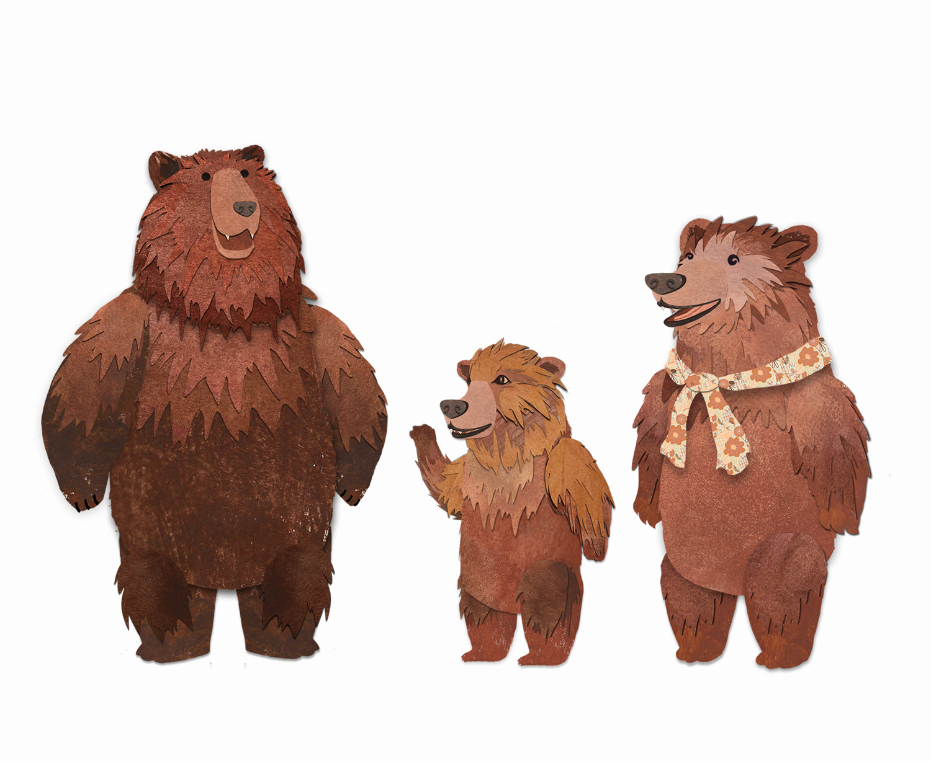

Flash - Flash -

Bat - girl Bat - girl

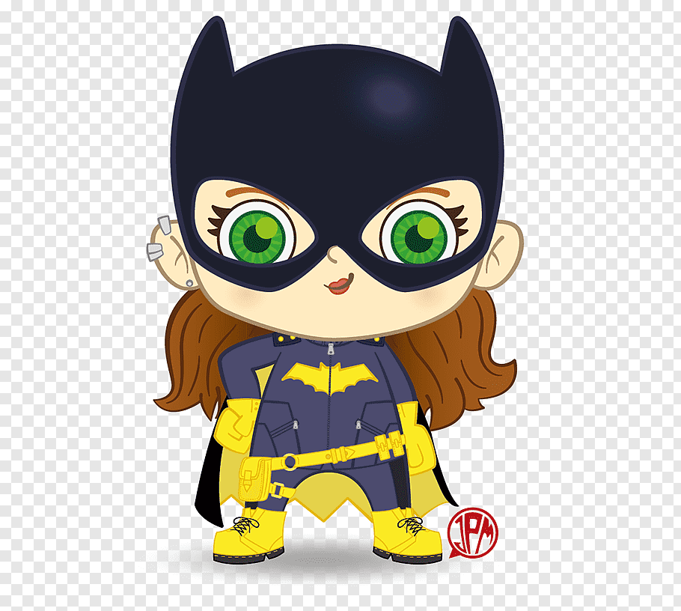

Spi – der - man Spi – der - man

