**Butter**

[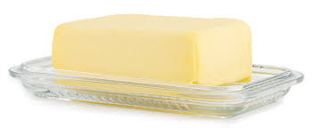](https://www.google.com/imgres?imgurl=https%3A%2F%2Ffoodsafetyblog.statefoodsafety.com%2Fwp-content%2Fuploads%2F2015%2F06%2F20150622_Dollarphotoclub_Butter-1024x423.jpg&imgrefurl=https%3A%2F%2Fwww.statefoodsafety.com%2FResources%2Farticle%2Fcategory%2FResources%2Farticle%2Fan-age-old-debate-can-you-leave-butter-out&docid=pJU29b9knUSxQM&tbnid=-ALLfmcl_zCqaM%3A&vet=10ahUKEwj52ZO7yYHeAhWIC8AKHcbkDc0QMwiKASgvMC8..i&w=1024&h=423&bih=917&biw=978&q=butter&ved=0ahUKEwj52ZO7yYHeAhWIC8AKHcbkDc0QMwiKASgvMC8&iact=mrc&uact=8)

**Sugar**

[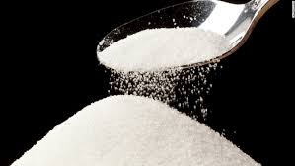](https://www.google.com/imgres?imgurl=https%3A%2F%2Fcdn.cnn.com%2Fcnnnext%2Fdam%2Fassets%2F140203172642-sugar-c2-horizontal-large-gallery.jpg&imgrefurl=https%3A%2F%2Fwww.cnn.com%2F2017%2F11%2F21%2Fhealth%2Fsugar-industry-cancer-history-study%2Findex.html&docid=W4Ip8a80L5Dz1M&tbnid=FfryWiJ3CpbOQM%3A&vet=10ahUKEwiY4I6EyoHeAhWsAcAKHUv7CucQMwiTASg5MDk..i&w=980&h=552&bih=917&biw=978&q=sugar&ved=0ahUKEwiY4I6EyoHeAhWsAcAKHUv7CucQMwiTASg5MDk&iact=mrc&uact=8)

Flour

[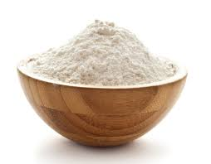](https://www.google.com/imgres?imgurl=https%3A%2F%2Fthehivebulkfoods.com%2Fwp-content%2Fuploads%2F2018%2F07%2FALL-PURPOSE-FLOUR_1600x1250_d570a5b0-faf7-420f-9e6b-02c5015b308a.jpg&imgrefurl=https%3A%2F%2Fthehivebulkfoods.com%2Fproduct%2Forganic-all-purpose-flour-100g%2F&docid=C5ZUIOYo2yZjuM&tbnid=CYHB2eESoBOIWM%3A&vet=10ahUKEwiP95SuyoHeAhUoglwKHcKTDHMQMwiPASg1MDU..i&w=1600&h=1250&bih=917&biw=978&q=flour&ved=0ahUKEwiP95SuyoHeAhUoglwKHcKTDHMQMwiPASg1MDU&iact=mrc&uact=8)

Milk

[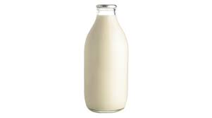](https://www.google.com/imgres?imgurl=https%3A%2F%2Fcdn-image.realsimple.com%2Fsites%2Fdefault%2Ffiles%2Fstyles%2Fmarquee_large_2x%2Fpublic%2Fmilk-bottle.jpg%3Fitok%3DdGm3pL3l&imgrefurl=https%3A%2F%2Fwww.realsimple.com%2Ffood-recipes%2Fshopping-storing%2Fmore-shopping-storing%2Fdairy-products&docid=zrgI_7ulQBo8-M&tbnid=fVOgTkEpZq37mM%3A&vet=10ahUKEwi61bjuyoHeAhXDIMAKHWnuA-YQMwhvKBUwFQ..i&w=1300&h=724&bih=917&biw=978&q=milk&ved=0ahUKEwi61bjuyoHeAhXDIMAKHWnuA-YQMwhvKBUwFQ&iact=mrc&uact=8)

Baking Powder

[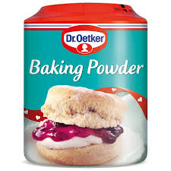](https://www.google.com/imgres?imgurl=https%3A%2F%2Fcdn.bmstores.co.uk%2Fimages%2FhpcProductImage%2FimgFull%2F298122-Gluten-Free-Baking-Powder-Tub.jpg&imgrefurl=https%3A%2F%2Fwww.bmstores.co.uk%2Fproducts%2Fdr-oetker-baking-powder-tub-170g-298122&docid=fsJCQ6wtRsvXZM&tbnid=7z9CY80mku3zlM%3A&vet=10ahUKEwiqhN2Ry4HeAhUsIsAKHSu5DLsQMwhTKAYwBg..i&w=800&h=800&bih=917&biw=978&q=baking%20powder&ved=0ahUKEwiqhN2Ry4HeAhUsIsAKHSu5DLsQMwhTKAYwBg&iact=mrc&uact=8)

Cocoa Powder

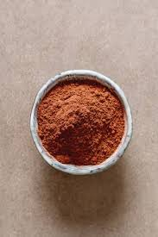

Icing

[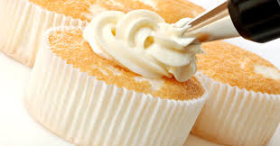](https://www.google.com/imgres?imgurl=http%3A%2F%2Fwww.kenwoodworld.com%2FGlobal%2Frecipes%2FRecipe%2520Images%2Fbasic%2FRoyal_Icing_1.jpg&imgrefurl=http%3A%2F%2Fwww.kenwoodworld.com%2Fen-int%2Fcooking%2Frecipes%2Fkitchen-machines-recipes%2Fbasic-recipes%2Froyal-icing&docid=eVgzgU0JNtQwBM&tbnid=iDnRFdA0HCeUPM%3A&vet=10ahUKEwihrpT3y4HeAhWObsAKHd3VBd8QMwh-KCQwJA..i&w=620&h=325&bih=917&biw=978&q=icing&ved=0ahUKEwihrpT3y4HeAhWObsAKHd3VBd8QMwh-KCQwJA&iact=mrc&uact=8)

Sprinkles

[](https://www.google.com/imgres?imgurl=https%3A%2F%2Fthumbs.dreamstime.com%2Fb%2Frainbow-sprinkles-yummy-deserts-ice-cream-48530800.jpg&imgrefurl=http%3A%2F%2Fwww.allfinweb.com%2Fgallery%2Frainbow-sprinkles-royalty-free.html&docid=pwgVpXFPG3nZmM&tbnid=pGIPgvAvKIlyRM%3A&vet=12ahUKEwi3gKf3zIHeAhXIB8AKHbfyDUI4rAIQMygVMBV6BAgBEBY..i&w=800&h=532&bih=917&biw=978&q=sprinkles&ved=2ahUKEwi3gKf3zIHeAhXIB8AKHbfyDUI4rAIQMygVMBV6BAgBEBY&iact=mrc&uact=8)

Eggs

[](https://www.google.com/imgres?imgurl=https%3A%2F%2Fcdn.japantimes.2xx.jp%2Fwp-content%2Fuploads%2F2018%2F05%2Ff-eggs-a-20180523-870x653.jpg&imgrefurl=https%3A%2F%2Fwww.japantimes.co.jp%2Fnews%2F2018%2F05%2F22%2Fworld%2Fscience-health-world%2Fegg-day-may-keep-doctor-away-chinese-british-study-claims%2F&docid=T35oI6RDIOii9M&tbnid=R4fneBuKdHvODM%3A&vet=10ahUKEwiVw9nbzoHeAhXGCMAKHeGtCAYQMwhXKAowCg..i&w=870&h=653&bih=917&biw=978&q=eggs&ved=0ahUKEwiVw9nbzoHeAhXGCMAKHeGtCAYQMwhXKAowCg&iact=mrc&uact=8)

Buttons

[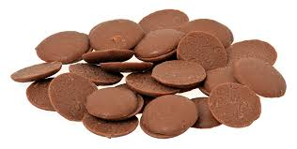](https://www.google.com/imgres?imgurl=https%3A%2F%2Fupload.wikimedia.org%2Fwikipedia%2Fcommons%2Fthumb%2F5%2F56%2FCadbury-Buttons.jpg%2F1200px-Cadbury-Buttons.jpg&imgrefurl=https%3A%2F%2Fen.wikipedia.org%2Fwiki%2FCadbury_Buttons&docid=v70VDYqoVup38M&tbnid=SMlWO30vBhNkzM%3A&vet=10ahUKEwiBpOeCz4HeAhXjAcAKHdShDK0QMwhRKAQwBA..i&w=1200&h=605&bih=917&biw=978&q=chocolate%20buttons&ved=0ahUKEwiBpOeCz4HeAhXjAcAKHdShDK0QMwhRKAQwBA&iact=mrc&uact=8)