C’s for Capybara

(Speak) 1 2 3 4 (Play) C’s for ………………………. Rhythm…………………………………………

(Speak) 1 2 3 4 (Play) D’s for ……………………… Rhythm…………………………………………

(Speak) 1 2 3 4 (Play) E’s for ……………………… Rhythm…………………………………………

(Speak) 1 2 3 4 (Play) F’s for ………………………. Rhythm…………………………………………

(Speak) 1 2 3 4 (Play) G’s for ………………………. Rhythm…………………………………………

(Speak) 1 2 3 4 (Play) A’s for ……………………… Rhythm…………………………………………

(Speak) 1 2 3 4 (Play) B’s for ……………………… Rhythm…………………………………………

(Speak) 1 2 3 4 (Play) C’s for ………………………. Rhythm…………………………………………

Secrets of the Rainforest 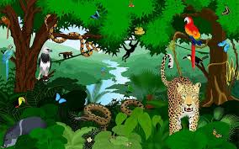

Question:...............................................................................................

..............................................................................................................

Notes:....................................................................................................

Answer:...............................................................................................

..............................................................................................................

Notes:....................................................................................................

Composers:......................................................

The Great Kapok Tree: Year 3/ 4

Name………………………………………. Class………………

Learning intention | I can | I can nearly | I find it hard to
Use sounds from the rainforest to make a texture of sounds

(I went to the rainforest and heard…)
Follow a beat- even when the tempo changes

(Get on Board)
Create phrases to play on the notes of the chime bars

(C’s for Capybara)
Listen to recorded music and identify the pace, duration, dynamics and movement of pitch
(The Kangaroo, Flight of the Bumble Bee, the Swan and The Elephant)
Create my own four-beat melody using notes of the C pentatonic scale

(Play a pattern in Space and Secrets of the Rainforest)
Work co-operatively in a group in order to create music to describe a creature from the rainforest

(Rainforest compositions)
Talk about/evaluate my own work and the work of others’

The Great Kapok Tree: Group Evaluation Sheet

The music you have been composing has involved you
- Selecting instruments
- Creating melodic phrases
- Layering/organising the different parts in your own way
- Making your music sound/move like a creature in the rainforest

Listen to each group’s music to listen to and put a tick under the symbol which best describes your reaction to these choices. Then do the same for your group

Group 1
Instruments selected

Melodies

Organisation of sounds and ideas

Music sounds/moves like a creature in the rainforest

Overall

Group 2
Instruments selected

Melodies

Organisation of sounds and ideas

Music sounds/moves like a creature in the rainforest

Overall

Group 3
Instruments selected

Melodies

Organisation of sounds and ideas

Music sounds/moves like a creature in the rainforest

Overall

Group 4
Instruments selected

Melodies

Organisation of sounds and ideas

Music sounds/moves like a creature in the rainforest

Overall

Group 5
Instruments selected

Melodies

Organisation of sounds and ideas

Music sounds/moves like a creature in the rainforest

Overall

My own group
Instruments selected

Melodies

Organisation of sounds and ideas

Music sounds/moves like a creature in the rainforest

Overall

Use these to help you form your choice of best composition.

The composition I liked best was by…………………………….

Because……………………………………………………………………….……………………………………………………………………

……………………………………………………………………………………………………………………………………………………….

Name of listener………………………………………………………………….

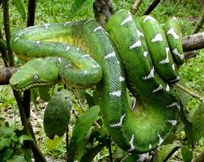
Boa Constrictor

Player 1: Un-tuned percussion (will you need long or short sounds)
1 2 3 4 1 2 3 4
Slithering snake – or your own phrase ……………………..

Player 2: Tuned percussion (will your notes move by step, skip or leap)
1 2 3 4 1 2 3 4
Hissing in your ear – or your own phrase …………………….

Player 3: Tuned percussion (will your notes by step, skip or leap)
1 2 3 4 1 2 3 4
Kapok tree is my home or your own phrase …………………….

Player 4: Un-tuned percussion (Think of the sounds/timbre you will need)
Add a background or special effects/create new rhythms

Names of Composers

……………………………………………………………………………………………………………………………
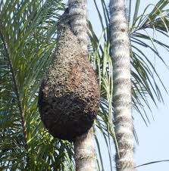 Bees 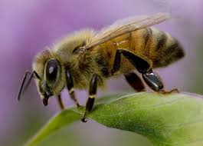

Player 1: Un-tuned percussion (will you need long or short sounds)
1 2 3 4 1 2 3 4
Bees - buzzing - or your own phrase ……………………..

Player 2: Tuned percussion (will your notes move by step, skip or leap)
1 2 3 4 1 2 3 4
Hive is in the tree - or your own phrase …………………….

Player 3: Tuned percussion (will your notes by step, skip or leap)
1 2 3 4 1 2 3 4
Col-lecting pol- len or your own phrase …………………….

Player 4: Un-tuned percussion (Think of the sounds/timbre you will need)
Add a background or special effects/create new rhythms

Names of Composers

…………………………………………………………………………………………………………………………….
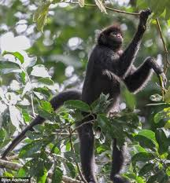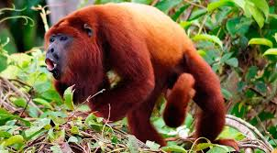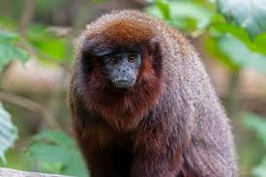

Monkeys

Player 1: Un-tuned percussion (will you need long or short sounds)
1 2 3 4 1 2 3 4
Scampering monkeys or your own phrase ……………………..

Player 2: Tuned percussion (will your notes move by step, skip or leap)
1 2 3 4 1 2 3 4
Climbing in the canopy or your own phrase …………………….

Player 3: Tuned percussion (will your notes by step, skip or leap)
1 2 3 4 1 2 3 4
Chattered to the man - or your own phrase …………………….

Player 4: Un-tuned percussion (Think of the sounds/timbre you will need)
Add a background or special effects/create new rhythms

Names of Composers…………………………………………………………………………………………
Toucans and Macaws 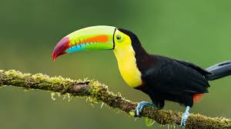

Player 1: Un-tuned percussion (will you need long or short sounds)
1 2 3 4 1 2 3 4
Squawking toucans or your own phrase ……………………..

Player 2: Tuned percussion (will your notes move by step, skip or leap)
1 2 3 4 1 2 3 4
Colourful beaks, colourful feathers or your own phrase …………………….

Player 3: Tuned percussion (will your notes by step, skip or leap)
1 2 3 4 1 2 3 4
Soaring over the forest or your own phrase …………………….

Player 4: Un-tuned percussion (Think of the sounds/timbre you will need)
Add a background or special effects/create new rhythms

Names of Composers…………………………………………………………………………………………
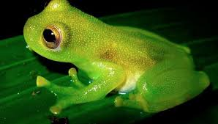 Frogs 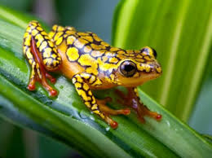

Player 1: Un-tuned percussion (will you need long or short sounds)
1 2 3 4 1 2 3 4
Crawling and hopping or your own phrase ……………………..

Player 2: Tuned percussion (will your notes move by step, skip or leap)
1 2 3 4 1 2 3 4
Colour-ful but poisonous or your own phrase …………………….

Player 3: Tuned percussion (will your notes by step, skip or leap)
1 2 3 4 1 2 3 4
Squeaky voice, in his ear or your own phrase …………………….

Player 4: Un-tuned percussion (Think of the sounds/timbre you will need)
Add a background or special effects/create new rhythms

Names of Composers…………………………………………………………………………………………

Jaguars

Player 1: Un-tuned percussion (will you need long or short sounds)
1 2 3 4 1 2 3 4
Sleeping on a branch - or your own phrase ……………………..

Player 2: Tuned percussion (will your notes move by step, skip or leap)
1 2 3 4 1 2 3 4
Spotted coat blen-ding or your own phrase …………………….

Player 3: Tuned percussion (will your notes by step, skip or leap)
1 2 3 4 1 2 3 4
Shadows of the under storey or your own phrase …………………….

Player 4: Un-tuned percussion (Think of the sounds/timbre you will need)
Add a background or special effects/create new rhythms e.g. Padding silently

Names of Composers…………………………………………………………………………………………
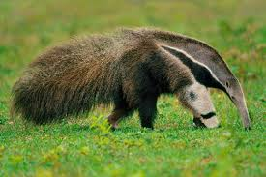 Giant Ant- Eater

Player 1: Un-tuned percussion (will you need long or short sounds)
1 2 3 4 1 2 3 4
Clinging to their backs - or your own phrase ……………………..

Player 2: Tuned percussion (will your notes move by step, skip or leap)
1 2 3 4 1 2 3 4
Un-striped anteater or your own phrase …………………….

Player 3: Tuned percussion (will your notes by step, skip or leap)
1 2 3 4 1 2 3 4
Long nose, long tongue or your own phrase …………………….

Player 4: Un-tuned percussion (Think of the sounds/timbre you will need)
Add a background or special effects/create new rhythms

Names of Composers…………………………………………………………………………………………
Sloth 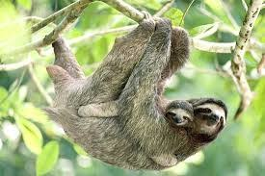

Player 1: Un-tuned percussion (will you need long or short sounds)
1 2 3 4 1 2 3 4
Three- toed sloth - or your own phrase ……………………..

Player 2: Tuned percussion (will your notes move by step, skip or leap)
1 2 3 4 1 2 3 4
Plodding ever so slow-ly or your own phrase …………………….

Player 3: Tuned percussion (will your notes by step, skip or leap)
1 2 3 4 1 2 3 4
Deep, lazy voice - or your own phrase …………………….

Player 4: Un-tuned percussion (Think of the sounds/timbre you will need)
Add a background or special effects/create new rhythms

Names of Composers…………………………………………………………………………………………

The Great Kapok Tree

Overview/ Medium Term Plan

Week | Learning Intentions  Children learn…. | Activities | Learning Outcomes  Children can… | Assessment
1 | A new game  About timbre  About rainforest sounds  About texture  About dynamics (volume)  About conducting and arranging sounds | Intro: Play, ‘Switch’, listen to the sounds of the Brazilian Rainforest, read ‘The Great Kapok Tree’ and discuss the themes of the story.  Main: Look at images of animals and birds that live in the rainforest and explore their sounds (timbre).  Play, ‘I went to the rainforest and I heard a…’  Choose 4 sounds and put together in order to explore texture.  Look at the changes in volume (dynamics) in the book, divide the children into 10 groups and perform the story  Plenary: Discuss the musical elements (inter-related dimensions) of music that they have explored today. | Describe sounds  Explore vocal and body sounds  Work in large and small groups  Follow visual cues
2 | About pace  About duration  About the ostinato  To listen attentively  A new game  To follow signs and symbols  To comment on the effectiveness of their work | Pace and Duration  Intro: Listening, ‘The Little Train of the Caipira’ by Villa-Lobos  Identify instrumental sounds and changes of tempo  Main: Play, ‘Get on Board’ in three groups with instruments. Follow beat then follow a changing tempo. Add tuned ostinato (GDED)  Consider movement of animals in the Great Kapok Tree story.  - Find verbs and adverbs to describe each.  - Consider the speed at which sounds should be played  - Consider the length of sounds that should be selected (duration)  Play, ‘Pass the sound’ and explore duration.  Select sounds for each creature and combine instrumental/vocal/body sounds when each pictures is pointed to.  Record sounds  Plenary: Listen to recordings and discuss its effectiveness | Comment upon music that they hear and compose using musical language  Maintain a beat with awareness of changes in pace  Select and change the duration of sounds  Follow signs | Can follow a changing beat
3 | About pitch  About ascending and descending sounds  About intervals between sounds (steps, skips and leaps)  How to relate pitch to the verbs which are used in the text  How to create and play rhythmic phrases  How to listen attentively | Pitch  Intro: Explore pitch with the Squirrel’s Story and chime bars/xylophones/glockenspiels etc.  Main: Look at pictures from the Brazilian Rainforest. They will choose a word to match the notes of the C scale or ladder (CDEFGABC’)  Try an example as a class and then ask children to complete the ‘C’s for Capybara’ sheet (see resources) in pairs.  - Select words/phrases  - Practice playing and saying the rhythm  - Perform  Plenary: Listening activity- Kangaroo and Elephant from Carnival of the Animals.  Either discuss or fill in listening log (see resources)  Identify timbre, duration of sounds, movement of pitch and pace. | Play and identify ascending/descending sounds  Can identify high and low sounds  Play and identify movement of pitch by step, skip or leap  Can play the rhythm of words and phrases accurately | Can create a simple rhythmic phrase
4 | About duration  About the movement of pitch  A new song  About the pentatonic scale  About question and answer phrases | Pitch and Structure  Intro: Revise the terms pace/tempo, duration and pitch. Revise ways in in which pitch can move (step, skip, leap, ascend or descend)  Listening: The Swan and Flight of the Bumble Bee  Identify musical elements orally or using listening log (see resources).  Main: Sing the first four lines of ‘Who built the Ark?  - Show the movement of pitch with hands  - Identify the Question and Answer structure  - Introduce the pentatonic scale  Play, ‘Play a pattern in Space. All play CDCD and then explore creating a simple melodic answer using just E (LA), E and G (MA) or EGA (HA)  Perform.  Make up own 4- beat Q&A phrases in pairs, if time.  Plenary: Think of a question they would like to answer about the rainforest in pairs.  Research the answer for next time | Identify the musical elements that make up a piece of music  Identify the structure and movement of pitch in the chorus of a song  Use notes of a pentatonic scale to create original melodic phrases  Work in pairs in order to create question and answer phrases | Can identify the use of the inter-related dimensions of music  Can create a simple melodic phrase
5 | To identify sounds from recorded music  To create question and answer phrases  To adapt phrases to fit the rhythm of words  About ostinato | Composition  Intro: Identify and respond to, sounds from Rainforest Dream with mimed actions  Revise Q&A phrases and fit over 4 or 8 beats. Make a note of phrases on, ‘Secrets of the Rainforest Sheets’ and clap/say to class.  Main: As a class, introduce group composition work using the woodcutter as an example.  Player 1: Ostinato (un-tuned)  Player 2: Melody 1 using C pentatonic scale  Player 3: Melody 2 using C pentatonic scale  Player 4: Copies ostinato or creates a new one and add sound effects (un-tuned)  Plan timbre/duration of sound, pace, dynamics and movement of pitch on composition sheets  Use given descriptive phrases or makeup own  Clap rhythms alone and together.  Plenary: Discuss the two activities explored today | Create melodic phrases to fit the rhythm of words  Play them as questions and answers  Use their knowledge of pitch, pace, duration and timbre to create a sound picture as a class  Plan group pieces to work on and perform next time
6 | How to revise and perform their work  To work on group compositions creatively and co-operatively  To perform, record and evaluate their work and the work of others’ | Composition, Performance and Evaluation  Intro: Practice, perform and record Q&A phrases and notate them on ‘Secrets of the Animal Kingdom’ worksheets (see resources)  Main: Re-cap phrases from group composition  - Select instruments according to timbre and duration of sound  - Practice rhythms alone  - Order, sequence, combine sounds (texture)  - Consider pace and dynamics of performance  - How to start and finish  Play, perform and record.  Children to complete evaluation sheets on other groups and themselves whilst listening (see resources)  Plenary: Listen to comments from each group and to recording, if time | Work co-operatively and creatively in order to compose Q&A phrases and apiece of descriptive music  They can use their knowledge of the inter-related dimensions of music to inform the selection of, manipulation and performance of sounds | Can create a simple melodic phrase  Can maintain an independent part within a large group

