Infant Project – Contrasting Localities
Year group | Learning objective | Activities | Assessment
KS1 | To continue to work towards pitching accurately.  To sing verses with differing tempi – slower, faster etc.  To sing verses with differing dynamics – louder, quieter etc.  To be able to recognise and play a repeated rhythm on unpitched percussion instruments.  To begin to develop an understanding of pitch.  To be able to sing pitches accurately.  To understand the terms ‘going up’ and ‘going down’ in relation to pitch.  To be able to use vocal sounds to represent the animals in the countryside.  To be able to use percussion instruments to represent the animals.  To understand that sound can be represented by pictures.  To be able to choose appropriate timbres to represent things in the environment.  To respond appropriately when different pictures are shown.  To begin to have a basic understanding of samba music.  To be able to sing a song with a syncopated rhythm.  To begin to play syncopated rhythms on percussion instruments and combine one of these with a straight rhythm. | Jogging Down the Road song. (Tune Knees Up Mother Brown).  Several verses.  In Our Town. (Tune Old McDonald).  Repeated rhythm to play along to; ‘hip hip hip hooray’.  Climbing Up the High Street Hill song. (Tune C scale).  To climb up one step at a time whilst singing the song.  To move the hand up one step at a time whilst singing the song.  Playing chime bars to represent going up and going down the hill.  Oh How Peaceful. Song from Flying Around. Sing in unison then add animal sounds in layers in canon. It is not at all peaceful in the county.  Pictures of things in the local environment; road, railway, canal, duck pond, factories, playground with slide, farm land with sheep, horses in paddock, etc . Discuss how these things may be represented – which could be loud or quiet; long or short sounds; high or low sounds; fast or slow sounds; metal sounds; twinkly sounds; scraping sounds etc. When picture is shown children play instruments.  To know about the carnival in Rio in Brazil. (Musical procession of samba, instruments used, costumes, competition element etc).  To learn Samba by Sarah Watts (Sixty Sizzling Songz).  Playing syncopated and straight rhythms, using suitable sentences as an aid. | A selection from:  To be able to play a repeated pattern  To be able to indicate high and low pitches with hand  To keep a part, in a group  To be able to respond to pictures using instruments  To be able to copy rhythms
Nicola Rose, MK Music Service.

Tune; Knees Up Mother Brown.
Jogging down the road, running down the road,
Lots of children, lots of footsteps,
Jogging down the road.
(Then try with walking, creeping, tiptoeing, striding, dashing etc).
Emphasise the different durations and dynamics of footsteps.
Tune; Old McDonald.
In our town we have a chip shop, hip hip hip hooray.
And in that chips shop there are some chips, hip hip hip hooray.
With a munch munch here and a munch munch there,
Here a munch there a munch everywhere a munch munch,
In our town we have a chip shop, hip hip hip hooray.

Subsequent verses use these words in place of underlined words above;
School ; children; play play here.
Hairdressers; scissors; chop chop here.
(Could play maracas every time ‘hip hip hip hooray’ is sung).

Tune; C major scale.
Walk-ing up the hill at town end,
Walk-ing down the hill at town end.
(Sing ascending or descending scale of C major. Play C major scale on chime bars afterwards).

Song; Oh How Peaceful.
From book Flying Around.

Samba song by Sarah Watts.
Samba in Sixty Sizzling Songz by Sarah Watts.

Link to samba video:
https://www.bing.com/videos/search?q=you+tube+samba+band&&view=detail&mid=25A4A591164A6808079F25A4A591164A6808079F&&FORM=VDRVRV

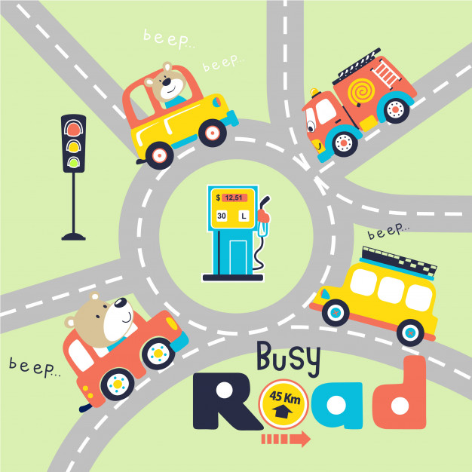

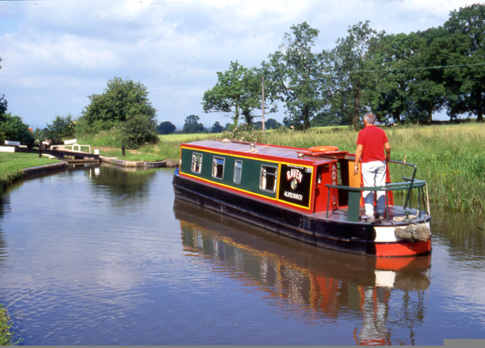

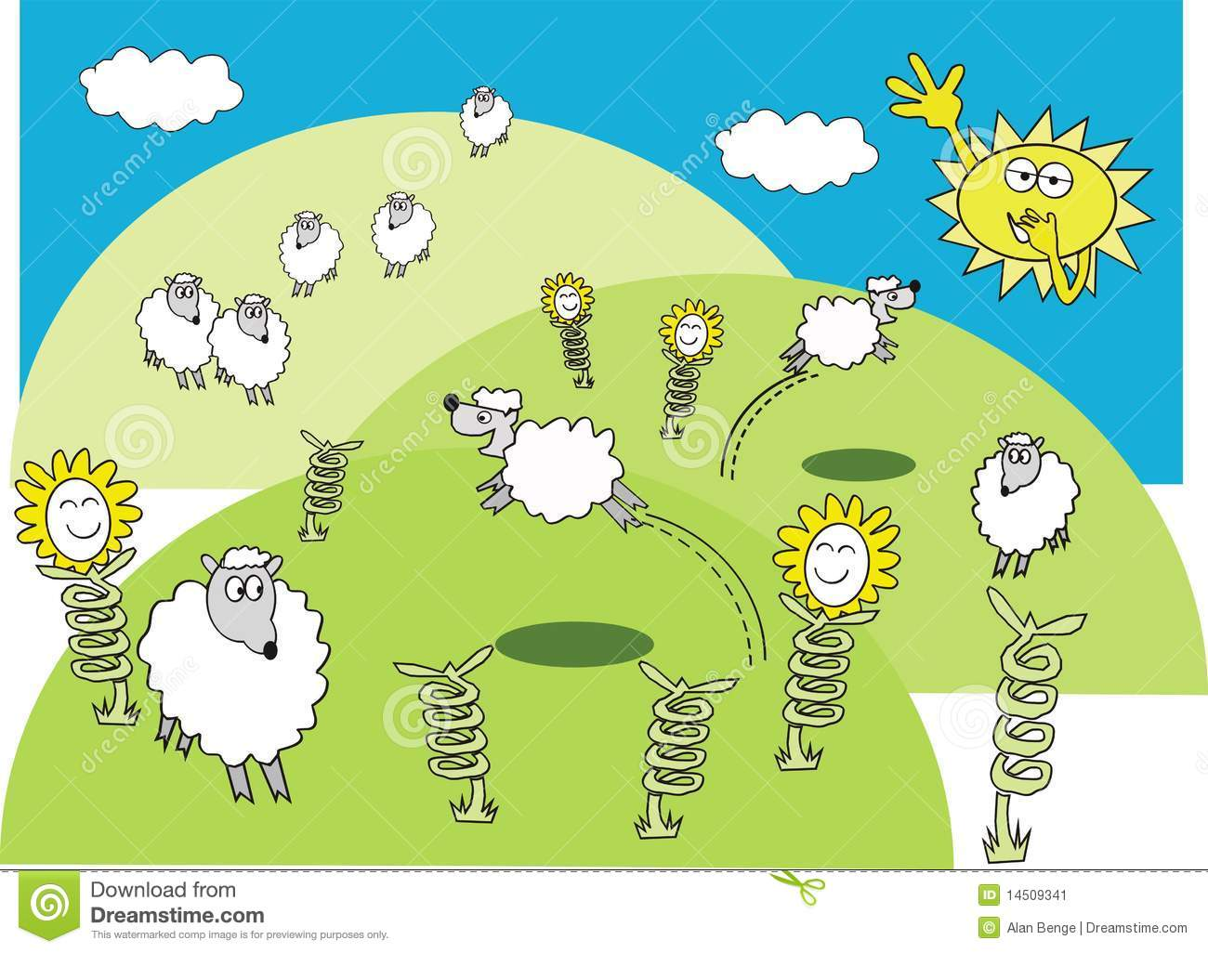
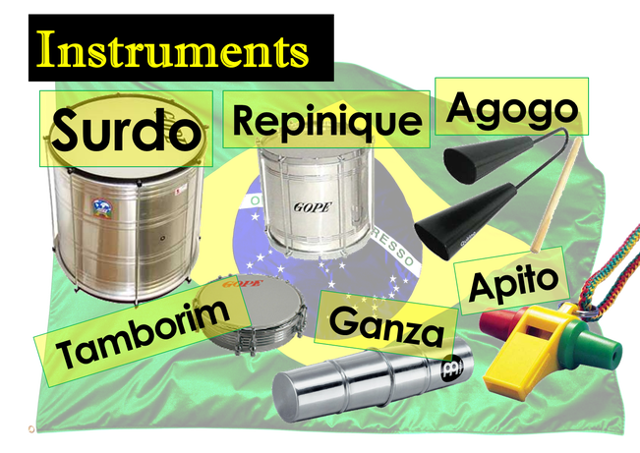
Samba instruments from Brazil
Assessment – Contrasting Localities
Choose two assessment criteria only.
Name | To be able to play a repeated pattern | To be able to indicate high and low pitches with hand | To be able to maintain a part, in a group | To be able to respond to pictures using instruments | To be able to copy rhythms
1 = exceeding expectation 2 = expected level 3 = emerging abilities

