Infant Project – Dinosaurs and Dragons

Week | Learning Intentions | Activities
1 | To be able to pitch match  To be able to copy simple clapped rhythms. | Intro - Using the song ‘Dino Dino Where’s Your Bone’ copy the pitches soh and me, as demonstrated by the teacher.  Children sing the whole song all together and then volunteers to pitch match alone. *Assessment opportunity*  Main – Using pictures of the dinosaurs, clap back the rhythms of dinosaur names. T-Rex, Pterodactyl, Plesiosaurus, Triceratops. Can they identify each dinosaur from its rhythm alone?  Learn the chant;  Stomp, chomp, big roars,  Here come the dinosaurs.  Once this chant is well known, add the rhythm of dinosaur name 4 times, then repeat. Spoken activity. Explain rondo form. See below. (Dino Rondo).  Plenary – recap vocabulary ‘pitch’ and ‘rhythm’.
2 | To be able to pitch match  To be able to sing alone (volunteers)  To be able to identify clapped rhythms  To be able to compare rhythms | Intro - Using the song ‘Dino Dino Where’s Your Bone’ copy the pitches soh and me, as demonstrated by the teacher.  Children sing the whole song all together and then volunteers to pitch match alone. *Assessment opportunity*  Main – Using pictures of the dinosaurs, recap the rhythms of dinosaur names. T-Rex, Pterodactyl, Plesiosaurus, Triceratops. Can they identify each dinosaur from its rhythm alone?  Recap the chant. Now do the chant with clapped, tapped rhythms only, no words.  Now introduce new dinosaur (Stegosaurus). Which of the original dinosaurs has the same rhythm (Pterodactyl).  *Assessment Opportunity*  Plenary – recap vocabulary ‘pitch’ and ‘rhythm’.
3 | To be able to pitch match  To be able to sing alone (volunteers)  To be able to pitch match using a wider range of pitches  To be able to make up their own rhythms based on dragon activities | Intro - Using the song ‘Dino Dino Where’s Your Bone’ copy the pitches soh and me, as demonstrated by the teacher.  Children sing the whole song all together and then volunteers to pitch match alone. *Assessment opportunity*  Main – Begin to learn the song Maggon the Dragon.  Discuss things that dragons do (breathe fire, eat maidens, fight knights etc). Children to initiate clapped patterns based on these activities.  Plenary – recap vocabulary used; pitch, rhythm, rondo.  Revisit Dino Rondo.
4 | To be able to pitch match  To be able to sing alone (volunteers)  To be able to initiate their own rhythmic patterns | Intro - Using the song ‘Dino Dino Where’s Your Bone’ copy the pitches soh and me, as demonstrated by the teacher.  Children sing the whole song all together and then volunteers to pitch match alone. *Assessment opportunity*  Main – Continue to learn the song Maggon the Dragon.  Discuss things that dragons do (breathe fire, eat maidens, fight knights etc).  Children to initiate clapped patterns based on these activities.  Encourage new examples.  *Assessment Opportunity*  Sing Maggon the Dragon alternated with these chosen rhythms (rondo).

Nicola Rose, MK Music Faculty.

Notes for class teacher.
(Using pitches soh and me).
Dino Dino where’s your bone? Someone took it from your home. Who took your bone?
(One child volunteer) I took your bone.

Dino Rondo
Stomp, chomp, big roars,
Here come the dinosaurs.
(Chant this phrase and then clap the rhythm of the dinosaur shown on the card 4 times).
Rondo form is where one part keeps coming back (chant above) alternated by new different parts (names of dinosaurs).
Chant – dinosaur 1 four times – chant - dinosaur 2 x 4 – chant – dinosaur 3 x 4 – chant – dinosaur 4 x 4 – chant.

Maggon the Dragon from the book Apuskidu. (A & C Black)
Once there was a dragon, a bad tempered dragon,
Maggon the dragon was his name.
Lived inside a cavern on top of a mountain,
People could see his smoke and flames.
(Children sing the song then make up their own rhythms to words associated with actions of dragons eg. ‘They breathe fire’. Perform as a rondo.

Infant Project - Dragons
Learning Objectives | Activities
To be able to say a poem, one line at a time, in the correct rhythm  To be able to play percussion instruments to represent parts of the poem  To add a pitched ostinato pattern to accompany the poem.  To know and be able to describe the difference between rhythm and pulse.  To combine rhythm and pitch using the poem.  To begin to sing in tune  To be able to play the rhythm of selected lines taken from the song  To combine several rhythms inspired by the song, using a recognised structure  To make up lines of a song using a well known structure, as a group  To understand how to create and perform a creative score  To make their own creative score | A Dragon’s Very Fierce From Music Express  Use lines to find suitable timbres on percussion instruments, and play in rhythm.  Alternating G and D in pulse.  Maggon the Dragon from Appuskidu  There Was a Dragon Long Ago  To draw a creative score as a class, indicating a day in the life of a dragon (modelling)  In groups, create their own version of a day in the life of a dragon, and play it

Nicola Rose, Community Learning MK, (Music Faculty)

Notes for MKMF teachers
A dragon’s very fierce, a dragon’s very tough,
And when he breathes out orange fire the smoke comes out in puffs.
His scales are shining green, they make a rattling sound,
His feet go stomp, his teeth go chomp, his tail thumps on the ground. X

Assessment in Music – Dragon Unit
Name | Copy rhythm | Create score | Comment

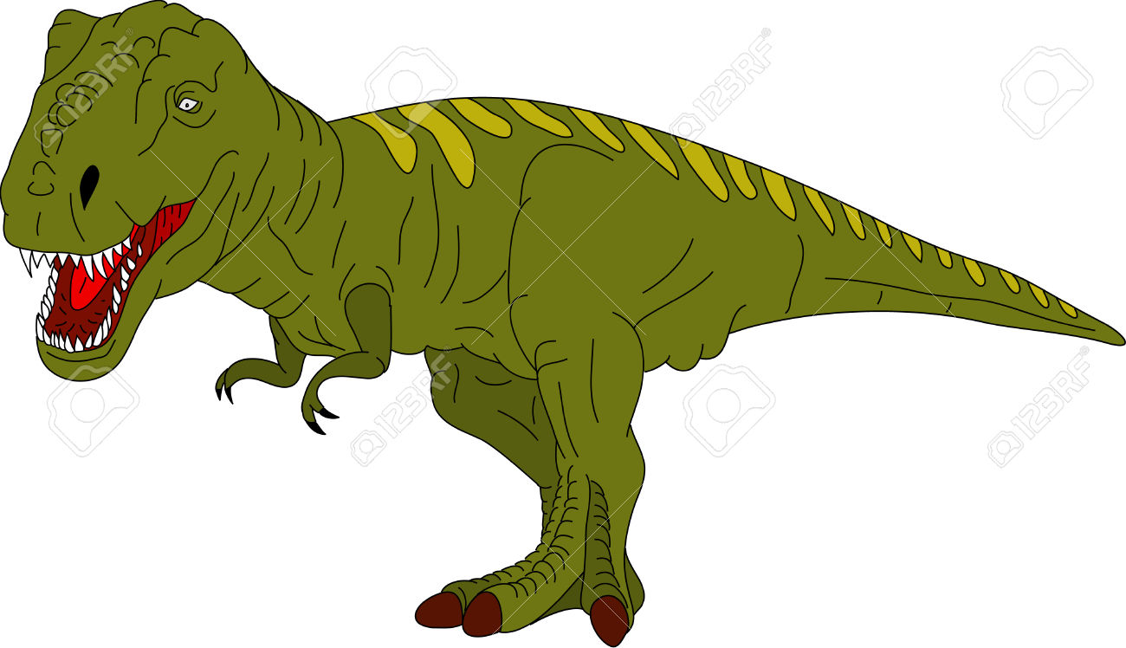T Rex

Triceratops
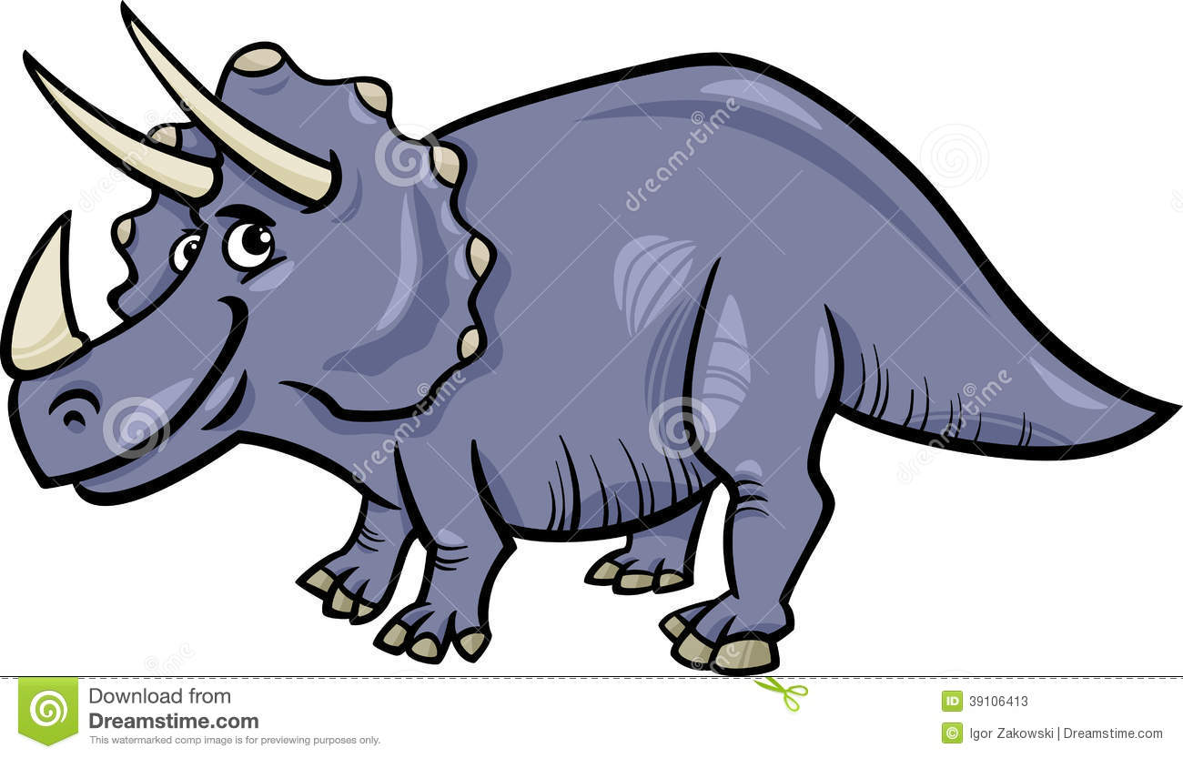
Pterodactyl
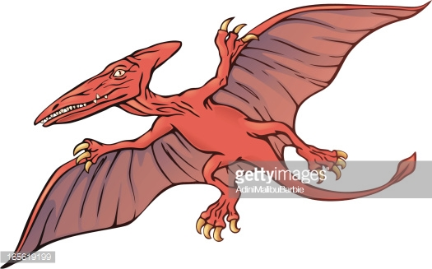

Stegosaurus
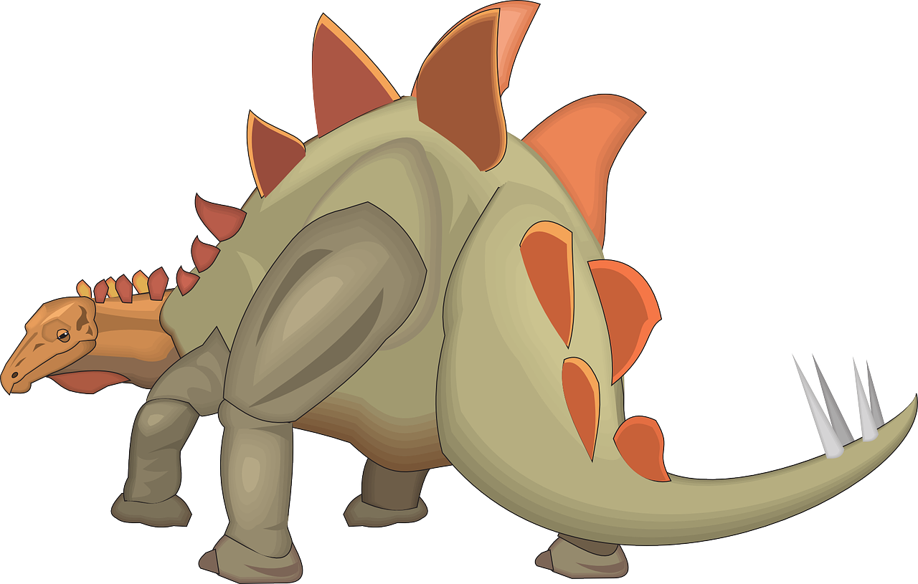
Plesiosaurus
