Out and About. (Minibeasts)

Week | Learning Objectives | Activities – see resources below. | Assessment
1 | To begin to pitch match accurately whilst singing, using tonic solfa interval soh, me.  To be able to clap the rhythm of names of mini-beasts. | Intro – Using soh and me, sing ‘hellos’ eg ‘hello blue group’ / ‘hello Mrs Rose’.  Main – To begin to learn the song ‘Well There Are Lots of Worms’, singing accurately.  To begin to clap / play the rhythm of a variety of mini-beast names (fly, spider, ladybird).  Plenary – Revise song.
2 | To continue to pitch match accurately whilst singing, using tonic solfa interval soh and me.  To be able to clap the rhythm of more names of mini-beasts.  To be able to clap rhythms in two parts.  To begin to sing a song using actions. | Intro – Using soh and me, sing ‘hellos’ eg ‘hello blue group’ / ‘hello Mrs Rose’.  Main – Continue to learn the song ‘Well There Are Lots of Worms’, singing accurately.  To clap more rhythms of a variety of mini-beast names (fly, spider, ladybird, grass hopper, caterpillar).  One group clap / play one rhythm, a second group another rhythm. Try a variety of combinations.  Begin to learn the song There’s a Tiny Caterpillar on a Leaf.  Plenary – Revise song. | Assessment Opportunity (rhythm).
3 | To continue to pitch match accurately whilst singing, using tonic solfa interval soh, me and la.  To be able to follow a simple grid score.  To understand some basic features of composing. | Intro – Using soh, me and la, sing ‘hellos’ eg ‘hello blue group’ / ‘hello Mrs Rose’  Main – Introduce 4 different percussion instruments; one for each of mini-beasts. Musical Clock game. Draw a ‘map’ where a route is indicated and mini-beasts are shown. Children to clap / play appropriate rhythm as the pointer moves. See resource below.  Continue to learn the song There’s a Tiny Caterpillar.  Plenary – Discuss the role of a composer (organising sound, no random choices, organisation of a composition etc). | Assessment Opportunity (rhythm).
4 | To continue to pitch match accurately whilst singing, using tonic solfa interval soh, me, la and doh.  To understand how onomatopoeic sounds can be used in song, regardless of the language used, but they are still recognisable. | Intro –Sing individual ‘hello’ to children who indicate they want to reply (solo) using soh, me, lah.  Main - Continue to learn the song There’s a Tiny Caterpillar. Add instruments as appropriate in different verses of the song.  Discuss which instruments might be best used for the story The Caterpillar That Roared by Michael Lawrence, and prepare for playing the story next week. | Assessment Opportunity (handling instruments).
5 | To be able to use the Kodaly handsigns soh, me, la and doh with accuracy.  To be able to make good choices of timbre when selecting instruments to depict an animal.  To be able to sustain a vocal part in a group. | Intro – Sing individual ‘hello’ to children who indicate they want to reply (solo) using soh, me, lah.  Main – a musical version of The Caterpillar That Roared by Michael Lawrence. Children to choose appropriate instruments for the animals mentioned in the story.  To sing There’s a Tiny Caterpillar on a Leaf with instruments. | Assessment Opportunity (handling instruments).
Nicola Rose, Community Learning MK, (Music Faculty).

Resources:

Well There Are Lots of Worms. In the Music Express Songbook KS1.

There’s Tiny Caterpillar on a Leaf. In the book Bobby Shaftoe by Sue Nicholls.

The Caterpillar That Roared by Michael Lawrence. (Story book).

A selection of unpitched percussion instruments owned by the school.

The Caterillar That Roared by Michael Lawrence.

(Ask Nicola to borrow the book).

Now some caterpillars want to be moths when they grow up, and some want to be butterflies. But Hugo, he wanted to be a lion.
Every morning when he woke up he would gaze at himself in the mirror to see if he looked like a lion.
He would pull himself up as tall as he could, toss his imaginary mane, twitch his imaginary whiskers and swish his imaginary tail. But it was no good. He still looked exactly like a caterpillar.

So, he would practise his roar. At first, the growl sounded more like a squeak. But as he practised and practised, it began to sound like a very small, very squeaky little growl. Hugo decided to show off his growl to his neighbours.

Nearby sat Winona the snail. Hugo growled at her. ‘What a funny noise for a caterpillar to make,’ Winona said.
‘I’m not a caterpillar,’ Hugo told her. ‘I’m a lion.’
Winona smiled. ‘No no,’ she said. ‘Not you. I’d be frightened of you if you were a lion.’

Next he met Ollie the Spider lazing in the sun. Hugo growled. Ollie frowned.
‘Are you feeling alright Hugo? I’ve never heard a caterpillar make a noise like that.’
‘I’m not a caterpillar,’ Hugo said, ‘I’m a lion.’ Ollie shook with laughter.
‘That’s the funniest thing I’ve heard all day. You’re no lion my lad. I’d be frightened of you if you were a lion.’

Hugo went on his way, practising his tiny growl and met Ruby the Tortoise returning from the shops. It had taken her three days to geet there and back and she was very tired. Hugo growled at her. ‘I’m a lion,’ he said proudly.
‘Oh are you now?’ Ruby said. ‘Well all I can say it it’s just as well you’re not. I’d be frightened of you if you were a lion.’

Hugo gazed up at the grass and flowers growing high above him. ‘If I were a lion,’ he said, ‘I’d be taller and bigger than the whole wide world.’
He tried to stretch himself up and puff himself out but it didn’t work. Even when he shut his eyes he didn’t feel any bigger.

He sat down on the riverbank and looked at himself in the clear water. He hoped to see a great big lion there, but all he saw was a little caterpillar.
‘It’s not fair!’ he wailed. ‘Lions can be lions, so why can’t I be one?’

Below the surface, Ferdinand the Fish was preparing his dinner. Suddenly he saw something moving up above. Through the ripples Ferdinand saw a huge and fearsome creature twitching its great whiskers, tossing its great mane and swishing its great tail. And then he heard …growl. A great and terrible growl.
‘It’s a lion!’ cried Ferdinand in fright and he swam away as fast as he could.

Hugo was horrified. ‘Come back Ferdinand!’ he shouted. ‘It’s me, Hugo. I’m not really a lion!’
But it was too late. Ferdinand was gone.
Hugo went home thinking about what had happened at the river. ‘If I was a lion,’ he said to himself, ‘everyone would run away from me. They wouldn’t even stop to say hello.’
And that night, as he snuggled down to sleep he thought, ‘I’m glad I’m a caterpillar.’

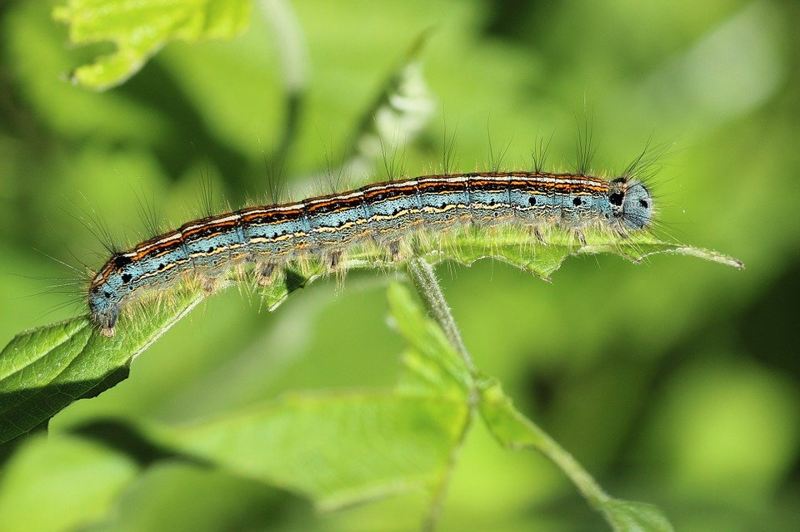

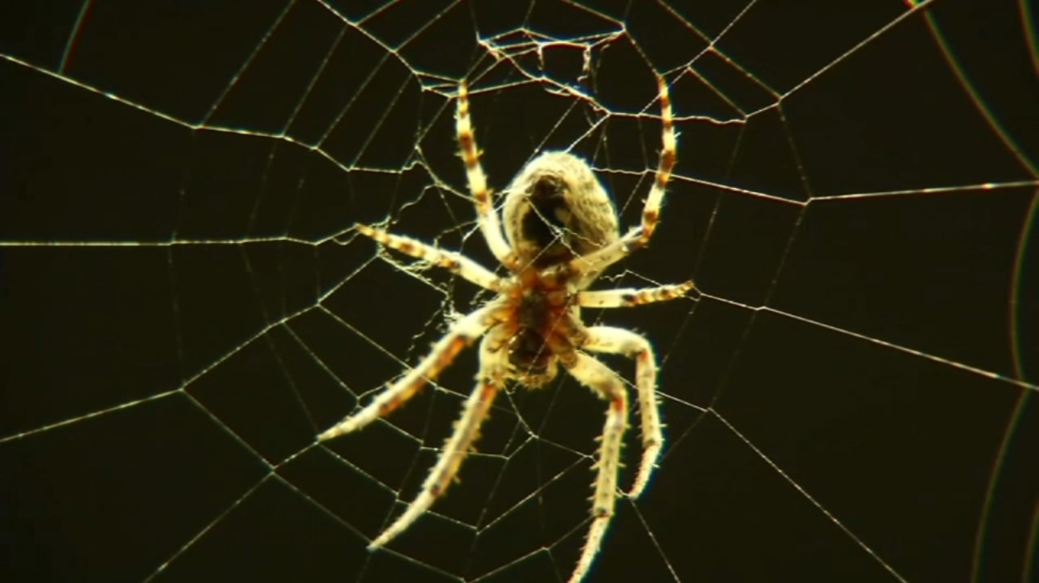

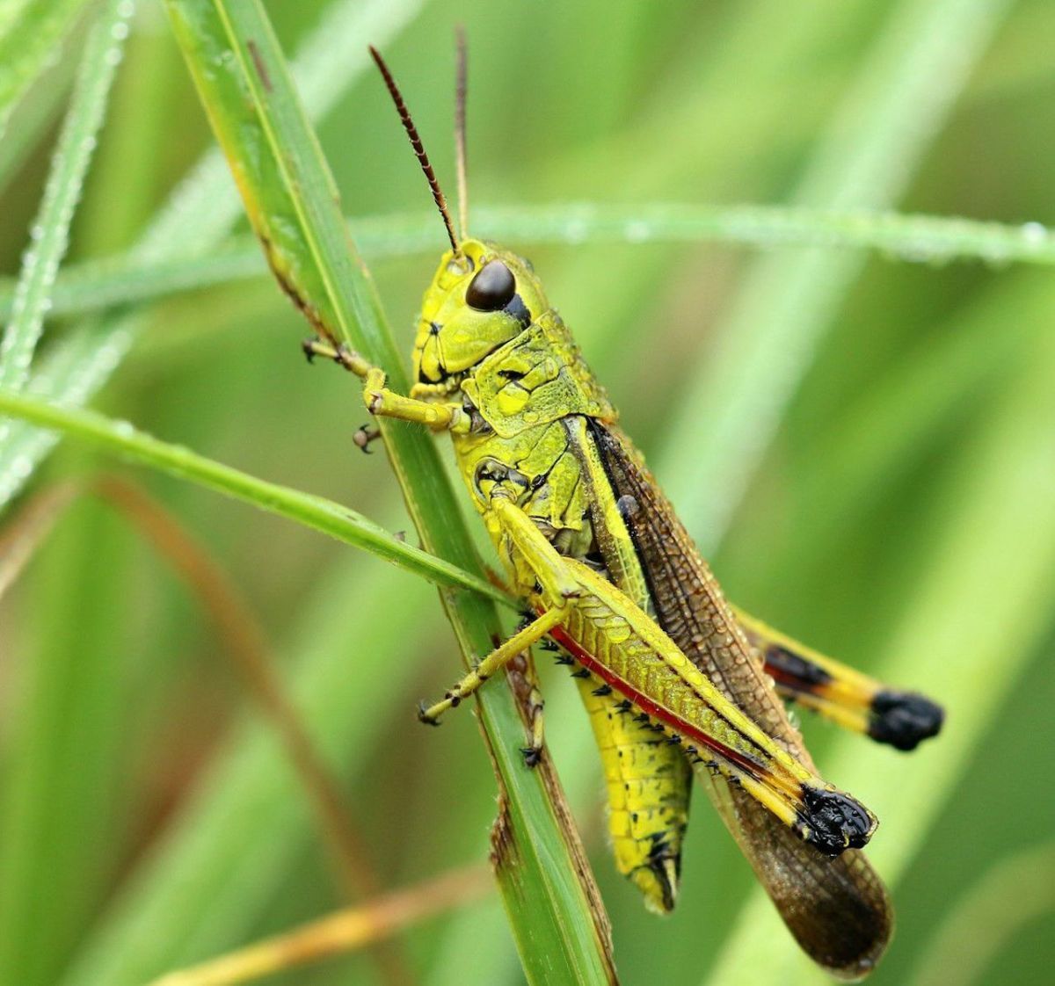

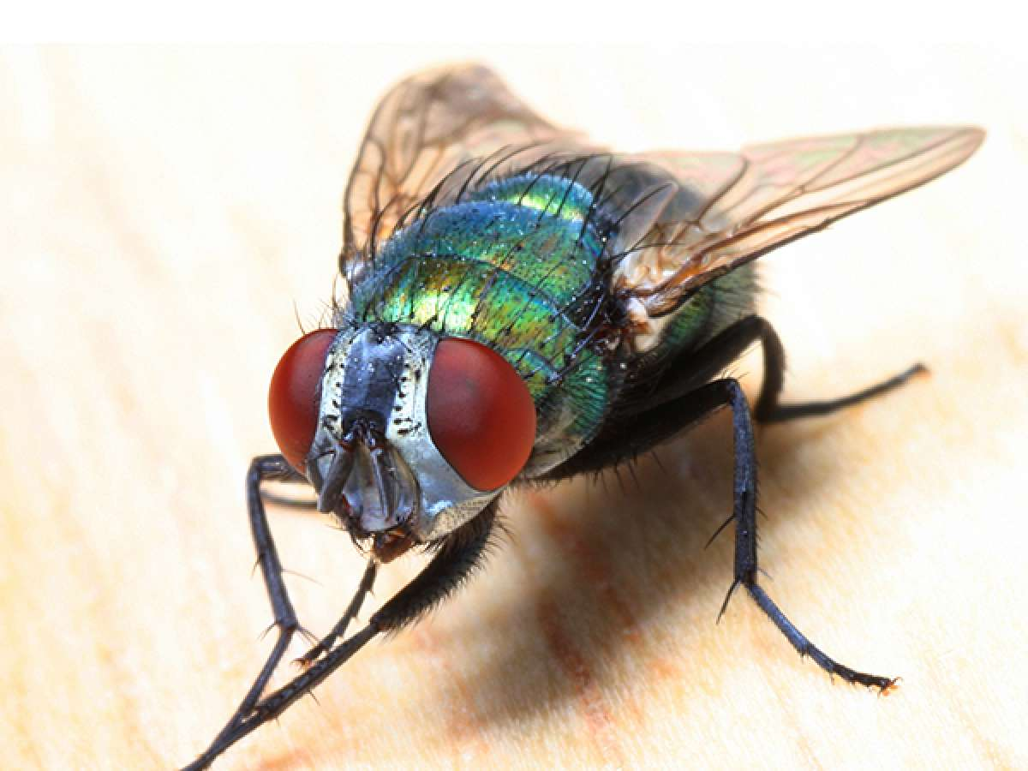
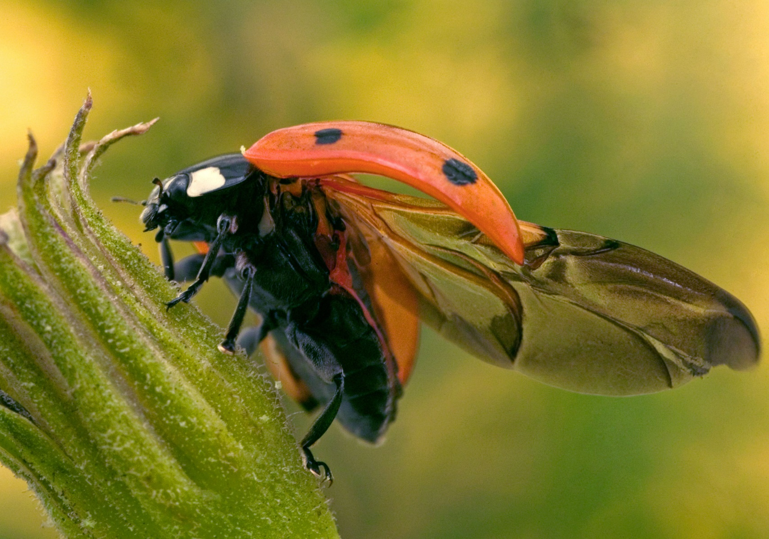

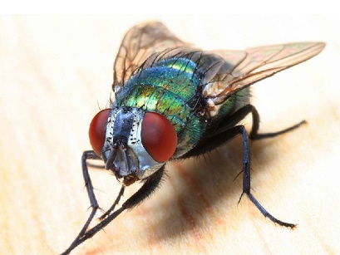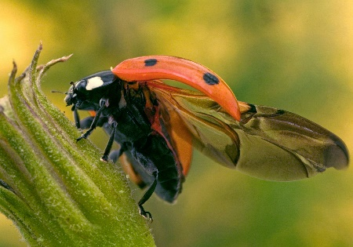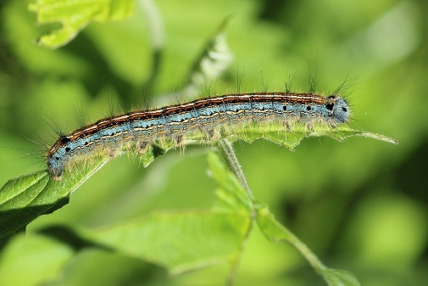

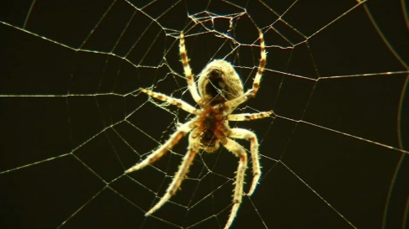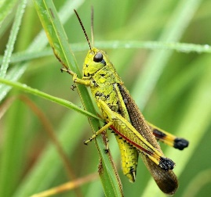

Assessment – Out and About.

Name | X is able to clap / play simple rhythms | X is able to play percussion instruments appropriately, with care. | Comment

1 = Exceeding expectation
2 = Expected achievement
3 = Emerging abilities

