Phonics Project 2

Aims
- To discriminate between high, middle and low sounds
- To recognise vocal and instrumental timbre
- To explore rhyme and compose original spoken chants
- To identify, internalise and play rhythmic patterns
- To blend and segment words orally
- To explore vocal sounds/dynamic range/range
- To encourage fine and gross motor skills using beaters and instruments
- To explore alliteration
- To create and select quiet and loud sounds
- To create sequences of sounds
- To play from simple graphic notation
- To discriminate between similar sounds
- To identify and generate rhyme

Links to Phase 2 of ‘Letters and Sounds’
- Children will learn a selection of letters (p, t, b, h, m, j, s,r)
- Activities will be multi-sensory
- Children will be taught ‘grapheme-phoneme correspondence’ i.e. relate sound to symbol
- Sessions will be daily, short and discrete

This series of lessons is designed for children in Year 1 or 2 who are finding it difficult to discriminate between phonetical sounds
They can also aide the general development of auditory awareness of children in year R
Each session is designed to be repeated and/or adapted by teachers and practitioners with groups of children or whole classes

Lesson 1 (30- 40mins)

Learning Intentions: Children learn
To identify objects that begin with ‘p’
To copy a simple sung phrase
To identify the timbre of a voice
To explore body percussion
To explore rhyming words
To play the rhythms of words
To make up sequences
To sing an action song

Introductory activity (10mins)
Sing ‘Hello Barnaby’ (GEggE) and look in his backpack. All the objects begin with the sound, ‘p’ (e.g. pen, panda, peach, penguin, puzzle). Say some of the easier objects like a robot (e.g. p-e-n or p-ea-ch)
Play a game of Pass the Puppet, using the notes C, E and G.
Who has the penguin?
C e e G G
I have the penguin
C e e G G
Ask a volunteer to close his or her eyes and to guess who is singing.

Main activity (15mins)
Explain to the children that ‘P’ is for ‘percussion’ but today we are going to make all the sounds with our bodies.
Teach the children the chant, ‘Bananas, bananas’ and ask them to talk about the action words- clap/ flap, click/flick, bump/jump- what do they notice?
Use new words to make up an action chant
E.g. stomp/clomp, trip/skip, hop/bop/pop
Did any of our action words begin with the sound, ‘p’?
Introduce some characters from children’s TV that begin with ‘p’.
Can they say and clap the following?
1 2 3 4
Pin- gu Pin- gu
Po - Po -
Ponti- pine Ponti- pine

Ask the children to lay out the picture cards in different orders and to say and clap each sequence of sounds.

Plenary (5mins)
Finish by singing the action song, ‘Little Peter Rabbit’
Little Peter Rabbit’s got a fly upon his nose x 3
So he swished it and he swashed it and the fly flew away.
Powder puff and curly whiskers x 3
And he swishes it and he swashed it and the fly flew away

Extension: Miss out some of the words e.g. ‘Little Peter Rabbit’ or ‘fly’ so that the children have to internalise them.

Learning Outcomes: Children can
Sing copy phrase using H/M/L notes
Identify vocal timbre
Find rhyming couplets
Move to a steady pulse
Play rhythmic patterns accurately
Relate pictures to words/syllables
Internalise the words of a song
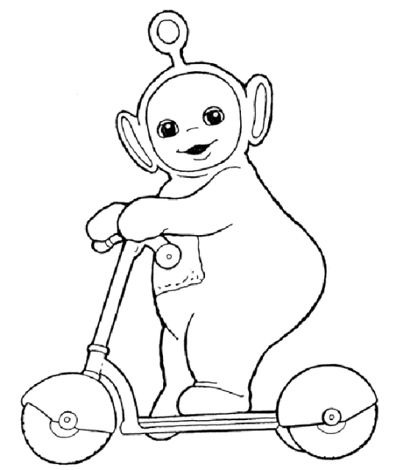

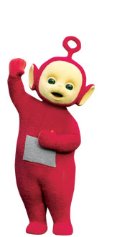

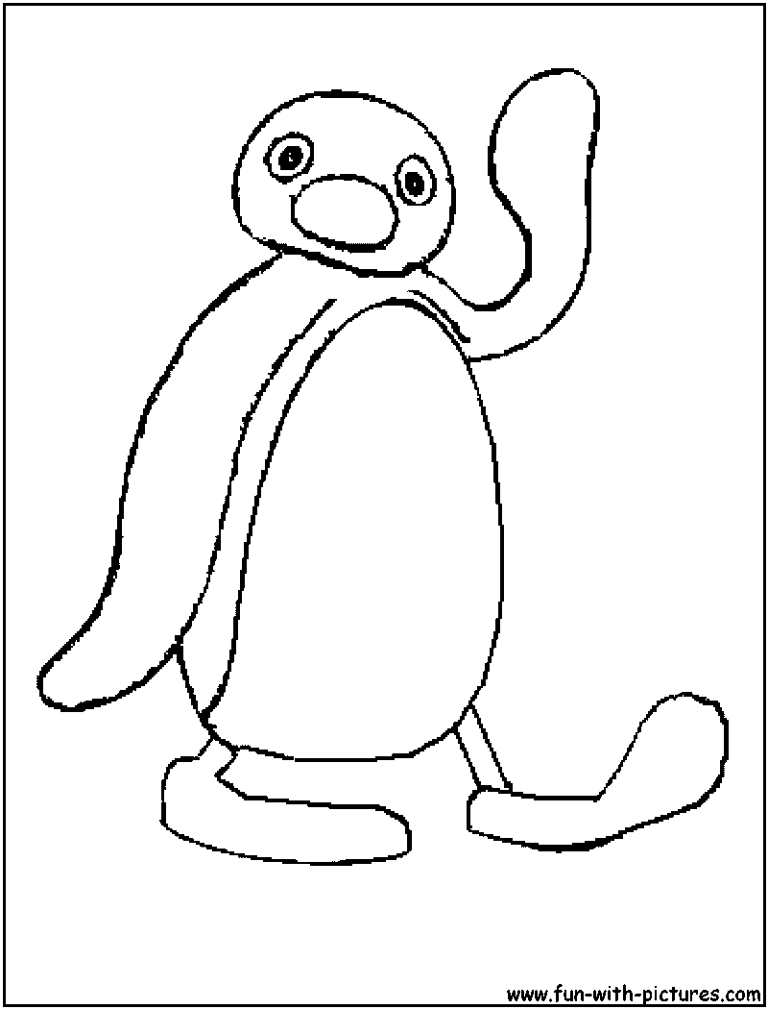

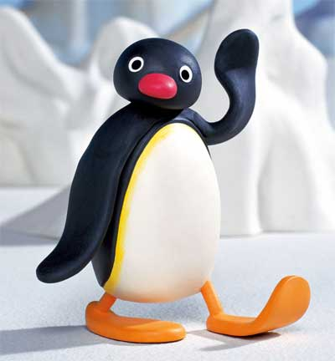

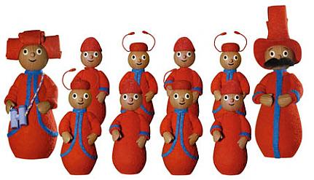

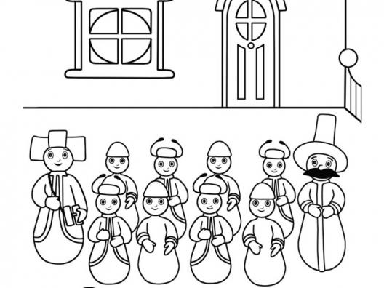

Lesson 2 (30-40mins)

Learning Intentions: Children learn
To recognize objects that begin with the sound ‘t’
About alliteration
A new singing game
How to segment and blend
To use their voices at different pitches
About dynamics
A new listening game

Introductory activity (10mins)
Sing, ‘Hello’ to Barnaby (GEggE) and look at what he has in his backpack. All the objects begin with ‘t’ (e.g. tomato, truck, treasure, tree, toast)
Say some of the easier examples like robots i.e. t-r-u-ck or t-r-ee.
Introduce the game, ‘Tommy Tattle Mouse’.
What does ‘Tommy’ and ‘Tattle mouse’ begin with?
One child sits in the centre with Tommy whilst a solo singer is chosen to sing the last line alone (Yes, it’s me)
All the children sing the following:
‘Little Tommy Tattle mouse
Lives in a little house
Someone’s coming wait and see

Someone’s coming’
Solo: ‘Yes it’s me’
The child in the centre has to guess who sang the last line

Main activity (15mins)
Introduce the children to a new Teddy. He has lots of clothes in his suitcase/bag and they are all messy.
Play, ‘Tidy Up Teddy’
What sound does ‘Teddy’ and ‘Tidy’ begin with?
Children choose items of clothing to put onto Teddy that they think they can say like robots (segment)
e.g. sh-o-r-t-s, sh-i-r-t, sc-ar-f, sh-oe-s, s-u-n-g-l-a-ss-es, s-o-ck-s

The new teddy has two other friends. We now have three teddies. They are three tapping teddies.
Introduce the chant, ‘Three Tapping Teddies’ and ask the children to tap the pulse on their knees.
Repeat the chant with the children saying the responses in different pitched voices
E.g. Tap, tap, tap, tiny tapping teddy (high-pitched voice)
How would each teddy move? Who would make the loudest tapping sound?
Give out drums to half the class/group and ask them to tap them whilst the other children speak and tap their knees.
Swap over activities.
Extension: Use the paws cards and ask the children to change the volume (dynamic level) of their taps according to the size of the paws.

Plenary (5mins)
Play a game of ‘Teddy’s Toes’.
Using one drum and moving away from the children, ask them to close their eyes and to point to which corner of the room I have tip-toed to with Barnaby.
What happened to the sound, as I got further away?
(This is a good game to play outside or in the hall)
Talk about all the games they played today that began with the sound, ‘t’.
They looked in Barnaby’s backpack and all his things began with ‘t’.
They played the singing game, ‘Tommy Tattle Mouse’.
They played ‘Tidy Up Teddy’, ‘Three Tapping Teddies’ and ‘Teddy’s Toes’.
Sing ‘Goodbye to Barnaby’ (GEggE)

Learning Outcomes: Children can
Listen attentively
Identify vocal timbre
Segment simple words
Identify initial sounds
Speak, tap and play with control
(Follow simple visual instructions)
Sing responses accurately
Identify H/M/L sounds
Recognise that sounds can get louder or quieter

Lesson 3 (30-40mins)

Learning intentions: Children learn
To recognize objects that begin with the sound ‘b’
A new singing game
To revise a rhyming chant
About the ‘b’ grapheme
A new instrumental song
About rhythm
How to imitate sounds

Introductory activity (10mins)
Sing, ‘Hello Barnaby’ (GEggE) and look at the objects that are in his backpack. They all begin with the sound, ‘b’ (e.g. banana, biscuit, book, ball, bee and boat) and say some of the simpler words like robots (i.e. b-oo-k, b-a-ll, b-ee and b-oa-t)
Can they make their voices bounce like a bouncy ball?
Revise the game, ‘I have got the ball’ and pass it to each other around the circle.
(Yr R: Roll the ball, roll the ball, roll the ball to....)
(Yr 2: Bounce high, bounce low, bounce the ball to...)
Try making up silly rhymes to go with the name of the person they are rolling/bouncing the ball to. They do not have to be real words or make any sense e.g. Louis Booey/ Phoebe Weeby/ Joseph Boseph.

Main activity (15mins)
Revise the chant, ‘Bananas, bananas’ (see week 1). Use the original rhyming words (clap/flap, click/flick, bump/jump) and the use made up words e.g. skip/flip, hop/bop, pop/chop
Introduce the song, ‘Now my bells are up’. Ask the children to follow the words with their bells held in their hands.
(As they follow the first two lines, they will be drawing the grapheme, ‘b’ in the air)

‘Now my bells are up and now my bells are down
Now my bells are dancing all around the town’.

(Follow the actions for the next two lines)
‘Dance them by my shoulders, dance them by my head
Dance them by my knees and tuck them into bed’

What shape were they drawing in the first part of the song?
What word rhymes with ‘down’?
What word rhymes with ‘head’?
If we danced our bells by our ‘nose’, where else could we dance the? (By our ‘toes’)
If we danced them by our ‘hips’, where else could we dance them? (By our ‘lips’)
Yr 2: If we danced them by our ‘shin’, where else could we dance them? (by our ‘chin’)

Play some trotting patterns to the children on the bells and ask them to copy

Leader 1 2 3 4 children 1 2 3 4
X xx xx X X xx xx X
Walk trotting trotting walk walk trotting trotting walk

Ask volunteers to lead the activity

Plenary (5mins)
Introduce Mrs. Browning’s Box. Inside it are all sorts of sounds e.g. a crisp packet, a rain maker, bubble wrap
Ask the children to imitate the sounds and to guess what they are.
What games have they played today that began with ‘b’?
Barnaby’s things began with the sound ‘b’
We played a ball game
We revisited the chant, ‘Bananas’
We played with our bells
We listened to objects inside Mrs. Browning’s Box
Sing, ‘Goodbye Barnaby’ (GEggE)

Learning Outcomes: Children can
Sing simple phrases accurately and confidently
Blend and segment simple words
Explore and find rhyming sounds
Move to a steady pulse
Explore gross motor skills
Copy rhythmic patterns
Use their voices to imitate sounds

Lesson 4 (30-40mins)

Learning Intentions: Children learn
About the sound, ‘h’
Revise a singing game
Learn a new singing game
Add long sounds to it
Draw the grapheme, ‘h’ with their beaters
Identify vocal sounds

Introductory activity (10mins)
Sing, ‘Hello Barnaby’ (GEggE) and look at the objects in his backpack. They all begin with the sound, ‘h’ (e.g. house, horse, hippo, hen, honey). Say some of the easier examples like robots (i.e. h-ou-se, h-i-pp-o, h-e-n)
Sing, ‘How are you today?’ (ggeeG)
Children should explore cross, tired, happy, excited and sad voices.
What words could they use in their replies that begin with the sound ‘h’? (Hungry, happy, horrid)
Make their voices sound out of breath as they say ‘ha ha ha’ with hands in front of their mouths. Now laugh like Father Christmas (ha,ho,hee)

Main activity (17mins)
Revise the game, ‘Hey, hey, look at me’ using words or actions that begin with ‘h’

‘Hey, hey look at me
I am (happy/humming/hungry/hopping) can’t you see?’

Or

I’m a (hippo/horsey/hen/hedgehog) can’t you see?’

Introduce the singing game, ‘We are singing’. (Tune: Frere Jacques, starting note, C)
One child sits in the centre of the circle with eyes closed and another is chosen to sing his or her name.

All: We are singing x 2
Listen now x 2
Tell us who is singing x 2
Solo: Hello .... x 2

The child in the centre identifies the singer.

We are going to add some long sounds to this song. In order to make the sounds long we have to make a special shape in the air.
Show the children how you raise the beater up in the air strike the chime bar by lowering the beater and then make an arch in the air
What letter/grapheme am I drawing as I do this? (‘h’)
Ask the children to do this in the air and then give half the children a mixture of C and G chime bars to play as we are singing.
(If the song is too low for the children, use D and A chimes and start on the note D)

1 2 3 4 1 2 3 4
We are sing -ing we are sing -ing
C/G - C/G - C/G - C/G -

Repeat the singing game several times with new children singing the last line, listening in the centre and playing the chime bars.

Plenary (3mins)
What games have we played today that begin with the sound, ‘h’?
We have made laughing sounds like Father Christmas
We have named the objects in Barnaby’s backpack like robots-they all began with ‘h’
We have played a game called, ‘Hey, hey’
We have sung, ‘Hello’ to our friends during our singing game
We have drawn the shape ‘h’ in the air with our beaters
Sing, ‘Goodbye Barnaby’ (GEggE)

Learning Outcomes: Children can
Copy sounds that begin with ‘h’
Sing responses confidently and accurately
Blend and segment simple words
Move to steady beat
Identify and select words that begin with ‘h’
Use fine motor skills to draw the ‘h’ grapheme
Play with control
Listen carefully

Lesson 5 (30-40mins)

Learning Intentions: Children learn
About the sound, ‘m’
About quiet and loud sounds
To identify and make loud and quiet sounds
About sounds that get quieter or louder

Introductory activity (10mins)
Sing, ‘Hello Barnaby’ (GEggE) and look at the objects in his backpack. They all begin with ‘m’. (E.g. melon, marmalade, mouse, monkey)
Say some of the simpler words like robots i.e. m-e-l-o-n, m-ou-se, m-o-n-k-ey)
Make some long sounds together e.g. mmmm (rubbing tummy), ahhh (cute kitten), weee (big slide), zoom (motor bike), brrr (digger), ohhh (fed up) ahhh (yawn).

Introduce Quiet Mouse and Loud Monkey.
They both like to hear sounds but Mouse likes the sounds to be quiet and monkey likes them to be loud.
Make vocal or body sounds and change them accordingly when the puppets are held up.

Main activity (15mins)
Play a game of ‘Make your sound as quiet/loud as mine’ (Tune: Muffin Man) and ask children to copy and then create their own quiet and loud sounds.

Look at the story, ‘The Animal Boogie’ by Debbie Harter (Tune: Down in the Jungle)
Ask the children to make the sound of each creature as it moves and to decide whether Quiet Mouse or Loud Monkey would like them.
Bear-shaky shake
Monkey- swingy swing
Elephant- stompy stomp
Leopard- leapy leap
Snake-slither slither
All- sway sway

Play a game of, ‘Mrs. Bear’ (Tune: Oats and Beans)
One child sits with Barnaby on the chair with eyes closed as another steals a sound (jingles/shaker). The thief plays it all the way round the circle and then back to his or her place before Mrs. Bear decides where the sound is (still with eyes closed)
Ask all the children to close their eyes as this game is played again. What happens to the sound as it gets further away/comes closer to them?
(This is a good game to play outside or in a big hall)

Plenary (5mins)
What games have they played today that began with ‘m’?
They looked at Barnaby’s things and discovered that they all began with ‘m’
They met Quiet Mouse and Loud Monkey and made sounds that they would like
They made loud and quiet sounds and thought about the sounds in the Jungle Boogie
Finally, Mrs. Bear had to listen very carefully to some sounds
Sing, ‘Goodbye Barnaby’ (GEggE)

Learning Outcomes: Children can
Sing responses confidently and accurately
Make and copy loud and quiet sounds
Make and copy long sounds
Identify sounds as loud or quiet
Listen carefully to sounds that get quieter or louder
Move to a steady pulse

Lesson 6 (30-40mins)

Learning Intentions: Children learn
To sing a new action song
About alliteration
About describing and selecting instrumental sounds
About rhythm and pulse

Introductory activity (10mins)
Sing, ‘Hello Barnaby’ (GEggE) and look at the objects on his backpack-they all start with the sound, ‘j’. (E.g. jelly, jam, jar and a Jedi Knight). Say some like robots i.e. j-e-ll-y, j-a-m, j-a-r
Introduce the singing game, ‘Jim along Josie’. Ask the children to step to a steady pulse as they listen to the song.
‘Hey Jim-along, Jim-along Josie
Hey Jim-along, Jim-along Joe’
How many names were in the song?
What did they all begin with?

Main activity (15mins)
Tell the children that we can change the words to suit actions that we might want to perform e.g. Hey clap along, clap along Josie
Can they think of a name that might begin with the same sound as ‘clap’?
E.g. Hey clap along, clap along Christopher
Spend time finding names to match actions such as hop, skip, stamp, jump, bounce, dance
One of the objects that Barnaby had in his backpack was some jelly.
Ask the children to sing verses from Jelly on a Plate
- Jelly on a Plate/wibble wobble
- Biscuits in a tin/shake them up
- Fire on the floor/stamp it out
- Candles on the cake/blow them out
- Sausage in the pan/sizzle pop
Ask the children to perform each of the actions (wibble wobble, shake, stamp, blow and sizzle pop)
Which verse has two sounds?
Lay out a selection of percussion instruments and ask volunteers to talk about the sort of sound they were looking for to illustrate one of the verses
Can they say why they chose a particular instrument to illustrate it?
Use the instruments to accompany each verse by playing the rhythm of the words e.g. wib-ble wob-ble and talk about the choices-did the colour or timbre of the sound suit the verse?

Plenary (5mins)
What games have they played today that started with ‘j’?
The objects in Barnaby’s backpack all began with ‘j’ and they spoke some of them like a robot
They played a game called ‘Jim along Josie’ and found that all the names began with the sound ‘j’
They used the first sounds of other action words and matched them to names of children in the group or names that they knew
They sang, ‘Jelly on a Plate’ and found sounds to match the action words in the song
Pretend that they have a jelly in a pot. Make sounds to show it sticking to the sides as they try to tip it out. Now make it flop out onto a plate. Cut it up and slurp it up from a spoon!
Sing, ‘Goodbye Barnaby’ (GEggE)

Learning Outcomes: Children can
Sing simple tunes confidently and accurately
Blend and segment words beginning with ‘j’
Find names beginning with a particular sound
Talk about sounds and sound colour (timbre)
Move to a steady beat
Play rhythmic patterns
Explore vocal sounds
Lesson 7 (30-40mins)

Learning Intentions: Children learn
About the sound ‘s’
To identify different instrumental sounds
To remember and create sequences of sound
To notate sequences of sound

Introductory activity (10mins)
Sing, ‘Hello Barnaby’ (GEggE) and look at the objects in his backpack-they all begin with the sound, ‘s’ (e.g. sausage, sweet corn, sock, Sally from ‘Cars’, Spider Monkey and Swamp Fire from ‘Ben Ten Alien Force’)
Say some of the simpler examples like robots i.e. s-o-ck, s-w-am-p, s-a-ll-y
‘S’ also starts the word ‘sound’. Try making sounds that objects or creatures starting with ‘s’ make e.g. a snake, a skier, sizzling sausages, Santa, Spider Monkey and Swamp Fire
Listen to three sounds- a shaker, scraper and tapper (maraca, guiro and woodblock)
Are they the same or different?

Main activity (15mins)
Revise the game, ‘I have sounds one and two’ (Tune: Tommy Thumb) and ask volunteers to play a sequence of three sounds (They must include a tapping sound, a scraping sound and a shaking sound).
Children in the group should identify the sounds
It is often easier to remember the order or sequence of sounds if we write it down in some way- how might we do this?
Show the children the attached cards and ask volunteers to place in them in the correct order when they hear the three sounds.
Give out groups of children three sounds (1 x tapper, 1 x scraper and 1 x shaker) and three cards. Ask them to create sequences of sound and to notate them using the cards.
Listen to examples from each group.
Stick the cards from each group on the board and try playing some in a sequence

E.g. 1) tap scrape shake 2) tap shake scrape 3) shake scrape tap 4) scrape shake tap

Year 2: Try playing two at the same time

E.g. 1) tap scrape shake
2) tap shake scrape

Year 2: Ask the children how they preferred to hear the sounds - in a sequence, one-by- one or played together at the same time?

Plenary (5mins)
What games have they played today that begin with the sound, ‘s’?
They have looked at objects that begin with ‘s’ in Barnaby’s backpack
They have listened to different sounds
They have made sequences of sound

Sing, ‘Goodbye Barnaby’ (GEggE)

Learning Outcomes: Children can
Identify the initial sound of a word
Blend and segment
Identify sequences of sound
Use simple graphic symbols to notate what they hear/play
Play from graphic symbols
Play an extended sequence
Play independent parts in large groups

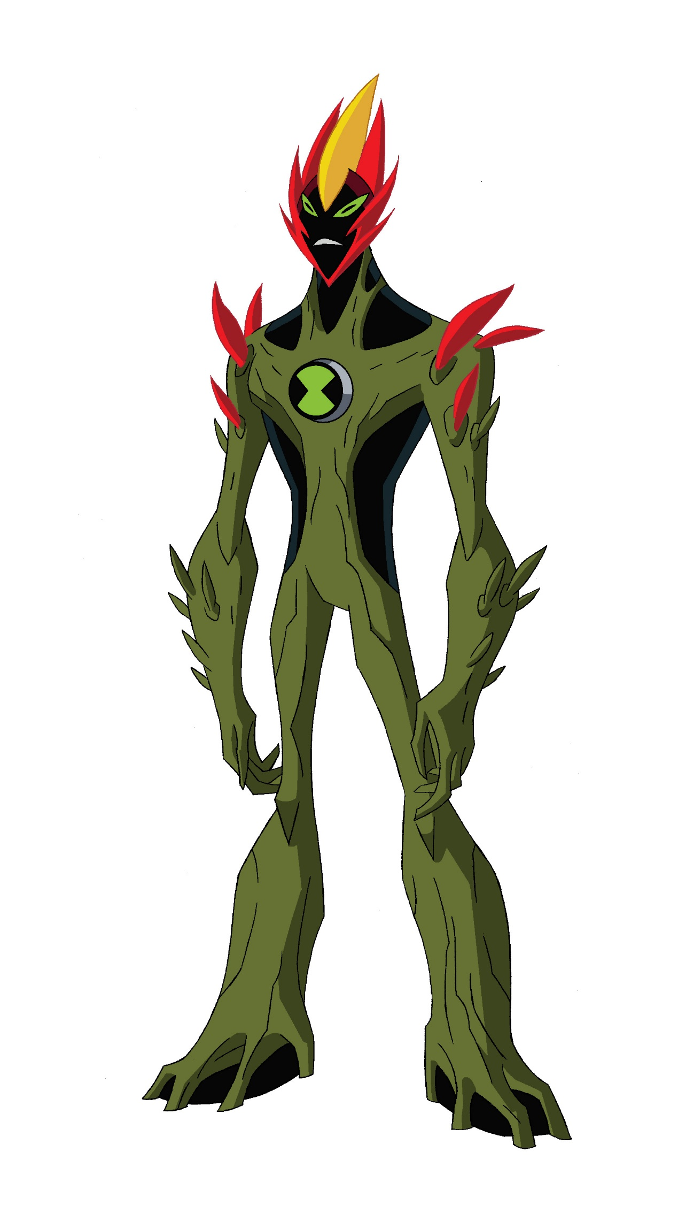

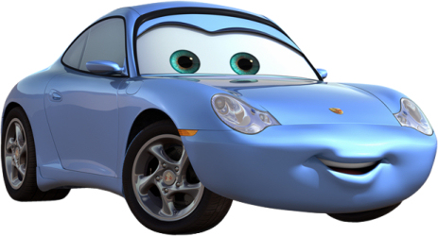

Lesson 8 (30-40mins)

Learning Intentions: Children learn
About rhyming sounds
To match rhyming words
To generate rhyming words
To select and identify similar percussion sounds

Introductory activity (10mins)
Sing, ‘Hello Barnaby’ (GEggE) and look at what he has in his backpack. All the things in his backpack today have a rhyming partner
(E.g. Ben and Gwen from Ben Ten, house and mouse, pear and chair, bee and tree)
Ask the children to match up the objects
Sometimes there are characters in a story who have rhyming names
Show the children pictures of the Ninky Nonk and the Pinky Ponk
Sometimes an object has two names that rhyme.
Show the children pictures of Iggle Piggle and Makka Pakka
Can they think of a rhyming sound that matches their name?

Main activity (15mins)
Revise the singing game, ‘Hickety Tickety Bumble Bee. Can you sing your name for me?’
What words rhyme in that song? (Hickety and Tickety and Bee and Me)
When they sing back their name, encourage the children to find or make up a nonsense word that rhymes with their name e.g. My name is straight Kate. My name is Beleanor Eleanor. My name is Wamsa Hamsa.
Last time we listened to some sounds that were very different (scrapers, shakers and tappers)
Today we are going to listen to similar sounds.

Show the children a triangle, some Chinese temple bells, some Indian bells and some finger cymbals.
Ask volunteers to play them.
How can we describe the sounds?
Are they long or short?
What words would they use to describe their sound?

in
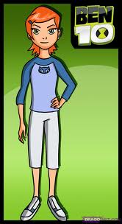

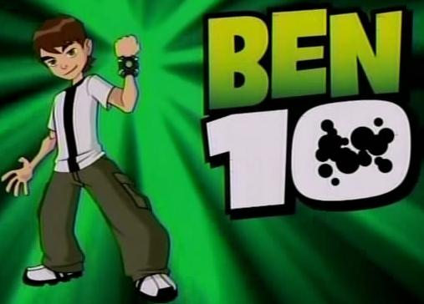

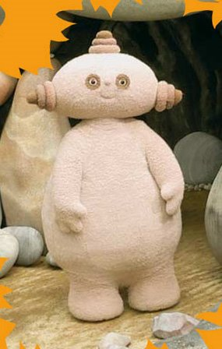

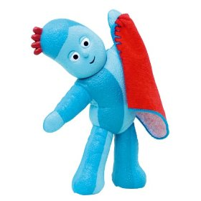
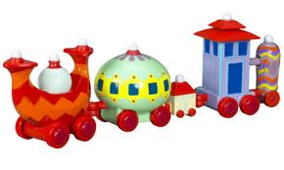

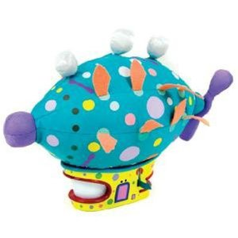

Lesson 9 (30-40mins)

Learning Intentions: Children learn
About the sound ‘i’
A new action song
A new singing game
About pulse and rhythm

Introductory activity (10mins)
Sing, ‘Hello Barnaby’ (GEggE) and look at what he has in his backpack. He has some insects and Iggle Piggle from ‘In the Night Garden’. It is very hard to find a snack for Barnaby to eat that begins with the sound ‘i’.
Try saying some of the words like robots e.g. i-gg-le p-igg-le, i-n-s-ec-t
Ask the children to say the phoneme, ‘i’- is it a short or long sound?
Do any of the children have a name that begins with ‘i’?
Ask the children to find some other short sounds with their mouths/voices/tongues/lips
Use a the game, ‘Children can you do this’ as a vehicle to show some of their ideas

‘Children can you do this, do this, do this?
Children can you do this just like...’

Main activity (15mins)
Introduce the game, ‘Ickle Ockle’. One child walks around the inside of the circle as the others sing,
‘Ickle Ockle Blue bottle
Fishes in the sea
If you want a partner
Just choose me’

The child chooses a partner form the circle and they decide how to keep the pulse or beat by using an action (Year R) or two actions (Yr 1 and 2) e.g. clap tap clap tap

Extension: Can they think of rhyming actions e.g. clap/tap, jump/bump, click/flick, hop/bop?

Introduce the singing game, ‘In and Out the Dusty Blue Bells’.
The children join hands and lift them up to make arches. One child weaves in and out of the arches until the words, ‘Tippy Tappy Tip Toe on my shoulder’. At this point the child chooses someone’s back on which to tap the rhythm of the words. This child becomes the new leader.
Ask all the children to tap the rhythm, ‘Tippy Tappy TipToe’ on their knees before starting the game.

Ask the children to sit down and to face a partner.
Class: Ask one child to tap a pattern for his or her partner to copy using body percussion
Group: Give each pair two instruments (woodblocks or claves) on which to create and copy the rhythmic patterns.

Plenary (5mins)
Listen to some examples.
Are the children copying well?
What skills do they have to use?
Are the sounds we are making short or long?
Who can think of a word that rhymes with ‘tip’ or ‘tap’?

Learning Outcomes: Children can
Explore vocal and body sounds
Select and identify short sounds
Work with partners to create a steady pulse
Copy and create rhythmic patterns
Explore and select rhyming sounds

Lesson 10 (30-40mins)

Learning Intentions: Children learn
About the sound ‘r’
About rhyming
About rhythm
A new action song

Introductory activity (10mins)
Sing, ‘Hello Barnaby’ and look at what he has in his backpack. All the objects begin with the sound, ‘r’. (E.g. A roll, a rhino, a racing car and Rumpelstiltskin)
Can they children tap out those words and decide how many taps there are in each one?
Play a game of, ‘What’s in the Backpack?’ The children will know which of the four objects is in Barnaby’s backpack by how many taps they hear.
Try talking like a robot, roaring like a lion and ringing like a telephone.

Main activity (10mins)
Introduce the story, ‘Rumble in the Jungle’ and ask the children to say and tap the rhythm of the title.
Can they do this over and over again whilst I read the first three verses?
What instrument do they think would be good to accompany our Jungle Poem? (Drums)
Use drums to pick out the following rhythms for each of the creatures in the book

Chimpanzee- swinging through the trees
Lion- roaring very loud
Elephant- big and fat and round
Zebra- black and white and fast
Snake- sliding round the tree
Giraffe- head up in the sky
Hippo- mooching in the mud
Crocodile- snapping all day long
Rhino- big and strong and tough
Gazelle- leaping in the air
Gorilla- beating hairy chests
Leopard- prowling through the night
Tiger- eyes are shining bright

Each time the children copy the words and rhythm led by the adult

What do they notice about the rhythms? (They are the same)
How can we make each rhythm sound different? (Use different percussion instruments)

Plenary (10mins)
The title of the story we read today was, ‘Rumble in the Jungle’.
What can the children tell me about the words, ‘rumble’ and ‘jungle’?
Play a game of ‘Ring a ring a roses’ Use all the verses so that the children can rhyme the words, ‘roses/posies’, ‘steeple/people’, ‘daughter/water’, ‘ringing/singing’ and ‘grass/last’

Learning Outcomes: Children can
Tap the syllables of words
Recall/internalise syllabic patterns/rhythms
Identify rhythmic patterns
Play rhythmic patterns
Identify rhyme

Lesson 11 (30-40mins)

Learning Intentions: Children learn
To sing simple phrases
About timbre (sound colour)
To select long and short sounds
To recognize sounds
About alliteration

Introductory activity (10mins)
Sing, ‘Hello Barnaby’ (GEggE) and look in his backpack. He has been playing with all his jungle friends.
Barnaby is called Barnaby Bear. Can the children find words to describe each of the jungle animals that start with the same sound?
E.g. Zippy Zebra, Energetic Elephant, Jolly Giraffe, Mucky Monkey, Lazy Lion, Cross Crocodile and Sneaky Snake
Revise the game, ‘Pass the Puppet’ and use the alliterative words in the phrase
E.g. Who’s got Zippy Zebra?
G E c c c c
I’ve got Zippy Zebra
G E c c c c

Main activity (15mins)
Remind the children of the book, ‘Rumble in the Jungle’ and ask them to say and tap the rhythm of the title.
Last week they realized that each of the phrases used to describe the creatures had the same rhythm.
They need to select instruments for each animal
How will they start? (They need to think of sounds that the creatures make with their voices or when they move- are they long or short?)
Lay out a selection of sounds and ask volunteers to choose one for each animal.
They need to tell the other children why they chose the sound.

There are 13 animals in the book.
If teaching a whole class, give pairs of children an animal each and then ask the four remaining children to play the title on the drums

Perform the story like so...

Rumble in the Jungle x 4
Swinging through the trees x 4
Rumble in the Jungle x 4
Roaring very loud x 4
Rumble in the Jungle x 4

And so on....

Plenary (10mins)
Ask the children to think of a word for each of their animals that start with the same sound.
(E.g. Cheerful Chimpanzee, Lazy, laughing Lion, Elphing, exercising Elephant, Zippy Zebra, Slithering, sliding, slippery Snake, Gentle Giraffe, Happy Hippo, Crafty Croc, Ridiculous Rhino, Galloping Gazelle, Great, greedy Gorilla, Light, lean Leopard, Terrible Tiger.)
Can they play that rhythm when they are asked to pack their instruments away?

Learning Outcomes: Children can
Explore alliterative sounds
Sing back phrase accurately
Select sounds according to their duration
Talk about sounds
Play rhythmic patterns with control
Lesson 12 (30-40mins) ‘A Christmas Special!’

Learning Intentions: Children learn
To sing back phrases
About tempo (speed)
About rhythm
About rhyme
About timbre

Introductory activity (10mins)
Sing, ‘Hello Barnaby’ (GEgge) and look inside his backpack. Inside he has various winter toys
(E.g. an elf, a penguin, a reindeer, Santa, a Polar Bear)
Can they children clap each word and count how many sounds are in each?
They are clapping the rhythm of the word

Play, ‘Pass the Christmas Puppet’.
E.g. Who has Santa?
G E C C
I have Santa
G E C C

Main activity (15mins)
Ask the children if they can find a word to rhyme with ‘elf’
Teach the children the following song, using call and response and the tune, ‘Frere Jacques’

I hear ringing (repeat)
Ding Dang Dong (repeat)
Christmas is a-coming (repeat)
Sing this song (repeat)

Which words rhyme?
Which sounds from the music trolley/box would be most appropriate- the shakers, tambours or triangles?

Use metal sounds to accompany the song- play its pulse and then try playing the rhythm of the words.

Can the children think of words to rhyme with ding (sing, ping, ching, ring)?
Can the children think of words to rhyme with dang (bang, clang)?
Can they think of words to rhyme with dong (bong, long, song)?
Can they find instrumental sounds that ring, ping, ching, bang, clang, bong or that are long?

Plenary (5mins)

Barnaby has enjoyed working with them and has had fun finding sounds that rhyme.
Can anyone find a word to rhyme with ‘bear’?

Extension activity: Play a game of ‘Big Bear’ using a Polar Bear, a reindeer and an elf
1 2 3 4 1 2 3 4
Big - Bear - Big - Bear -
What can you - see - - -?
I see a rein- deer trotting by me -

Reindeer, reindeer, what can you see? I see a little elf running by me
Little Elf, Little Elf, what can you see? I see a hole in the ground. Can’t catch me!

1 2 3 4
Big - Bear -
Rein -deer Rein- deer
Little Elf Little Elf

