Infant Project – Under the Sea
Week | Learning Objectives | Activities – see notes below | Resources / Assessment
1 | To be able to use high and low pitches with the speaking voice.  To be able to move up and down in response to differing pitches.  To begin to have an awareness of pitch, as a solo.  To be able to sing soh and me pitches accurately.  To be able to indicate higher and lower pitches with the hand in a song. | Have You Brought Your Speaking Voice?  Musical Park game.  Dog Fish Dog Fish Where’s Your Bone?  Down Down to the Bottom of the Sea. | Assessment opportunity – pitch.  Singing Sherlock book 3.
2 | To be able to sing soh and me pitches as a solo.  To be able to indicate higher and lower pitches with the hand in a song.  To begin to have an awareness of different timbres of percussion. | Dog Fish Dog Fish Where’s Your Bone?  Down Down to the Bottom of the Sea.  Choosing timbres that might represent things under the sea; shark, octopus, stones, weed, shoal of fish etc.  Respond to individual pictures of underwater objects. | Assessment opportunity – pitch.  Assessment opportunity – choosing timbres appropriately.  School percussion.
3 | To be able to sing soh and me pitches as a solo.  To be able to follow a creative score, choosing appropriate timbres.  To be able to sing an echo song. | Dog Fish Dog Fish Where’s Your Bone?  Using the individual pictures from last week, combine the pictures into a creative score. Children to choose appropriate instrument and follow score.  New song – Dolphin Can You Hear Me? | Assessment opportunity – pitch.  Assessment opportunity – choosing timbres appropriately.  Singing Sherlock book 1.  School percussion.
4 | To be able to copy simple rhythms.  To be able to recognise one particular rhythm when it is clapped.  To be able to clap the rhythm of a named object.  To be able to follow a grid score.  To continue to learn an echo song. | Copy Clapping.  Don’t Clap That One Back.  To be able to clap the rhythm of objects found under the sea; fish, dolphin, octopus, sunken shipwreck. Discuss number of syllables.  Using the objects here, combine into a grid score, where there is sometimes more than one rhythm at the same time; a repeating pattern; periods of silence. Children to follow the score, clapping the rhythms as appropriate.  Dolphin Can You Hear Me? | Assessment opportunity – rhythm.  Singing Sherlock book 1.
5 | To be able to copy more complex rhythms including syncopated.  To be able to recognise the rhythm of given sentences.  To be able to create their own score. | Copy Clapping.  Don’t Clap That One Back.  ‘Bishop Parker is the best’.  Children to devise their own score - either creative score or grid score. Group leaders will be year 2 children, children participating will be year 1, if mixed age class. There will be rehearsal time. | Assessment opportunity –  rhythm.  Assessment opportunity -  creative ideas.
6 | To be able to create their own score.  To be able to perform their own piece of music. | Children to devise their own score - either creative score or grid score. Group leaders will be year 2 children, children participating will be year 1. There will be rehearsal time.  Children to show what they have done.  Reasons why they have chosen particular sounds.  Constructive peer evaluation. | Assessment opportunity – creative ideas.

Nicola Rose, Community Learning MK.

Notes on activities
You will need Singing Sherlock Book 1 and Singing Sherlock Book 3.
Teacher: Have you brought your speaking voice
Pupils: Yes we have, yes we have
Teacher then uses a variety of high pitched / low pitched voices from stories and children reply, using the same voice. (Baby Bear / Daddy Bear; mouse; dragon; king; queen etc). Make sure to use the word ‘pitch’.

Musical Park game.
Sing a scale and do the actions of climbing up the climbing frame, one rung at a time.
Sing soh – me pretending to play on a see-saw.
Sing a descending glissando – going down the slide.

Dog fish dog fish where’s your bone? Someone took it from your home.
Who took your bone? I took your bone.
(Sing the above on pitches soh – me. Before you start give someone the ‘bone’ eg pencil, that they hide behind them. Then all sing the first three phrases. Only the child hiding the bone sings the last phrase. The child in the middle of circle who is hiding eyes has to guess who sang. (Good for assessing singing).

Creative score (week 3)
Using pictures, discuss appropriate timbres. Rough, harsh shark; flowing, lilting octopus etc. Children play instruments in response to their picture.
Grid score (week 4)
Choose 4 pictures that have different rhythms. Put pictures in spaces on grid. Not all boxes need to be filled. As a ruler is passed from left to right, children play their rhythm. Work with children to decide where to put pictures.

Grid score (week 4)
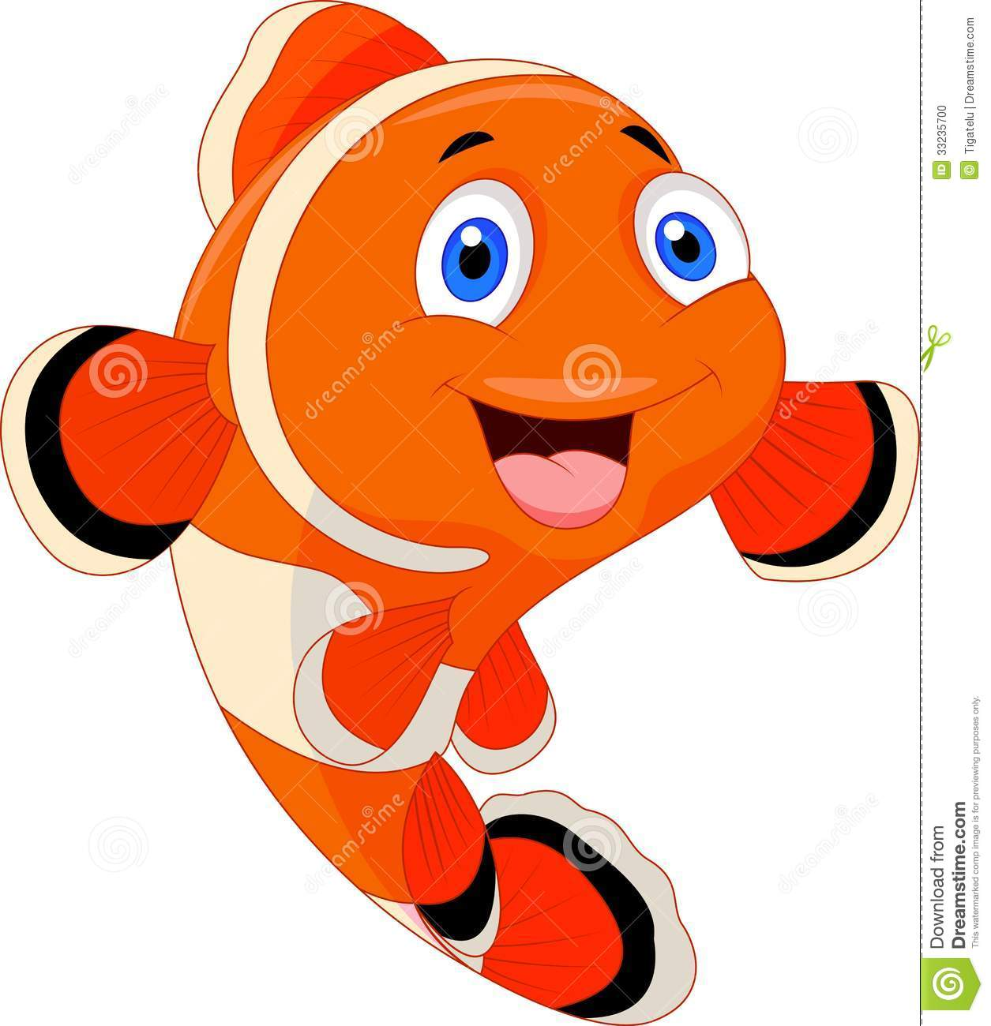

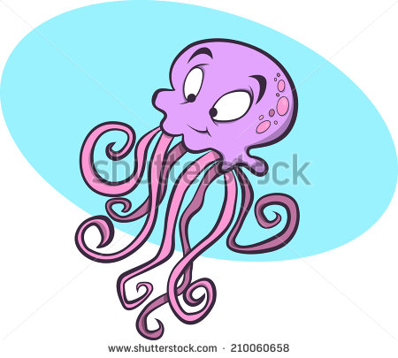

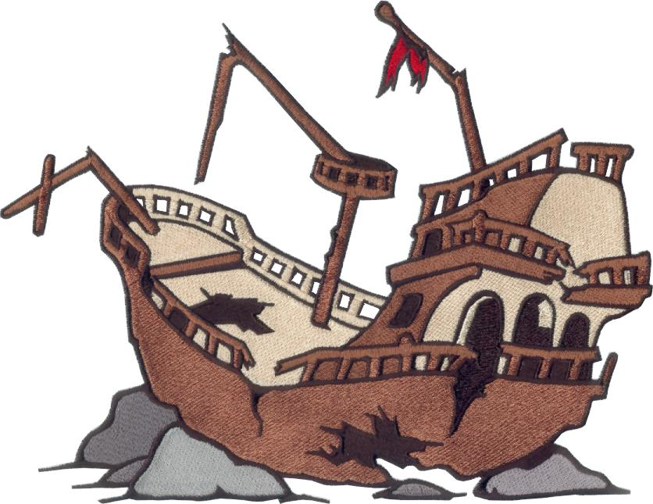

Under the Sea – Assessment
Choose two assessment activities from the following:
Name | Is able to sing soh me pitches | Is able to choose appropriate timbre | Is able to copy a clapped rhythm | Is able to create own score (Y2)
1 = exceeding expectation. 2 = expected level. 3 = emerging abilities.

