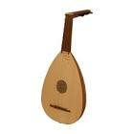

The Lute

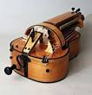

The Hurdy Gurdy

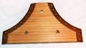

The Psaltery

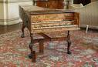

The Harpsichord

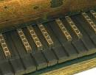

Queen Elizabeth’s Virginals

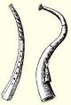

Cornetts

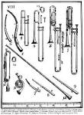

Tudor trombones, trumpets and cornets
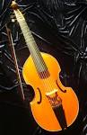

The Viol

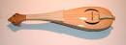

The Rebec

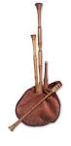

Tudor Bagpipes

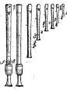
Tudor recorders

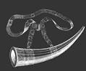

Hunting Horn

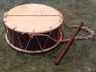

Tudor Tabor

