The Olympics (Champions)

Learning Intentions  Children learn… | Activities | Learning Outcomes  Children can..
About the Olympic Games | Brainstorming- facts about the Olympic Games (ancient and modern) | Talk about the history of the Olympics
About the values and philosophy attached to the Olympics | Discussion about motivation, commitment, talent, respect, self-belief  Songs- Believe, Power in Me, Be Amazing, Sporting World | Sing tunefully and confidently in two parts
About music written for the Olympic games | Listen and respond to three Fanfares written by John Williams  Identify instrumental sounds, discuss the purpose, venue and mood of the music | Talk about recorded sound using musical vocabulary L4
About Greek Music  - Ostinato  - Rhythm  - Melody | Revise the elements of musical composition  Play a tuned ostinato- DDAA (LA)  Play an un-tuned ostinato using drums and tambourines (MA)  Add a tune in two parts (HA) | Identify and use musical devices such as ostinato, harmony, rhythm and melody
About North American Music and culture  - Ostinato  - Chords  - Pentatonic scale  - Melody  - Creative composition  - Graphic scores | Revisit part-singing and playing (ensemble work), chords, the pentatonic scale (FGACD) and melodic improvisation  Chicken on a fencepost  Drone CCF- (Can’t dance now)  Chord- F F (Josie)  Ostinato- ffffFF (Chicken on a Fencepost)  Explore the native American story of ‘Turtle Island’ (the creation) and illustrate each character using the devices of drone, ostinato, rhythm and melody. | Select, explore, organise and create layers of sound to illustrate characters from a story using their knowledge of musical devices and elements
About Australian Music  - Rhythm  - Ostinato  - Pentatonic scale | Revise part-singing and consolidation of improvisation  Kookaburra (melody/ostinato/drone)  Secrets of the Animal Kingdom (Q&A phrases using DEGAB) | Can improvise melodic phrases L4
About Brazilian music  - Samba rhythms  - Ensemble playing  - Improvisation | Listening and responding to Samba music (mood, instruments, purpose, venue)  Learning and playing samba rhythms  Playing as an ensemble  Improvising rhythmic patterns | Can combine several layers of sound L4
About music with a purpose (Fanfares) | Revise chords, gather rhythmic patterns as a class and compose a class fanfare to announce the start of our Olympic Tour  Perform all the music we have played and composed throughout the term (Record and evaluate) | Can identify the relationship between sound and purpose L4  Can maintain an independent part L4

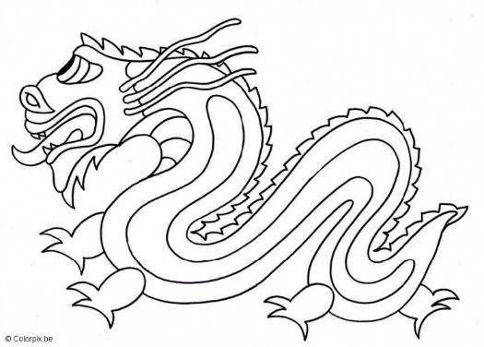 Chinese Questions and Answers (DEGAB)
Names:

Question .....................................................................

Notes ....................................................................

Answer .....................................................................

Notes .....................................................................
Fanfare for the Olympics Ceremony (D F sharp A)

1 2 3 4

left right left right

halt - halt -

standing to at- ten- tion
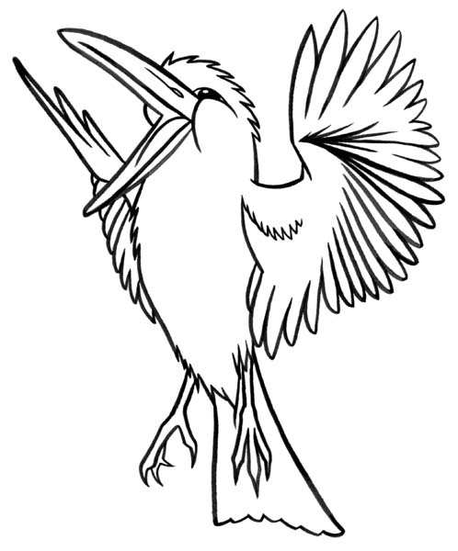 Kookaburra sits by the Old Gum Tree

1 2 3 4 1 2 3 4
a a a a B - a a a a A - (Kookaburra sits -)

A - gg gg A - dd dd (Laugh- kookaburra)

D D D - D D D - (Old Gum Tree-)

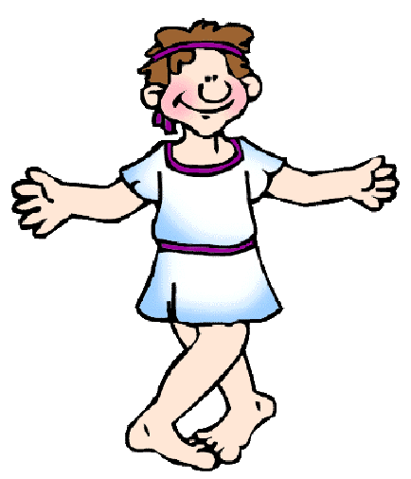 Greek Music: Part 1

1 2 3 4 1 2 3 4
D - A - D - A -

D - A - D - A -

A - A - A - A -

D - A - D - A -
Greek Music: Part 2
1 2 3 4 1 2 3 4
g♯ a aa aa aa g♯ a aa aa aa

g♯ a aa aa aa g♯ a aa aa aa

f♯ g gg gg gg f♯ g gg gg gg

g♯ a aa aa aa g♯ a aa aa aa
Greek Music: Part 3
1 2 3 4 1 2 3 4
f f♯ f ♯f♯ f♯f♯ f♯f♯ f f♯ f♯f♯ f♯f♯ f♯f♯

f f♯ f ♯f♯ f♯f♯ f♯f♯ f f♯ f♯f♯ f♯f♯ f♯f♯

e♭e ee ee ee e♭e ee ee ee

f f♯ f ♯f♯ f♯f♯ f♯f♯ f f♯ f♯f♯ f♯f♯ f♯f♯

Greek Music: Part 4

1 2 3 4

Drum X - X -

Tambourine - X - X

