The Little Red Hen

Planning for Foundation 2

Week 1
Focus: Short and long sounds- copying and creating body, vocal/phonetical sounds and following symbols for both
Looking at items in Barnaby’s backpack which remind him of his holiday on the beach and sorting them into long and short sounds

Week 2
Focus: short and long sounds- sorting out instrumental sounds into long and short, comparing short/long phonemes
Following symbols with short/long instrumental sounds
Moving to Silly Sam (long sounds) and Peter taps (short sounds)
Singing and name game and thinking about long and short initial sounds

Week 3
Focus: The Little Red Hen – finding short or long sounds to illustrate planning the seeds, cutting the wheat, carrying the wheat and baking the bread
Learning a short song and use the instruments as a class and in large groups to keep the beat

Week 4
Focus: Little Red Hen- Follow symbols on a simple score using vocal and then instrumental sounds
Identify hidden short and long sounds

Week 5
Focus: The Little Red Hen- rhythm and structure
Use the phrase’s Little Red Hen, Lazy Dog, Sleepy Cat, Yellow Duck and say/clap/play in different sequences. Make a pattern, following the structure of the story

Week 6
Focus: Assessment week
Children to - Sort sounds into short and long hoops
- Follow symbols for short and long sounds
- Follow Little Red Hen symbols
- Play the rhythm of the characters in the story
- Keep a steady beat whilst singing the song
- Listen to ‘Hens and Cocks’ from Mussorgsky’s ‘Pictures at an Exhibition’ and move their hands in time to the beat

Week 1: 30mins

Learning intentions: Children learn
How to say hello using soh and mi
About long and short sounds
About symbols and puppets

Introductory activity (10mins)
Sing, ‘hello children’ (GEGE) and show them how to sing back.
Introduce Barnaby Bear and look in his backpack. He has lots of things inside it that remind him of his holiday on the beach.
Make sounds that go with each and introduce the concept of long and short sounds.

Main activity (15mins)
Introduce the song, ‘Make your sound as long as mine’ (Tune: Muffin Man) and ask the children to copy some short sounds using their hands, fingers, feet, tongues etc. and then give volunteers the opportunity to create and demonstrate their own.
Introduce Charlie Crocodile. He likes short sounds best.
Repeat this activity with long sounds; introduce Sidney snake
Sort Barnaby’s seaside sounds into two hoops: one for long and one for short sounds
Hold up one of the cards/puppets and ask the children to make the sounds from the correct hoop

Plenary (5mins)
As I pack away Barnaby’s toys, ask the children to make the vocal/body sounds that we used to illustrate each.

Learning Outcomes: Children can
Copy soh and mi accurately
Identify short and long vocal and body sounds
Copy and create short/long vocal or body sounds
Follow puppets and simple symbols

Week 2: 30mins

Learning Intentions: Children learn
A new name game
About duration
About vocal, body and instrumental sounds
About short and long initial sounds
About symbols
Two new songs

Introductory activity (10mins)
Sing, ‘Hello Barnaby’ (GEggE) and look in his backpack. He has some farm animals. Make the sounds that the animals make and divide them into long and short sounds. Now explore the initial sound of each animal and sort them into long and short sounds e.g. ’p’ for pig= short and ‘sh’ for sheep= long

Introduce Hickety Tickety Bumble Bee and her song and encourage the children to sing back their names when they hold her.

Main activity (15mins)
Ask the children to stand up; and sing, ‘Peter taps with one hammer’- keeping a steady beat with their hands, feet and head.
What instrument would be best to accompany the song? (A tapping sound)
Ask the children to sort out some tapping sounds form the instrument trolley and put them into one of the hoops.
Introduce the song, ‘Silly Sam’ and ask the children to follow the words and add the appropriate actions.
Which instrument would make a good hissing sound? (A shaking sound)
Put some shaking sounds in the other hoop and then show the children two cards.

Show the children a symbol for short sounds that looks like a spike from Charlie crocodile’s back and ask them to make their sounds every time the card is raised. Repeat this with instruments that have short sounds.

Now show the children a card with a wiggly snake symbol on it like Sidney snake. Ask them to make long sounds when the card is raised and then ask children to play instruments that have long sounds.

Can the children respond to the correct card/toy?

Plenary (5mins)
Pack away the instruments and remind the children that when they held Hickety Tickety at the beginning of the lesson they sang their names.
Can they say the first sound of their name to themselves and work out if it is short like c, p, d or b or long like m, n, l or s?

Learning Outcomes: Children can
Song/say their names
Explore long/short vocal, body and instrumental sounds
Identify long/short sounds
Discriminate between long and short sounds
Follow puppets/symbols

Week 3: 30mins

Learning intentions: Children learn
A new song
About timbre
About pulse
To play in small and large groups

Introductory activity (10mins)
Sing, ‘Hello Barnaby’ and look in his backpack
He has lots of different birds (e.g. a woodpecker, a robin, a duck, a parrot and a hen). They are all birds but they make different sounds.
Explore the sounds and then explain to the children that Barnaby wants them to explore sounds today.
They have already explored long and short sounds.
Ask the children to make long sounds when you hold up Sidney Snake and the card with his symbol on it and to make short sounds when you hold up Charlie Crocodile and the card with his symbols on it.

Main activity (15mins)
Introduce or remind the children of the story of the Little Red Hen.
What did she have to do all by herself?
- Plant the seeds
- Cut the wheat
- Carry the wheat
- Bake the bread

Introduce the children to the Little Red hen’s song (Tune: have you seen the Muffin man?)

Who will help me plant the seeds?
Plant the seeds, plants the seeds
Who will help me plant the seeds?
On this sunny day

Ask the children to copy a steady beat that you will keep with your hands on your knees

After each verse encourage the children to explore vocal sounds for the dog, the cat and the duck as they say, “Not I’.

The little red hen sings,
I will plant the seeds alone
Seeds alone, seeds alone
I will plant the seeds alone
On this sunny day

Repeat this with new words for each part of the story and keep a steady beat with different body percussion each time

Who will help me cut the wheat…?

Who will help me carry the wheat…?

Who will help me bake the bread…?

Who will help me eat the bread…?

After the last verse the children sing,

I will help you eat the bread …
Cried her lazy friends

But the little red hen replies

I will eat the bread myself…
Because you wouldn’t help

Think of the actions- Planting (raking/watering)
- Cutting
- Carrying (footsteps)
- Baking

And ask the children to choose sounds to go with each e.g. jingles/tambourines, claves/woodblocks, drums and maracas.

Give out groups of these instruments around the circle and ask each group to keep a steady beat whilst the other children use body percussion to show the beat and sing the song.

Plenary (5mins)
Put away the instruments and remind the children that chose the instruments because of their different sounds and they played a steady beat to accompany the song.

Learning Outcomes: Children can
Discriminate between long and short sounds
Respond to symbols
Sing tunefully
Maintain a steady beat
Play with control

Week 4: 30mins

Learning intentions: Children learn
About signs and symbols (graphic scores)
Playing in groups and as a class
About duration
A new listening game

Introductory activity (7mins)
Sing, ‘Hello Barnaby’ and look at the animals he has in his backpack-a hen, a dog, a cat, a cow, a pig, a rat and a duck. Make the sound of each and decide which one is short (duck, rat, pig and dog) and which is long (cat and cow).
The hen makes a mixture of long and short sounds
Revise the game, ‘Sounds are short, some sounds are long’ and explore some long and short body/vocal sounds following Charlie Crocodile and Sidney Snake and their symbols.

Main activity (15mins)
Remind the children of the story of the Little Red hen and show them some pictures. Ask them to help you stick them up in the correct order on the board.

Follow a beater as it points to each card in turn and make some vocal or body sounds for each picture.
Now ask the children what sort of instrumental sound each of the activities requires
- Planting (short/jingles)
- Watering (long/triangles)
- Cutting (short/claves)
- Carrying/stepping (short/drums)
- Grinding (long/guiros)
- Baking (long/maracas shaken)

Give out the instruments around the circle and ask each group to play when their picture is pointed to.

Follow the story of the Little Red Hen using the symbols and the instruments.

Plenary (3mins)
Pack up the instruments into their trays on the floor in the centre of the circle and ask the children to listen to an example of each and to show with their hands close together or far apart if the sounds are long or short

Learning Outcomes: Children can
Explore long and short body/vocal sounds
Match the duration of the sound to a corresponding puppet/symbol
Follow a sequence of symbols with sounds
Play in a large group
Identify short/long sounds

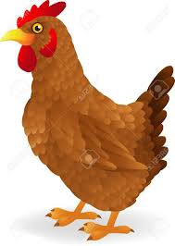

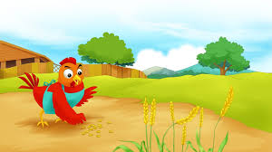

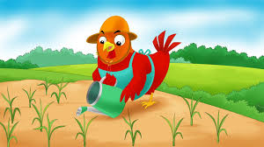

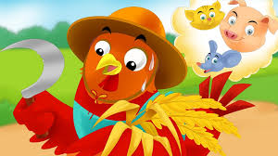

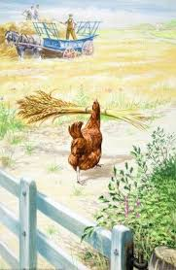
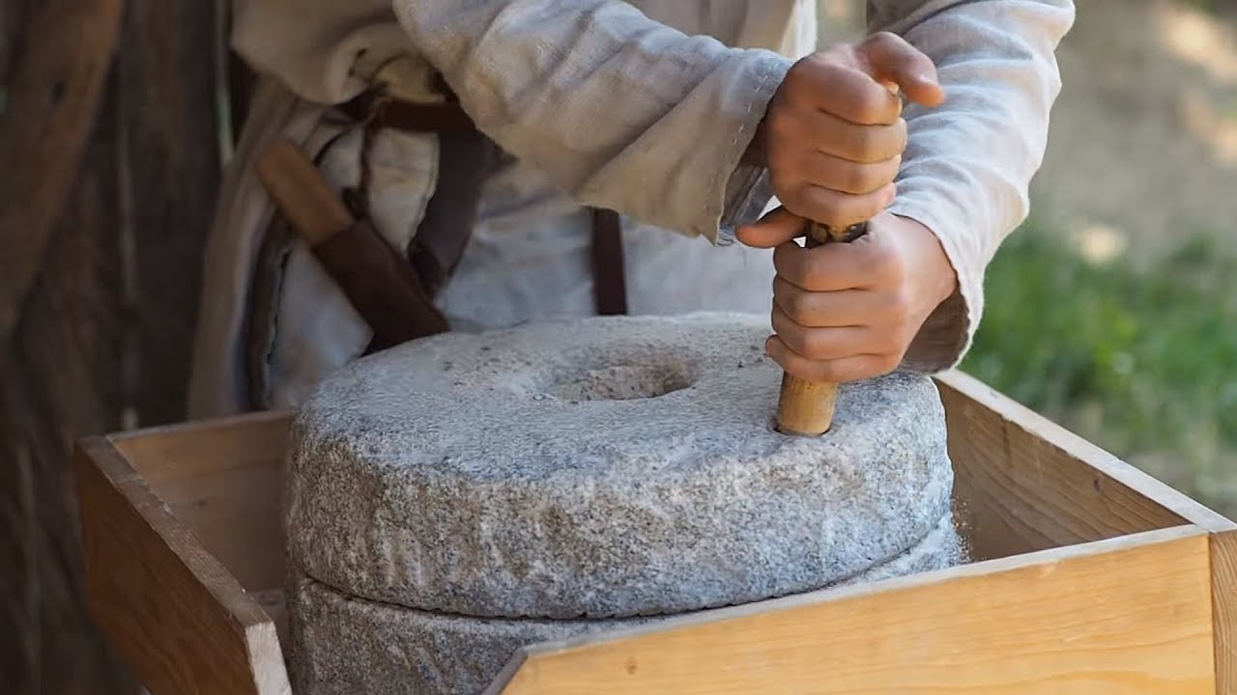

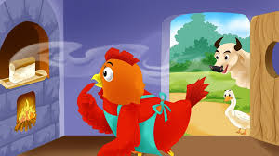

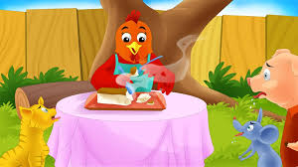

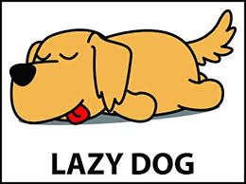

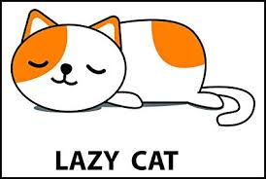

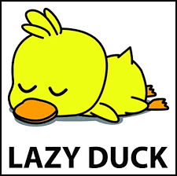

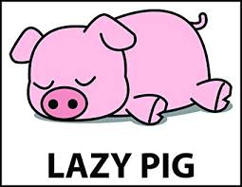

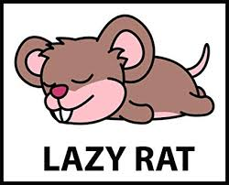

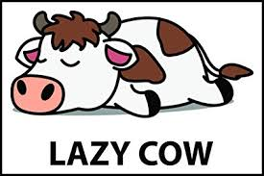

Week 5: 30mins

Learning intentions: Children learn
About rhythm
About pattern and sequence
To follow symbols

Introductory activity (10mins)
Sing, ‘Hello Barnaby’ and look at the pictures of the lazy friends of the ‘Little Red Hen.’ Ask the children to clap the name of each animal.
Now ask the children to describe each one e.g. Yellow duck, spotty cow, sleepy rat, pink pig, purring pussycat and snoring dog.

Main activity (15mins)
Pin the pictures up on the board in a row and ask the children to clap and say the phrase they have chosen for each animal.
Now show the children pictures of the little red hen. (There will be 8 pictures of her in all).
Ask the children to suggest how they might make a pattern using all the pictures.
E.g. Hen- dog-hen-cat etc.
Try clapping and saying the phrases for each
Repeat this activity with the children playing sounds on instruments. Give them a free choice today.

Plenary (5mins)
Before the children pack their instruments away, ask them to keep a steady pulse as they sing each of the verses of Little Red Hen’s song.

Learning Outcomes: Children can
Think of describing words
Clap the pattern of words and phrases
Play with control
Follow symbols
Organise sounds into patterns and sequences

Week 6: 30mins (Assessment week)

Learning Intentions: Children revise and revisit
Duration (short and long sounds)
Follow symbols
Rhythm and pulse

Introductory activity (5mins)
Sing, ‘Hello Barnaby’ and get Sidney snake and Charlie crocodile out of his backpack.
What sort of sounds does each of the toys prefer?
Sing, ‘Some sounds are short, some sounds are long. Let’s make some short/long sounds after this song’ and make some together.

Main activity (20mins)
Lay out two hoops on the floor and put Charlie and Sidney in each.
Ask volunteers to place a drum, a tambourine, some jingles, some finger cymbals, some maracas, a guiro, a triangle, a woodblock, some claves and some castanets in the correct ring and for the other children to check that they have completed the task correctly.
Ask the children to collect an instrument and to follow Charlie and Sidney with the correct sounds

Assess: Can follow visual cues

Ask the children to play the rhythm of the names of the characters from the ‘Little Red Hen’ and assess

Assess: Can copy rhythmic patterns

Follow the symbols for the story and ask the children to keep a steady beat

Assess: Can maintain a steady beat

Plenary (5mins)
If time, pack the instruments away and ask the children to make two fingers into the beak of a hen and then to pretend to peck up seeds of corn from the farmyard floor as they listen to ‘Hens and Cocks’ from Mussorgsky’s Pictures at an Exhibition’.

Learning Outcomes: Children can
Maintain a steady beat
Copy rhythmic patterns
Follow visual cues
Differentiate between short and long sounds
Respond to music with movement

Foundation 2 Generic Music Assessment

Autumn 1 and 2

Class:

Name of child | Can copy a soh-mi sung phrase  (Hello)  Date Date | Can maintain a steady beat  Date Date | Can copy rhythmic patterns  Date Date | Can follow visual cues  (Symbols/puppets)  Date Date

Foundation 2 Generic Music Assessment

Autumn 1 and 2

Class:

Name of child | Can copy a soh-mi sung phrase  (Hello)  Date Date | Can maintain a steady beat  Date Date | Can copy rhythmic patterns  Date Date | Can follow visual cues  (Symbols/puppets)  Date Date

Foundation 2 Generic Music Assessment

Autumn 1 and 2

Class:

Name of child | Can copy a soh-mi sung phrase  (Hello)  Date Date | Can maintain a steady beat  Date Date | Can copy rhythmic patterns  Date Date | Can follow visual cues  (Symbols/puppets)  Date Date

