The Very Hungry Caterpillar

Lesson 2: 30mins

Learning Intentions: Children learn
A new poem
About beat and rhythm
About alliteration

Introductory activity (5mins)
If you want to….
Sing Hello Barnaby (GEGE) and look at the fruit and vegetables he has in his backpack
Clap the rhythm of each one.

Main activity (20mins)
Tell the children that they are going to make some soup for Barnaby and show them a saucepan, wooden spoon, a chopping board and plastic knife.
Ask the children to listen to a poem and to tell me which word is repeated most. (Chop)

Chop, chop
Chop, chop, choppity chop
Chop off the bottom and chop off the top
What we have left we will put in the pot
Chop, chop, choppity chop

Ask the children to lay the palm of one hand out flat like a chopping board and to use the other hand to pretend to chop some vegetables up on it.
They will be keeping a steady beat as the poem is repeated
Ask the children to listen to three sounds and to choose the best one for a chopping sound. (E.g. a shaker, a scraper and some wooden claves)
Show the children how to keep a steady beat using their tapping sounds as the poem is read again.

Now show the children the sack of fruit and vegetables and give each child the chance to pick one out.
Can the children tap the rhythm of the fruit or vegetable as the child chops it up and put it in the saucepan?

Repeat the chorus each time and ask all the children to tap the pulse again.

Look at the story of ‘The Very Hungry Caterpillar’ and ask the children to play each of the fruits that he eats.

Ask the children what sound each of the fruits begins with and then try to make up some words to describe them using the same sound (alliteration)

- Squishy strawberry
- Perfect pear
- Odd orange
- Angry apple
- Pretty Plum

Each time, ask the children to play the rhythm of the words

Plenary (5mins)
Pack the instruments away and ask the children if they remember which fruits the Hungry Caterpillar eats in the story.
Can they clap their rhythm?

Learning Outcomes: Children can
Keep a steady beat
Play the rhythm of words
Help to create alliterative words

Lesson 3: 30mins

Learning Intentions: Children learn
About rhythm
A new rhythm/counting game
To sing and play

Introductory activity (10mins)
If you want to….
Sing, ‘Hello’ to Barnaby and look at the pictures of food from the story of ‘The very Hungry Caterpillar’ that he has I his backpack.
Ask the children to clap the rhythm of each food
Look at each of the fruits in the book and ask the children to clap the rhythm of each but to follow the pictures at the same time.

Main activity (15mins)
Sing the song (from lesson 1), ‘Tiny Caterpillar’ and add actions for wiggle, munch, spin and flap.
Remind the children that they choose some sounds to add to each verse of the song and ask them to help find some for each of the verbs.
(It doesn’t matter if the children all play together on each verse but this week try to encourage them to only play when they see our hands making the actions)
Ask the children to use their instruments to play the fruits and the foods that the caterpillar ate.
Now lay out three cards- Swiss cheese, ice cream cone and watermelon. Ask the children to tap each one and to count how many taps there were in each word.
Look at the other foods and see if the children can identify which pile they should go on- two, three or four taps.

Finish by singing and playing the final verse of the song, ‘Now that tiny caterpillar went like this….’

Plenary (5mins)
Pack away the instruments and ask the children if they know a food that the caterpillar could have eaten with one tap.
Sing ‘Goodbye’ to Barnaby and to the caterpillar.

Learning Outcomes: Children can
Play rhythmic patterns
Count the number of taps in a word/words
Play with control
Sing tunefully and enthusiastically
Follow visual cues

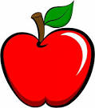

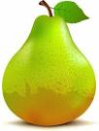

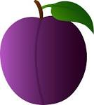

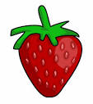

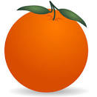

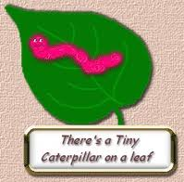
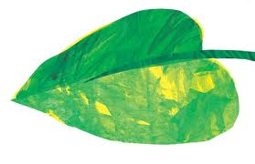
He will eat the leaves around him ‘til he’s full

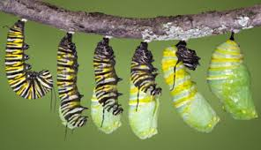

A cocoon is what he’s spinning for his home

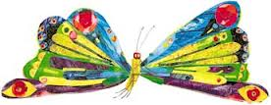

Then he’ll be a butterfly and flap away

