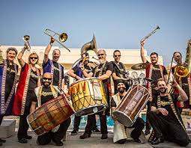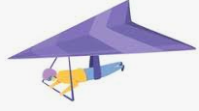

What is **PITCH?**

RESEARCH…

FIND OUT THE NAMES OF BOLLYWOOD FILMS AND ACTORS

glide

stride

jogging

walk

stride

PLANET BRASS

Bollywood Brass – AUTUMN TERM

NAME:

CLASS