Weekly term planning - Year 1 – Jolly Postman
Week | Learning Objective  Pupils should learn………….. | Summary of Teaching activities | Notes for support staff/resources needed etc
1 | Y1 - To be able to keep a steady pulse  Y2 – to be able to play word rhythms | Warm up: Hello BB – find Characters from different fairy tales  Have you brought you X voices chant (SS1) (Include 3 bears, witch etc) .  Introduce Soh and Mi and do some echo phrases  Main activity:  Teach the chant 1 2 3 4 Mary at the Kitchen Door from Active music digital . Change words to Jolly Postman at the Door. Ask children to tap pulse as you say the rhyme.  Y1 – Make up new verses about ‘Goldilocks/Daddy Bear etc at the door’.  Ask children to move to the pulse like that character as you say the rhyme i.e. skip, stamp tiptoe etc  Show instruments and demonstrate sounds. Ask children to work in pairs.  They should decide which character they want to be and which instrument they would need.  Invite children to choose and show the class their sounds – which character were they being?  Repeat chant with children playing the pulse using their sound.  Y2 – Teach words of the chant – say and tap, think and tap, tap on each others hands etc.  Make up new verses using children in the class. Clap and say their names i.e. Emily at the door.  Show instruments and ask children to suggest an instrument for playing 1 2 3 4. Repeat for the words ‘Jolly Postman at the Door’  Children choose which part they want to play and their instrument.  Perform chant on instruments with new verses  Plenary:  Y1 - Play ‘We will copy you’ AMD using ball  Y2 - Play listening game ‘Don’t Clap this one back’ using ‘Watch out for Mister Wolf!’ as the rhythm they mustn’t clap back | Singing Games and Rhymes (SGR)  3 Tapping Teddies  3 Singing Pigs  CT join in all activities / support a child as necessary
2 | To be able to sing back 2 notes (Soh/Mi)  Y1 - To identify changes in tempo  Y2 – to be able to play word rhythms  - To match sounds to symbols (ta tete) | Warm up: Hello BB – find letters from Jolly Postman Book  Introduce/revise soh and mi and echo phrases - begin assessment  Y1 – Hickety Tickety song and name game  Y2 - ‘Who’s got the rhythm’ song and game - pass a drum round the cirdle as you sing. Whoever has the drum at the end of the song listens to your rhythm and copiesit back  Who’s got the rhythm E e d C C  Who’s got the rhythm D d d E C  Who’s got the rhythm E e d C C  Please let us hear. E d d C  Main activity:  Y1 – Teach 3 tapping teddies from 3TT - keep steady pulse (tap knees as you say the chant)  Follow lesson plan in book - Extension 1 activity Children read symbols in the book and make appropriate action and sound  Y2 – Revise word rhythms from previous week and learn ta tete symbols  Say and tap rhythms of Mary at the Kitchen Door using words then ta tete  Read Goldilocks Rap from 3 SP – ask children to keep pulse using body percussion  Explore the last 2 lines of each verse – cornflakes rice cakes/ arm chair deck chair, bath tub etc  What do they notice (has the same rhythmic pattern)  Divide children into groups for each verse. Choose an instrument for each verse and perform chant with children playing the last 2 lines of each verse  Plenary –  Hidden sounds game – ask a child to use one of the paws cards and play that teddy’s sound. The listener has to select the correct teddy  Y2 Show ta tete symbols again - – can they work out the ta and tete pictures that match the words from the chant?  Play don’t clap this one back as in previous week – assessment opportunity for Y2 . | SGR  CT support with passing and rules of the game  CT Support children holding and playing instruments correctly  3TT  CT join in all activities  3SP  CT support children as necessary  CT help assess x can play word rhythms
3 | To be able to sing back 2 notes (Soh/Mi)  Y1 - To be able to identify changes in pitch  Y2 – To combine word rhythms | Warm up: Hello BB - Jack props and letter  Make raisin faces/wide faces/roller coaster etc  Revise sol fa characters  Y1/Y2 - Doggie Doggie song and game from SGR with a postman theme! ‘Postman Postman where’s you sack? Someone stole it – I want it back!  Main activity:  Y1 – Listen to Jack and the beanstalk from SS1. Add actions as you listen.  Teach song slowly using hands/bodies to chow pitch changes. Children copy you line by line.  What happened to our voices as our hands/ we climb up? (Voices follow hands)  Repeat song with children showing pitch changes with hands/bodies.  Teach the climbing down song in the same way.  Show chime bars.  Play 5 note scale up or down - ask children to show you whether Jack is climbing up or down. They show with their hands/bodies. Now ask children to close eys or turn around/hide the chimes and repeat activity. Begin assessment  Y2 – Continue with Goldilocks rap – do long activity from 3SP book  Plenary – repeat we will copy you song from Week 1 and assess pulse for Y1.  Y2 don’t clap this one back as in previous week | SS1 - Singing Sherlock Book 1  CT join in and support with learning the song  CT help assess
4 | To be able to identify changes in pitch  To match movements to music  To play TP instrument with control | Warm up: Hello BB – Animals/characters that have high and low voices  Y1 / Y2- Revise warm up from previous week – assess s/m phrases (doggie doggie)  Main Activity:  Listen to ‘Belle et la Bete’ from Ravel’s Mother Goose Suite. Ask children which traditional tale characters they think they are hearing for each section.  Revise Jack song from previous week with body actions  Play the climbing up and down music on chimes again and children show with their hands as in previous week . Invite a child to play and repeat activity.  Establish the small chimes are high and big chimes are low  How else could Jack move up and down the beanstalk. Model a few ideas for going up and down.  Paired activity – make Jack climb up or down the beanstalk.  Y2 as Y1 but do the Jack activities from lessons 3 and 4 this week.  Plenary – share music and identify what Jack was doing!  Extension – play some ‘hidden sounds’ - children play and the listening children say what happened without looking at the players | SGR  SS1  CT support children with pitch  CT work with children as necessary
5 | To be able to choose appropriate instrument to represent a character  To play instruments with control  Y2 – to identify a word rhythm | Warm up: Hello BB and find different puppets – clap the name of each  Y1 - ‘Pass the Puppet’ from SGR – fairy tale characters. Assess can sing soh me lah pattern.  Y2 – Postman Postman or Pass the Puppet. Link to sol fa characters and sing in sol fa  Main Activities:  Y1 - Revise Jack and the Beanstalk song and work on the Giant section using different voices for Jack and the Giant.  Teach Fee Fi Fo Fum part with stamps.  Identify suitable instruments to play Giant music . Give out a drum to a pair of children – take turn to say and tap Giant’s words.  Y2 – add claves for the chip chop part – are you playing the pulse or a word rhythm?  Hear a few children and evaluate.  Show chimes and revise Jack climbing up and down beanstalk as in previous week.  Invite children to choose to be Jack or the Giant and perform whole song.  Plenary:  Pack away and play a pitch listening game – i.e. ask children to show a shape for a high or low sound that you play on chimes/piano etc. Play with children looking at you and then eyes closed.  What was your favourite sound today? How did Jack’s music change? (It got higher and lower) Did you hear any changes in the Giant’s music? (It stayed loud and was the same each time). | CT join in the game  SS1  CT support with playing in correct place  CT could record to watch back in class later
6 | Y1 - To be able to play sounds to represent a character  To keep the steady pulse  Y2 – to be able to play a word rhythm | Warm up: Teach ‘Early in the Morning’ song and Game from SGR. Children should hand out letters to the pulse 1 ,2, 3, 4 at the end of the song  Main Activity:  Watch the Jolly Postman video or summarise story again.  Y1 –  Show the picture of the Jolly Postman at the tea party. Show characters from the book and discuss what they are doing.  Sing ‘Come to the Party’ from ‘the songbook ‘Game Songs’.  Ask what the fairy tale characters would like to do at a party and model singing words. Actions in the song for each character.  Explain that we are going to find a sound for each character and create a musical ‘party’ using different sounds.  Show a range of percussion instruments and model sounds - Which character need a soft/loud/high/low sound?  Children talk with a partner about the best instruments to represent that character.  In pairs they choose an instrument and practice playing the pulse to the song instead of doing actions.  Assess x can playing instruments with control / represent a character  Y2 – Come to the party song and actions as Y1. Show characters from the book and discuss what they are doing.  Show the word rhythm for each i.e. Jolly Postman drinks his tea.  Hold up picture of the word rhythm then as a class work out how the ta and tete pictures fit.  Finally clap the ta tete rhythm cards for each rhythm.  Try to combine 2 rhythms or one rhythm with pulse.  Play on instruments to create a musical party!  Assess x can play word rhythms  Plenary: Pack away and play games from the unit to complete assessment  i.e. Pass the Puppet, doggie doggie. CHECK assessment grid! | SGR  Game Songs – CT join in with singing and actions  CT support children as necessary  CT could assess  CT join in and clap ta tete patterns  CT could assess
Week 7 | To clap ta tete rhythms  To recognise notation for ta tete | Warm up: Hello BB. Postman Postman singing game OR Early in the morning  Hickety Tickety and video again for assessment evidence  Main Activity:  Show word rhythms from Jolly Postman from previous week . Clap and say together.  Choose one and play Don’t clap this one back with one phrase chosen to not clap back  Y2 - Show ta tete cards again. Make a few rhythms with individual cards as a class and clap and say together.  Divide children into 4 groups and give each a rhythm card. Clap each rhythm  Play one rhythm on violin and they clap when they hear their rhythm.  Repeat playing rhythms on instruments  Y1 - Show instruments – choose an instrument for each word rhythm and repeat playing rhythms.  Divide class into 4 groups and ask each group to pay their rhythm. Try combining with the pulse or one other rhythm if appropriate  Plenary: Pack away and play Early in the Morning. complete assessment
Christmas week – games and parachute etc

Cake! - Yum! -

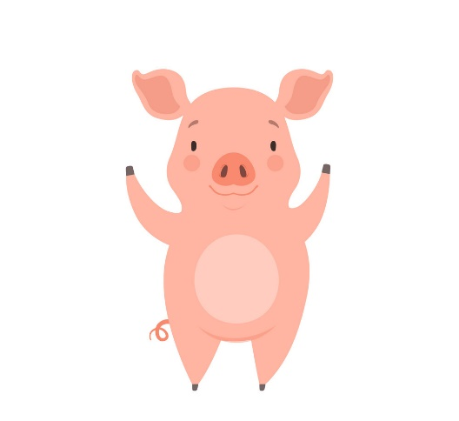
Lit-tle Pig drink- ing juice
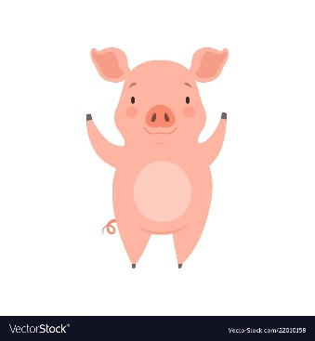

Jol - ly Post – man

Hap - py Birth - day Gold - i - locks!

